# **Invitation Letter**

**Frigid Zone Medicine**

Dear Prof. _________:

We are writing to invite you to join the Editorial Board of “Frigid Zone Medicine (FZM)”, in view of your expertise and record of contributions in the field of frigid-zone medicine.

*FZM*, launched in 2021, aims to build a high-quality international medical platform for academic communication and development, lead the academic study of frigid-zone medicine, and ensure rapid dissemination of important scientific achievements to the public all over the world. *FZM* publishes articles on the latest research results and leading developments in the field of frigid-zone medicine in biology and biomedicine, providing an international academic platform for the local and overseas researchers of related fields. The scope of *FZM* covers basic science and translational research of pathophysiology, pharmacology, medical biochemistry, medical molecular biology, medical genetics, medical immunology, medical microbiology, clinical medicine and traditional medicine.

*FZM* is a peer-reviewed journal that aims to publish the latest research in the field of frigid-zone medicine. Multiple types of articles are welcome, including Editorials, Review Article, Original Article, Case Report and Rapid communication. In addition, *FZM* also publishes comments from outstanding experts, clinical guideline, letters, new methods and technologies, etc. in this field. Details information is available at: [www.frigidzonemedicine.com](http://www.frigidzonemedicine.com)

The principal responsibilities of editorial board members are:

·Participating in providing new ideas or suggestions to improve the standard of the journal  
·Contributing two articles a year to support the journal issues  
·Encouraging submission of quality articles  
·Performing peer review and recommending reviewers

We appreciate so much if you accept our invitation and do not hesitate to contact us if you have any question. We will be pleased to work with you.

Best regards,

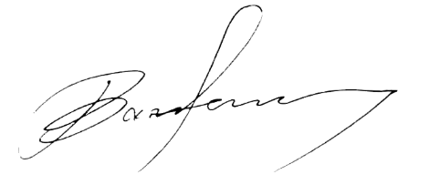

Baofeng Yang

Professor

Editor-in-Chief,

Harbin Medical University