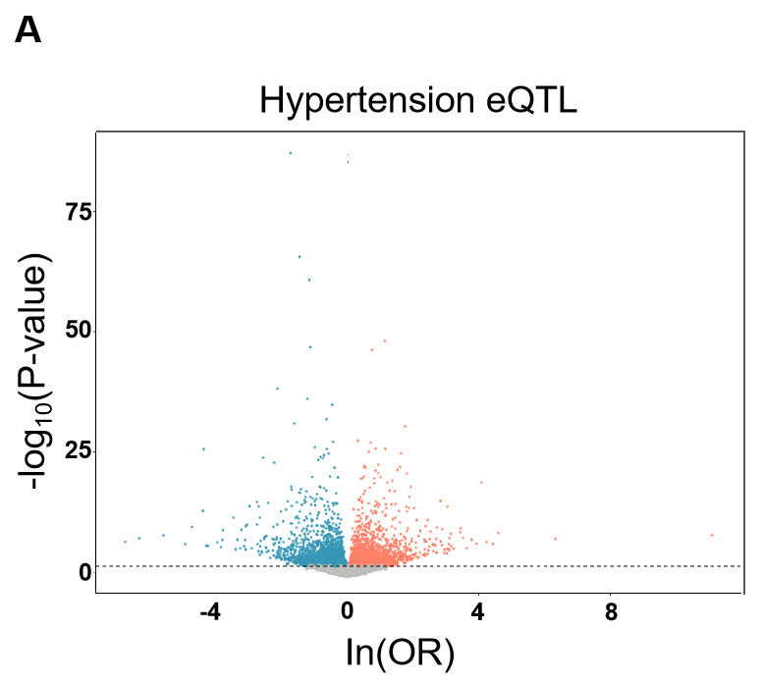

Figure S1. The expression quantitative trait loci of hypertension.
- Volcano Plot of Hypertension-Associated eQTLs displays the expression quantitative trait loci (eQTL) associated with hypertension.

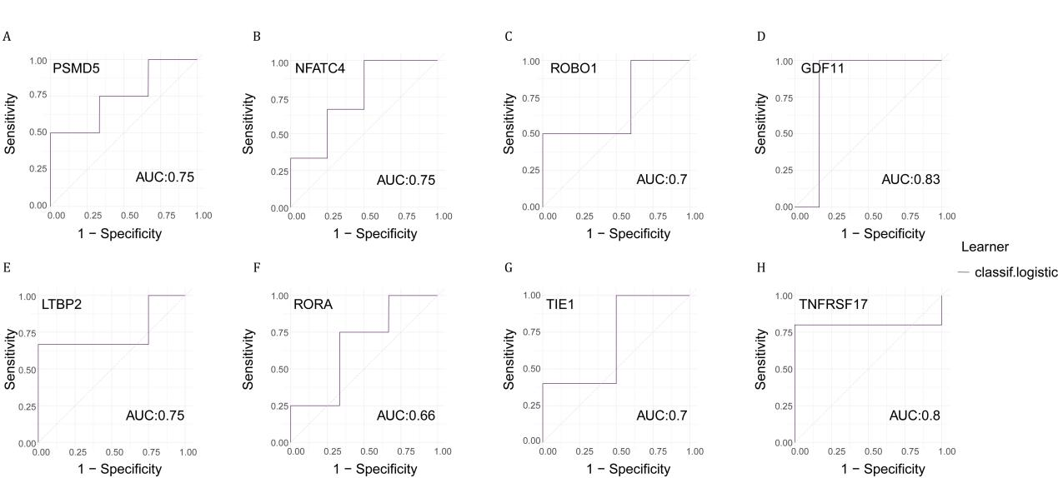
Figure S2. Receiver Operating Characteristic (ROC) curves assessing the diagnostic performance of selected hypertension-related genes using transcriptome data.
(A-H) Each subfigure represents the ROC curve for an individual gene, demonstrating its ability to distinguish between hypertensive and non-hypertensive subjects. The Area Under the Curve (AUC) values indicate the diagnostic effectiveness of each gene.
(A) ROC curve for PSMD5 to distinguish between hypertensive and non-hypertensive subjects with an AUC of 0.75.
(B) ROC curve for NFATC4 ROC curve for PSMD5 to distinguish between hypertensive and non-hypertensive subjects with an AUC of 0.75.
(C) ROC curve for ROBO1 to distinguish between hypertensive and non-hypertensive subjects with an AUC of 0.7.
(D) ROC curve for GDF11 to distinguish between hypertensive and non-hypertensive subjects with an AUC of 0.83.
(E) ROC curve for LTBP2 to distinguish between hypertensive and non-hypertensive subjects with an AUC of 0.75.
(F) ROC curve for RORA to distinguish between hypertensive and non-hypertensive subjects with an AUC of 0.66.
(G) ROC curve for TIE1 to distinguish between hypertensive and non-hypertensive subjects with an AUC of 0.7.
(H) ROC curve for TNFRSF17 to distinguish between hypertensive and non-hypertensive subjects with an AUC of 0.8.

Fig. S3 Protein-Protein Interaction (PPI) network of hypertension-associated hub genes.
- Network visualization of protein-protein interactions (PPI) and functional associations. Edges denote different types of interactions including physical interactions, co-expression, predicted interactions, shared pathways, and protein domains.

Fig. S4 Knockdown of TIE1 has no impacts on the blood pressure of spontaneously hypertensive rats.
- Statistical analysis of systolic and diastolic blood pressure in both groups of rats.

Fig. S5 MR analysis of gut microbiota abundance and TIE1 expression.
Mendelian randomization analysis using gut microbiota-associated GWAS data and hypertension-related SNPs revealed that higher Adlercreutzia abundance was inversely associated with TIE1 expression.

