Supplementary material
Table S1 The SEV and burden of IHD attributed to non-optimal temperatures in Global, 1990-2021
Risk | Sex | 1990 |  |  |  |  |  | 2021
Risk | Sex | SEV (95% UI) |  | Death (95% UI) |  | DALYs (95% UI) |  | SEV (95% UI) |  | Death (95% UI) |  | DALYs (95% UI)
Risk | Sex | All ages (%) | Age-standardized (%) | Numbers (n) | ASMR (1/10⁵) | Numbers (n) | ASDR (1/10⁵) | All ages (%) | Age-standardized (%) | Numbers (n) | ASMR (1/10⁵) | Numbers (n) | ASDR (1/10⁵)
Non-optimal temperature | Both | 30.20 (26.10, 34.87) | 30.12 (26.05, 34.77) | 355,694 (291,438, 465,059) | 10.57 (8.63, 13.74) | 7,720,584 (6,227,786, 10,156,652) | 201.94 (164.76, 265.82) | 32.23 (28.00, 36.92) | 32.29 (28.06, 37.01) | 610,524 (459,424, 862,748) | 7.39 (5.57, 10.44) | 12,418,517 (9,158,607, 17,640,354) | 146.03 (107.55, 207.43)
Non-optimal temperature | Male | 30.43 (26.31, 35.12) | 30.35 (26.26, 35.02) | 185,685 (150,374, 244,730) | 12.50 (10.22, 16.41) | 4,508,109 (3,596,472, 5,973,279) | 251.98 (202.89, 332.76) | 32.5 (28.25, 37.21) | 32.52 (28.28, 37.24) | 339,797 (255,301, 473,534) | 9.33 (7.05, 12.98) | 7,589,533 (5,526,063, 10,668,882) | 191.30 (140.47, 268.49)
Non-optimal temperature | Female | 29.97 (25.89, 34.62) | 29.90 (25.84, 34.53) | 170,009 (137,754, 220,710) | 8.95 (7.26, 11.57) | 3,212,475 (2,588,803, 4,240,017) | 156.44 (126.48, 206.42) | 31.97 (27.74, 36.64) | 32.07 (27.84, 36.78) | 270,727 (203,906, 380,651) | 5.79 (4.35, 8.14) | 4,828,984 (3,550,228, 6,840,546) | 105.05 (76.94, 149.00)
High temperature | Both | 31.96 (26.22, 37.78) | 31.69 (25.97, 37.52) | 32,569 (-675, 86,633) | 0.90 (-0.03, 2.46) | 813,984 (3056, 2,042,308) | 20.18 (-0.12, 51.93) | 37.18 (31.35, 43.1) | 37.33 (31.49, 43.26) | 112,390 (17,052, 256,434) | 1.34 (0.20, 3.07) | 2,623,940 (467,681, 5,727,664) | 30.57 (5.41, 66.96)
High temperature | Male | 32.34 (26.61, 38.17) | 32.08 (26.35, 37.91) | 18,182 (-276, 46,868) | 1.14 (-0.02, 3.01) | 483,972 (3579, 1,206,452) | 25.6 (-0.2, 65.26) | 37.51 (31.67, 43.43) | 37.58 (31.74, 43.5) | 65,880 (10,491, 149,756) | 1.74 (0.26, 4.01) | 1,640,366 (290,897, 3,596,848) | 40.34 (7.01, 89.25)
High temperature | Female | 31.58 (25.84, 37.39) | 31.34 (25.61, 37.15) | 14,387 (-579, 38,760) | 0.72 (-0.04, 1.99) | 330,012 (386, 829,767) | 15.44 (-0.04, 39.55) | 36.85 (31.02, 42.77) | 37.09 (31.25, 43.03) | 46,510 (6718, 107,921) | 1.00 (0.15, 2.32) | 983,574 (175,608, 2,153,944) | 21.65 (3.91, 47.27)
Low temperature | Both | 24.84 (22.82, 27.73) | 24.86 (22.82, 27.76) | 325,588 (285,690, 387,323) | 9.74 (8.52, 11.60) | 6,967,336 (6,137,182, 8,362,562) | 183.27 (161.52, 219.62) | 24.18 (22.37, 26.78) | 24.16 (22.34, 26.74) | 505,298 (432,024, 619,922) | 6.14 (5.23, 7.53) | 9,961,231 (8,580,362, 12,290,759) | 117.4 (101.19, 144.86)
Low temperature | Male | 24.97 (22.97, 27.83) | 24.98 (22.96, 27.86) | 168,875 (149,613, 202,575) | 11.45 (10.10, 13.75) | 4,060,233 (3,570,698, 4,893,294) | 228.31 (201.97, 274.56) | 24.33 (22.52, 26.92) | 24.31 (22.49, 26.89) | 278,113 (239,044, 335,466) | 7.71 (6.60, 9.29) | 6,053,401 (5,188,099, 7,363,848) | 153.52 (131.80, 186.39)
Low temperature | Female | 24.71 (22.68, 27.63) | 24.73 (22.70, 27.66) | 156,712 (135,895, 186,372) | 8.28 (7.10, 9.86) | 2,907,103 (2,521,611, 3,489,523) | 142.15 (123.20, 170.66) | 24.03 (22.21, 26.65) | 24.00 (22.18, 26.59) | 227,185 (189,494, 279,596) | 4.85 (4.05, 5.97) | 3,907,830 (3,330,660, 4,792,650) | 84.78 (72.14, 103.95)
UI (uncertainty interval) is based on the 2.5th and 97.5th percentiles of the posterior distribution from 1000 Monte Carlo draws, representing the 95% uncertainty interval. SEV, summary exposure value; DALY, disability-adjusted life year; ASMR, age-standardized mortality rates; ASDR, age-standardized disability-adjusted life years.

Table S2 The SEV and burden of IHD attributed to non-optimal temperatures in high SDI, 1990-2021
Risk | Sex | 1990 |  |  |  |  |  | 2021
Risk | Sex | SEV (95% UI) |  | Death (95% UI) |  | DALYs (95% UI) |  | SEV (95% UI) |  | Death (95% UI) |  | DALYs (95% UI)
Risk | Sex | All ages (%) | Age-standardized (%) | Numbers (n) | ASMR (1/10⁵) | Numbers (n) | ASDR (1/10⁵) | All ages (%) | Age-standardized (%) | Numbers (n) | ASMR (1/10⁵) | Numbers (n) | ASDR (1/10⁵)
Non-optimal temperature | Both | 28.61 (24.75, 34.19) | 28.76 (24.90, 34.30) | 118,035 (100,413, 154,879) | 10.75 (9.12, 14.12) | 2,151,261 (1,862,973, 2,817,799) | 196.60 (170.05, 257.76) | 30.74 (27.11, 35.59) | 31.21 (27.63, 36.05) | 99,831 (79,887, 136,197) | 4.25 (3.43, 5.82) | 1,683,160 (1,372,572, 2,319,191) | 83.20 (66.68, 116.00)
Non-optimal temperature | Male | 28.81 (24.95, 34.32) | 28.9 (25.04, 34.38) | 60,988 (53,169, 79,288) | 14.50 (12.55, 18.91) | 1,278,975 (1,118,770, 1,660,268) | 280.16 (244.84, 364.25) | 31.40 (27.83, 36.13) | 31.72 (28.18, 36.47) | 55,648 (46,267, 75,144) | 5.84 (4.83, 7.92) | 1,066,711 (870,440, 1,462,912) | 119.59 (95.88, 164.85)
Non-optimal temperature | Female | 28.41 (24.56, 34.07) | 28.62 (24.77, 34.21) | 57,046 (46,805, 74,966) | 8.10 (6.64, 10.66) | 872,285 (734,809, 1,150,588) | 129.59 (109.40, 171.34) | 30.09 (26.43, 35.04) | 30.67 (27.04, 35.61) | 44,183 (32,933, 60,268) | 2.93 (2.25, 3.99) | 616,449 (481,819, 840,551) | 49.80 (39.13, 69.13)
High temperature | Both | 25.34 (19.11, 32.07) | 25.55 (19.32, 32.26) | 5710 (-843, 20,607) | 0.53 (-0.08, 1.89) | 110,946 (-13,041, 386,360) | 10.29 (-1.15, 35.64) | 28.21 (22.43, 34.62) | 28.77 (22.98, 35.14) | 9186 (-482, 28,525) | 0.45 (0, 1.31) | 206,268 (9553, 570,322) | 12.05 (0.95, 31.71)
High temperature | Male | 25.64 (19.40, 32.35) | 25.76 (19.52, 32.46) | 3037 (-395, 10,653) | 0.72 (-0.10, 2.55) | 67,237 (-6871, 228,809) | 14.67 (-1.55, 50.16) | 28.96 (23.14, 35.30) | 29.35 (23.53, 35.66) | 5650 (-150, 16,766) | 0.64 (0, 1.83) | 141,151 (8861, 379,191) | 17.59 (1.46, 45.87)
High temperature | Female | 25.04 (18.83, 31.8) | 25.35 (19.13, 32.07) | 2674 (-432, 9,954) | 0.39 (-0.06, 1.43) | 43,709 (-6264, 157,714) | 6.75 (-0.89, 24.01) | 27.46 (21.63, 33.93) | 28.16 (22.35, 34.55) | 3535 (-360, 11,657) | 0.28 (-0.01, 0.85) | 65,116 (-584, 189,185) | 6.66 (0.40, 17.77)
Low temperature | Both | 25.17 (22.50, 29.02) | 25.23 (22.59, 29.06) | 112,781 (99,382, 135,438) | 10.27 (9.00, 12.35) | 2,049,378 (1,840,342, 2,461,668) | 187.15 (168.11, 224.88) | 26.10 (23.71, 29.51) | 26.29 (23.93, 29.66) | 91,335 (74,987, 109,635) | 3.84 (3.21, 4.60) | 1,492,427 (1,287,865, 1,795,630) | 72.06 (63.43, 86.78)
Low temperature | Male | 25.26 (22.61, 29.08) | 25.30 (22.66, 29.10) | 58,197 (52,693, 69,573) | 13.84 (12.40, 16.58) | 1,217,284 (1,113,419, 1,452,000) | 266.70 (243.19, 318.55) | 26.39 (24.02, 29.71) | 26.52 (24.18, 29.82) | 50,424 (43,712, 60,039) | 5.25 (4.56, 6.24) | 936,248 (836,553, 1,116,371) | 103.34 (92.47, 123.28)
Low temperature | Female | 25.08 (22.40, 28.96) | 25.17 (22.52, 29.01) | 54,584 (46,171, 65,729) | 7.74 (6.56, 9.32) | 832,094 (724,856, 1,004,209) | 123.38 (108.27, 148.94) | 25.81 (23.38, 29.28) | 26.05 (23.65, 29.49) | 40,911 (31,551, 50,166) | 2.67 (2.12, 3.25) | 556,179 (448,265, 674,211) | 43.64 (36.55, 52.71)
UI (uncertainty interval) is based on the 2.5th and 97.5th percentiles of the posterior distribution from 1000 Monte Carlo draws, representing the 95% uncertainty interval. SEV, summary exposure value; DALY, disability-adjusted life year; SDI, socio-demographic index; ASMR, age-standardized mortality rates; ASDR, age-standardized disability-adjusted life years.

Table S3 The SEV and burden of IHD attributed to non-optimal temperatures in high-middle SDI, 1990-2021
Risk | Sex | 1990 |  |  |  |  |  | 2021
Risk | Sex | SEV (95% UI) |  | Death (95% UI) |  | DALYs (95% UI) |  | SEV (95% UI) |  | Death (95% UI) |  | DALYs (95% UI)
Risk | Sex | All ages (%) | Age-standardized (%) | Numbers (n) | ASMR (1/10⁵) | Numbers (n) | ASDR (1/10⁵) | All ages (%) | Age-standardized (%) | Numbers (n) | ASMR (1/10⁵) | Numbers (n) | ASDR (1/10⁵)
Non-optimal temperature | Both | 28.83 (25.10, 33.46) | 28.81 (25.08, 33.43) | 111,042 (96,120, 141,142) | 13.43 (11.58, 17.12) | 2,286,646 (1,977,350, 2,908,872) | 244.78 (210.67, 311.09) | 30.85 (26.11, 36.54) | 30.88 (26.18, 36.58) | 174,249 (140,196, 241,841) | 9.07 (7.30, 12.61) | 3,059,320 (2,474,472, 4,230,961) | 158.14 (127.62, 218.78)
Non-optimal temperature | Male | 28.94 (25.22, 33.56) | 28.89 (25.18, 33.51) | 53,965 (46,510, 68,723) | 16.00 (13.70, 20.40) | 1,296,521 (1,121,400, 1,653,440) | 314.45 (270.50, 400.65) | 30.96 (26.21, 36.64) | 30.98 (26.26, 36.68) | 86,967 (69,551, 119,023) | 11.08 (8.84, 15.08) | 1,752,397 (1,396,168, 2,418,951) | 205.85 (163.76, 283.48)
Non-optimal temperature | Female | 28.73 (24.99, 33.37) | 28.73 (25.00, 33.36) | 57,077 (49,149, 72,756) | 11.44 (9.84, 14.60) | 990,125 (848,898, 1,257,971) | 185.12 (158.76, 235.36) | 30.74 (26.02, 36.44) | 30.78 (26.10, 36.46) | 87,282 (68,347, 122,672) | 7.49 (5.88, 10.53) | 1,306,923 (1,041,322, 1,834,431) | 115.98 (92.41, 162.91)
High temperature | Both | 25.51 (19.45, 31.90) | 25.48 (19.42, 31.86) | 3688 (-1,506, 14,669) | 0.44 (-0.18, 1.76) | 80,526 (-33,463, 310,966) | 8.46 (-3.53, 33.02) | 32.23 (25.55, 38.87) | 32.4 (25.75, 38.93) | 13,445 (-3337, 46,855) | 0.70 (-0.18, 2.45) | 243,057 (-57,272, 828,097) | 12.67 (-3.03, 43.09)
High temperature | Male | 25.79 (19.72, 32.21) | 25.71 (19.66, 32.13) | 1,894 (-777, 7,386) | 0.55 (-0.22, 2.18) | 46,875 (-18,598, 180,200) | 11.18 (-4.55, 43.36) | 32.41 (25.75, 38.97) | 32.53 (25.89, 39.11) | 7003 (-1927, 24,525) | 0.89 (-0.26, 3.15) | 143,360 (-36,942, 492,060) | 16.93 (-4.48, 58.32)
High temperature | Female | 25.24 (19.18, 31.57) | 25.26 (19.21, 31.59) | 1794 (-727, 7,282) | 0.35 (-0.14, 1.45) | 33,651 (-14,287, 132,301) | 6.24 (-2.64, 24.68) | 32.05 (25.36, 38.70) | 32.27 (25.6, 38.8) | 6441 (-1354, 23,396) | 0.56 (-0.12, 2.01) | 99,696 (-19,620, 353,142) | 8.98 (-1.76, 31.54)
Low temperature | Both | 25.51 (22.86, 29.10) | 25.49 (22.84, 29.09) | 107,644 (96,963, 127,764) | 13.03 (11.64, 15.52) | 2,212,526 (2,000,186, 2,637,370) | 237.00 (213.64, 281.68) | 25.07 (22.44, 28.47) | 24.93 (22.33, 28.32) | 161,776 (138,029, 198,114) | 8.42 (7.17, 10.32) | 2,833,786 (2,470,377, 3,454,141) | 146.38 (127.31, 178.50)
Low temperature | Male | 25.52 (22.91, 29.08) | 25.5 (22.88, 29.05) | 52,222 (47,018, 62,098) | 15.50 (13.88, 18.37) | 1,253,405 (1,133,504, 1,493,367) | 304.16 (272.95, 362.23) | 25.05 (22.42, 28.45) | 24.93 (22.34, 28.33) | 80,469 (69,651, 98,255) | 10.25 (8.85, 12.46) | 1,619,327 (1,405,315, 1,986,806) | 190.13 (164.91, 232.67)
Low temperature | Female | 25.49 (22.82, 29.10) | 25.48 (22.81, 29.08) | 55,422 (49,246, 66,066) | 11.11 (9.85, 13.25) | 959,121 (859,138, 1,142,830) | 179.37 (160.41, 213.65) | 25.10 (22.46, 28.50) | 24.91 (22.32, 28.31) | 81,308 (66,257, 101,224) | 6.97 (5.70, 8.68) | 1,214,460 (1,011,555, 1,509,127) | 107.65 (90.19, 133.69)
UI (uncertainty interval) is based on the 2.5th and 97.5th percentiles of the posterior distribution from 1000 Monte Carlo draws, representing the 95% uncertainty interval. SEV, summary exposure value; DALY, disability-adjusted life year; SDI, socio-demographic index; ASMR, age-standardized mortality rates; ASDR, age-standardized disability-adjusted life years.

Table S4 The SEV and burden of IHD attributed to non-optimal temperatures in middle SDI, 1990-2021
Risk | Sex | 1990 |  |  |  |  |  | 2021
Risk | Sex | SEV (95% UI) |  | Death (95% UI) |  | DALYs (95% UI) |  | SEV (95% UI) |  | Death (95% UI) |  | DALYs (95% UI)
Risk | Sex | All ages (%) | Age-standardized (%) | Numbers (n) | ASMR (1/10⁵) | Numbers (n) | ASDR (1/10⁵) | All ages (%) | Age-standardized (%) | Numbers (n) | ASMR (1/10⁵) | Numbers (n) | ASDR (1/10⁵)
Non-optimal temperature | Both | 28.40 (24.17, 33.40) | 28.37 (24.14, 33.35) | 65,831 (-4810, 488,906) | 8.06 (5.83, 10.80) | 1,641,966 (-11,899, 162,220,213) | 161.04 (117.42, 217.83) | 29.42 (25.13, 34.56) | 29.44 (25.13, 34.60) | 184,316 (-137,985, 251,710) | 7.85 (5.93, 10.74) | 3,827,648 (-28,452, 775,241,034) | 147.98 (110.75, 202.53)
Non-optimal temperature | Male | 28.58 (24.35, 33.57) | 28.54 (24.31, 33.52) | 36,231 (-2617, 548,834) | 9.23 (6.71, 12.40) | 970,250 (-6936, 21,313,809) | 191.04 (138.01, 257.79) | 29.61 (25.30, 34.74) | 29.61 (25.30, 34.77) | 106,851 (-78,965, 145,953) | 10.10 (7.52, 13.70) | 2,382,771 (-17,172, 493,280,137) | 194.89 (142.02, 267.64)
Non-optimal temperature | Female | 28.22 (23.99, 33.23) | 28.19 (23.96, 33.18) | 29,600 (-2182, 339,769) | 7.01 (5.15, 9.40) | 671,716 (-4940, 28,904,079) | 132.01 (96.87, 177.58) | 29.23 (24.95, 34.38) | 29.26 (24.96, 34.44) | 77,465 (-57,745, 105,513) | 6.04 (4.49, 8.23) | 1,444,876 (-10,568, 851,982,057) | 106.32 (78.30, 145.64)
High temperature | Both | 29.84 (23.82, 35.74) | 29.74 (23.72, 35.64) | 7,842 (-948, 19,930) | 0.92 (-0.13, 2.40) | 204,634 (-19,098, 507,057) | 19.46 (-2.17, 49.10) | 34.33 (28.77, 39.93) | 34.41 (28.84, 39.97) | 36,664 (-611, 82,777) | 1.51 (0.24, 3.47) | 821,556 (-1568, 1,786,205) | 31.05 (5.67, 68.28)
High temperature | Male | 30.05 (24.04, 35.96) | 29.95 (23.94, 35.86) | 4,524 (-373, 11,298) | 1.11 (-0.11, 2.82) | 125,390 (-8193, 308,229) | 23.98 (-1.83, 59.82) | 34.56 (28.99, 40.17) | 34.61 (29.04, 40.20) | 21,662 (-357, 47,838) | 1.96 (0.29, 4.43) | 517,407 (-996, 1,114,274) | 41.03 (7.42, 89.32)
High temperature | Female | 29.62 (23.59, 35.51) | 29.52 (23.49, 35.41) | 3,318 (-567, 8817) | 0.76 (-0.15, 2.07) | 79,243 (-11,213, 204,072) | 15.12 (-2.44, 39.63) | 34.10 (28.55, 39.68) | 34.21 (28.66, 39.75) | 15,002 (-244, 33,704) | 1.15 (0.18, 2.61) | 304,149 (-58, 653,059) | 22.03 (4.09, 47.72)
Low temperature | Both | 22.85 (20.93, 25.79) | 22.86 (20.93, 25.81) | 58,688 (-4867, 770,587) | 7.22 (5.96, 8.63) | 1,455,176 (-11,977, 261,755,209) | 143.32 (118.78, 172.54) | 21.67 (19.85, 24.50) | 21.60 (19.79, 24.43) | 150,114 (-127,839, 178,552) | 6.44 (5.45, 7.62) | 3,060,593 (-26,217, 293,653,430) | 119.00 (101.56, 142.01)
Low temperature | Male | 23.00 (21.07, 25.92) | 23.00 (21.07, 25.95) | 32,103 (-2633, 738,800) | 8.22 (6.79, 9.95) | 855,624 (-7033, 1,035,803) | 169.16 (138.85, 204.69) | 21.79 (19.97, 24.60) | 21.73 (19.92, 24.55) | 86,634 (-73,271, 103,481) | 8.27 (6.97, 9.88) | 1,899,458 (-16,030, 52,288,871) | 156.58 (132.67, 187.74)
Low temperature | Female | 22.71 (20.77, 25.65) | 22.71 (20.78, 25.68) | 26,585 (-2190, 932,251) | 6.32 (5.16, 7.64) | 599,552 (-4966, 38,727,377) | 118.27 (97.46, 143.46) | 21.55 (19.74, 24.39) | 21.47 (19.67, 24.30) | 63,479 (-5245, 976,018) | 4.97 (4.10, 5.94) | 1,161,135 (-9717, 521,394,432) | 85.76 (71.71, 103.05)
UI (uncertainty interval) is based on the 2.5th and 97.5th percentiles of the posterior distribution from 1000 Monte Carlo draws, representing the 95% uncertainty interval. SEV, summary exposure value; DALY, disability-adjusted life year; SDI, socio-demographic index; ASMR, age-standardized mortality rates; ASDR, age-standardized disability-adjusted life years.

Table S5 The SEV and burden of IHD attributed to non-optimal temperatures in low-middle SDI, 1990-2021
Risk | Sex | 1990 |  |  |  |  |  | 2021
Risk | Sex | SEV (95% UI) |  | Death (95% UI) |  | DALYs (95% UI) |  | SEV (95% UI) |  | Death (95% UI) |  | DALYs (95% UI)
Risk | Sex | All ages (%) | Age-standardized (%) | Numbers (n) | ASMR (1/10⁵) | Numbers (n) | ASDR (1/10⁵) | All ages (%) | Age-standardized (%) | Numbers (n) | ASMR (1/10⁵) | Numbers (n) | ASDR (1/10⁵)
Non-optimal temperature | Both | 35.72 (30.10, 42.13) | 35.72 (30.10, 42.12) | 47,961 (28,867, 68,692) | 9.00 (5.48, 12.90) | 1,295,937 (778,238, 1,863,197) | 202.03 (121.50, 289.48) | 38.44 (32.77, 44.27) | 38.33 (32.66, 44.19) | 124,313 (74,277, 186,369) | 9.53 (5.74, 14.23) | 3,141,203 (1,853,504, 4,707,169) | 211.78 (125.60, 317.34)
Non-optimal temperature | Male | 36.09 (30.41, 42.50) | 36.13 (30.44, 42.54) | 27,236 (16,320, 39,674) | 9.92 (5.87, 14.52) | 762,731 (455,223, 1,104,502) | 230.46 (137.95, 334.79) | 38.74 (33.05, 44.54) | 38.63 (32.95, 44.44) | 73,813 (43,279, 111,874) | 11.87 (7.00, 18.05) | 1,955,081 (1,137,863, 2,950,392) | 270.27 (157.97, 408.96)
Non-optimal temperature | Female | 35.34 (29.77, 41.74) | 35.30 (29.75, 41.68) | 20,725 (12,366, 30,312) | 8.06 (4.88, 11.69) | 533,206 (312,688, 784,172) | 172.39 (102.28, 252.20) | 38.14 (32.48, 44.04) | 38.03 (32.38, 43.96) | 50,500 (30,100, 74,255) | 7.46 (4.47, 10.94) | 1,186,122 (694,696, 1,738,120) | 157.21 (93.05, 230.72)
High temperature | Both | 43.84 (36.50, 51.04) | 43.89 (36.53, 51.07) | 13,156 (1730, 25,329) | 2.42 (0.29, 4.71) | 359,615 (49,161, 690,157) | 55.56 (7.38, 106.82) | 48.31 (41.29, 55.04) | 48.20 (41.19, 54.94) | 45,828 (12,527, 86,439) | 3.49 (0.96, 6.57) | 1,169,779 (314,977, 2,214,820) | 78.49 (21.27, 148.31)
High temperature | Male | 44.35 (36.99, 51.49) | 44.45 (37.08, 51.58) | 7528 (1095, 14,773) | 2.72 (0.35, 5.37) | 211,587 (31,189, 413,211) | 63.72 (9.29, 125.20) | 48.70 (41.59, 55.40) | 48.59 (41.51, 55.31) | 27,317 (7,320, 52,248) | 4.37 (1.18, 8.38) | 728,414 (190,072, 1,397,548) | 100.33 (26.49, 192.02)
High temperature | Female | 43.31 (35.99, 50.57) | 43.31 (35.97, 50.56) | 5629 (640, 11,113) | 2.12 (0.22, 4.23) | 148,027 (17,677, 292,102) | 47.12 (5.43, 92.91) | 47.92 (40.95, 54.68) | 47.81 (40.85, 54.58) | 18,511 (5,035, 34,265) | 2.71 (0.74, 5.02) | 441,365 (119,338, 818,033) | 58.14 (15.78, 107.87)
Low temperature | Both | 27.91 (24.97, 31.19) | 27.95 (25.00, 31.24) | 35,692 (26,578, 45,723) | 6.75 (4.99, 8.67) | 960,195 (715,701, 1,234,847) | 150.20 (111.81, 192.41) | 27.26 (24.36, 30.24) | 27.22 (24.31, 30.19) | 81,159 (61,932, 104,899) | 6.24 (4.79, 8.06) | 2,041,109 (1,536,905, 2,659,163) | 137.93 (104.51, 178.71)
Low temperature | Male | 28.13 (25.16, 31.46) | 28.19 (25.21, 31.53) | 20,216 (14,654, 26,090) | 7.40 (5.37, 9.60) | 565,145 (407,052, 730,000) | 171.01 (123.68, 220.67) | 27.50 (24.58, 30.48) | 27.46 (24.54, 30.45) | 48,096 (36,240, 63,274) | 7.75 (5.86, 10.25) | 1,270,074 (952,425, 1,670,326) | 175.88 (132.25, 231.11)
Low temperature | Female | 27.67 (24.76, 30.94) | 27.71 (24.79, 30.97) | 15,477 (11,372, 20,180) | 6.08 (4.50, 7.80) | 395,050 (286,522, 520,288) | 128.44 (94.06, 168.00) | 27.02 (24.13, 29.98) | 26.98 (24.08, 29.93) | 33,063 (24,743, 42,612) | 4.90 (3.68, 6.29) | 771,035 (573,748, 992,951) | 102.49 (76.63, 131.86)
UI (uncertainty interval) is based on the 2.5th and 97.5th percentiles of the posterior distribution from 1000 Monte Carlo draws, representing the 95% uncertainty interval. SEV, summary exposure value; DALY, disability-adjusted life year; SDI, socio-demographic index; ASMR, age-standardized mortality rates; ASDR, age-standardized disability-adjusted life years.

Table S6 The SEV and burden of IHD attributed to non-optimal temperatures in low SDI, 1990-2021
Risk | Sex | 1990 |  |  |  |  |  | 2021
Risk | Sex | SEV (95% UI) |  | Death (95% UI) |  | DALYs (95% UI) |  | SEV (95% UI) |  | Death (95% UI) |  | DALYs (95% UI)
Risk | Sex | All ages (%) | Age-standardized (%) | Numbers (n) | ASMR (1/10⁵) | Numbers (n) | ASDR (1/10⁵) | All ages (%) | Age-standardized (%) | Numbers (n) | ASMR (1/10⁵) | Numbers (n) | ASDR (1/10⁵)
Non-optimal temperature | Both | 29.37 (24.18, 36.39) | 29.64 (24.39, 36.71) | 12,347 (7844, 17,925) | 6.35 (4.02, 9.13) | 335,096 (211,949, 484,415) | 142.43 (90.24, 206.68) | 30.85 (25.71, 37.23) | 30.92 (25.80, 37.25) | 27,317 (17,633, 38,683) | 6.41 (4.17, 9.00) | 698,295 (451,664, 995,445) | 133.91 (86.51, 190.05)
Non-optimal temperature | Male | 29.61 (24.37, 36.64) | 29.94 (24.64, 37.01) | 7009 (4580, 10,188) | 7.04 (4.54, 10.43) | 193,771 (125,717, 277,726) | 160.88 (104.82, 233.82) | 30.98 (25.83, 37.37) | 31.09 (25.98, 37.41) | 16,264 (10,422, 23,254) | 7.85 (5.08, 11.20) | 427,367 (273,208, 614,766) | 165.98 (106.34, 237.35)
Non-optimal temperature | Female | 29.13 (23.98, 36.13) | 29.35 (24.15, 36.41) | 5338 (3196, 7784) | 5.66 (3.39, 8.27) | 141,325 (83,836, 206,086) | 123.31 (73.49, 180.08) | 30.72 (25.59, 37.08) | 30.75 (25.64, 37.10) | 11,053 (6989, 15,677) | 5.10 (3.29, 7.22) | 270,929 (169,133, 384,336) | 103.57 (65.23, 147.13)
High temperature | Both | 37.21 (29.95, 45.73) | 37.62 (30.36, 46.02) | 2158 (-445, 5090) | 1.13 (-0.26, 2.68) | 57,961 (-11,493, 135,912) | 24.90 (-5.09, 58.76) | 38.89 (32.12, 46.30) | 39.04 (32.23, 46.46) | 7218 (1077, 14,336) | 1.71 (0.26, 3.36) | 182,248 (25,887, 367,294) | 35.29 (5.17, 70.32)
High temperature | Male | 37.57 (30.31, 46.02) | 38.05 (30.81, 46.39) | 1192 (-229, 2833) | 1.22 (-0.24, 2.93) | 32,702 (-6241, 76,829) | 27.40 (-5.22, 65.20) | 39.06 (32.26, 46.46) | 39.24 (32.44, 46.66) | 4220 (668, 8414) | 2.06 (0.35, 4.09) | 109,405 (15,813, 221,974) | 42.96 (6.69, 85.62)
High temperature | Female | 36.85 (29.58, 45.43) | 37.19 (29.92, 45.68) | 966 (-250, 2305) | 1.04 (-0.32, 2.52) | 25,259 (-5918, 59,281) | 22.30 (-5.68, 53.08) | 38.73 (31.98, 46.15) | 38.83 (32.04, 46.27) | 2998 (409, 5893) | 1.39 (0.19, 2.74) | 72,843 (9744, 144,054) | 28.04 (3.77, 55.19)
Low temperature | Both | 22.69 (20.57, 25.33) | 22.93 (20.78, 25.56) | 10,319 (7942, 13,190) | 5.29 (4.03, 6.78) | 280,661 (215,303, 356,449) | 119.02 (91.62, 151.98) | 21.53 (19.49, 24.06) | 21.75 (19.74, 24.22) | 20,462 (15,999, 25,361) | 4.79 (3.74, 5.92) | 525,391 (412,150, 652,771) | 100.40 (78.76, 124.52)
Low temperature | Male | 22.88 (20.74, 25.50) | 23.16 (20.99, 25.76) | 5890 (4458, 7545) | 5.90 (4.44, 7.63) | 163,079 (123,009, 206,998) | 135.16 (102.21, 172.82) | 21.68 (19.63, 24.18) | 21.94 (19.94, 24.42) | 12,261 (9601, 15,410) | 5.90 (4.60, 7.40) | 323,676 (252,245, 410,320) | 125.24 (97.99, 157.59)
Low temperature | Female | 22.50 (20.39, 25.15) | 22.69 (20.57, 25.32) | 4429 (3283, 5684) | 4.68 (3.47, 5.96) | 117,582 (85,539, 151,667) | 102.33 (75.39, 131.65) | 21.39 (19.35, 23.94) | 21.56 (19.57, 24.05) | 8201 (6314, 10,185) | 3.78 (2.91, 4.73) | 201,716 (154,877, 250,988) | 76.89 (59.26, 95.73)
UI (uncertainty interval) is based on the 2.5th and 97.5th percentiles of the posterior distribution from 1000 Monte Carlo draws, representing the 95% uncertainty interval. SEV, summary exposure value; DALY, disability-adjusted life year; SDI, socio-demographic index; ASMR, age-standardized mortality rates; ASDR, age-standardized disability-adjusted life years.

Table S7 The SEV and burden of IHD attributed to non-optimal temperatures in China, 1990-2021
Risk | Sex | 1990 |  |  |  |  |  | 2021
Risk | Sex | SEV (95% UI) |  | Death (95% UI) |  | DALYs (95% UI) |  | SEV (95% UI) |  | Death (95% UI) |  | DALYs (95% UI)
Risk | Sex | All ages (%) | Age-standardized (%) | Numbers (n) | ASMR (1/10⁵) | Numbers (n) | ASDR (1/10⁵) | All ages (%) | Age-standardized (%) | Numbers (n) | ASMR (1/10⁵) | Numbers (n) | ASDR (1/10⁵)
Non-optimal temperature | Both | 32.02 (27.47, 37.80) | 32.03 (27.47, 37.81) | 43,844 (32,820, 58,959) | 7.54 (5.62, 10.20) | 1,063,545 (794,030, 1,426,016) | 129.92 (107.24, 155.20) | 32.32 (26.86, 38.98) | 32.37 (26.95, 39.03) | 153,587 (114,658, 213,453) | 8.72 (6.52, 12.17) | 2,710,087 (2,014,522, 3,774,896) | 141.49 (105.00, 197.45)
Non-optimal temperature | Male | 32.01 (27.46, 37.77) | 32.02 (27.46, 37.78) | 22,338 (16,105, 29,745) | 8.71 (6.48, 11.51) | 585,833 (420,586, 782,517) | 148.92 (117.56, 179.40) | 32.26 (26.78, 38.92) | 32.32 (26.88, 38.97) | 85,505 (61,593, 121,448) | 11.68 (8.62, 16.39) | 1,639,682 (1,156,250, 2,324,755) | 189.71 (136.18, 270.03)
Non-optimal temperature | Female | 32.02 (27.47, 37.78) | 32.02 (27.47, 37.80) | 21,506 (15,338, 29,701) | 6.81 (4.91, 9.42) | 477,712 (339,272, 659,413) | 114.39 (91.45, 142.97) | 32.29 (26.82, 38.95) | 32.35 (26.92, 39.00) | 68,083 (48,566, 96,332) | 6.75 (4.78, 9.57) | 1,070,406 (768,799, 1,520,094) | 102.40 (73.46, 145.71)
High temperature | Both | 30.38 (23.48, 37.13) | 30.42 (23.50, 37.16) | 2996 (-2216, 11,241) | 0.53 (-0.39, 1.98) | 71,411 (-53,169, 268,114) | 9.48 (-6.99, 35.65) | 33.08 (25.96, 40.02) | 33.16 (26.05, 40.10) | 15,145 (-5764, 54,802) | 0.87 (-0.33, 3.13) | 265,350 (-103,120, 951,142) | 13.93 (-5.46, 50.36)
High temperature | Male | 30.38 (23.48, 37.13) | 30.42 (23.51, 37.17) | 1503 (-1059, 5537) | 0.60 (-0.42, 2.17) | 38,969 (-27,432, 145,438) | 10.71 (-7.55, 39.34) | 33.02 (25.87, 39.96) | 33.09 (25.95, 40.02) | 8465 (-3344, 30,498) | 0.67 (-0.25, 2.40) | 161,909 (-66,212, 586,757) | 18.83 (-7.71, 68.17)
High temperature | Female | 30.38 (23.48, 37.13) | 30.42 (23.51, 37.17) | 1494 (-1122, 5603) | 0.49 (-0.36, 1.82) | 32,441 (-24,348, 122,041) | 8.45 (-6.32, 31.73) | 33.05 (25.92, 39.99) | 33.13 (26.00, 40.06) | 6680 (-2438, 24,065) | 1.16 (-0.46, 4.18) | 103,442 (-37,278, 374,012) | 9.94 (-3.61, 36.02)
Low temperature | Both | 27.33 (24.70, 30.88) | 27.33 (24.71, 30.88) | 41,094 (33,944, 49,099) | 7.06 (5.83, 8.39) | 998,021 (821,369, 1,199,219) | 138.62 (104.09, 186.56) | 26.39 (23.47, 30.18) | 26.37 (23.47, 30.18) | 139,588 (113,521, 170,846) | 7.92 (6.46, 9.67) | 2,464,745 (1,996,481, 3,056,585) | 128.60 (104.68, 158.35)
Low temperature | Male | 27.33 (24.71, 30.88) | 27.33 (24.71, 30.88) | 20,958 (16,424, 25,577) | 8.17 (6.58, 9.68) | 550,057 (425,760, 677,884) | 158.75 (115.27, 210.31) | 26.41 (23.47, 30.18) | 26.39 (23.47, 30.18) | 77,679 (60,829, 97,586) | 10.61 (8.38, 13.11) | 1,489,947 (1,146,161, 1,891,557) | 172.30 (134.79, 216.40)
Low temperature | Female | 27.33 (24.71, 30.88) | 27.33 (24.71, 30.88) | 20,136 (16,136, 25,163) | 6.37 (5.06, 7.89) | 447,964 (357,072, 562,726) | 122.15 (87.06, 169.07) | 26.40 (23.47, 30.18) | 26.38 (23.47, 30.18) | 61,909 (47,447, 79,395) | 6.14 (4.71, 7.87) | 974,798 (748,557, 1,260,785) | 93.21 (71.35, 120.31)
UI (uncertainty interval) is based on the 2.5th and 97.5th percentiles of the posterior distribution from 1000 Monte Carlo draws, representing the 95% uncertainty interval. SEV, summary exposure value; DALY, disability-adjusted life year; ASMR, age-standardized mortality rates; ASDR, age-standardized disability-adjusted life years.

Table S8 Joinpoint regression analysis: trends in ASMR, ASDR (per 100,000 persons) in Global, 1990-2021
Risk | Gender | ASMR |  |  |  |  | ASDR
Risk | Gender | Period | APC (95% CI) | P | AAPC (95% CI) | P | Period | APC (95% CI) | P | AAPC (95% CI) | P
Non-optimal temperature | Both | 1990-1992 | 2.65 (-3.66, 9.37) | 0.4057 | -1.16 (-1.56, -0.76)* | <0.0001 | 1990-1992 | 3.42 (-2.63, 9.84) | 0.2625 | -1.03 (-1.41, -0.65)* | <0.0001
Non-optimal temperature |  | 1992-2021 | -1.42 (-1.54, -1.31)* | <0.0001 | -1.16 (-1.56, -0.76)* | <0.0001 | 1992-2021 | -1.33 (-1.44, -1.22)* | <0.0001 | -1.03 (-1.41, -0.65)* | <0.0001
Non-optimal temperature | Male | 1990-1993 | 2.15 (-0.91, 5.30) | 0.1622 | -0.90 (-1.31, -0.48)* | <0.0001 | 1990-1992 | 3.40 (-3.19, 10.43) | 0.3605 | -0.85 (-1.27, -0.44)* | 0.0001
Non-optimal temperature |  | 1993-1999 | -2.07 (-3.56, -0.56)* | 0.0094 | -0.90 (-1.31, -0.48)* | <0.0001 | 1992-2021 | -1.14 (-1.26, -1.02)* | <0.0001 | -0.85 (-1.27, -0.44)* | 0.0001
Non-optimal temperature |  | 1999-2021 | -0.98 (-1.16, -0.80)* | <0.0001 | -0.90 (-1.31, -0.48)* | <0.0001 |  |  |  | -0.85 (-1.27, -0.44)* | 0.0001
Non-optimal temperature | Female | 1990-1992 | 2.77 (-3.15, 9.06) | 0.3523 | -1.43 (-1.80, -1.06)* | <0.0001 | 1990-1992 | 3.14 (-2.82, 9.46) | 0.2962 | -1.30 (-1.67, -0.92)* | <0.0001
Non-optimal temperature |  | 1992-2021 | -1.71 (-1.82, -1.61)* | <0.0001 | -1.43 (-1.80, -1.06)* | <0.0001 | 1992-2021 | -1.59 (-1.70, -1.49)* | <0.0001 |  | <0.0001
High temperature | Both | 1990-2021 | 1.64 (1.28, 2.01)* | <0.0001 | 1.64 (1.28, 2.01)* | <0.0001 | 1990-2021 | 1.66 (1.29, 2.04)* | <0.0001 | 1.66 (1.29, 2.04)* | <0.0001
High temperature | Male | 1990-2021 | 1.76 (1.39, 2.13)* | <0.0001 | 1.76 (1.39, 2.13)* | <0.0001 | 1990-2021 | 1.80 (1.43, 2.18)* | <0.0001 | 1.80 (1.43, 2.18)* | <0.0001
High temperature | Female | 1990-2021 | 1.43 (1.07, 1.80)* | <0.0001 | 1.43 (1.07, 1.80)* | <0.0001 | 1990-2021 | 1.40 (1.03, 1.78)* | <0.0001 | 1.40 (1.03, 1.78)* | <0.0001
Low temperature | Both | 1990-1992 | 2.94 (-4.63, 11.13) | 0.4429 | -1.54 (-2.01, -1.06)* | <0.0001 | 1990-1992 | 3.73 (-3.96, 12.03) | 0.3382 | -1.47 (-1.95, -0.99)* | <0.0001
Low temperature |  | 1992-2021 | -1.84 (-1.96, -1.72)* | <0.0001 | -1.54 (-2.01, -1.06)* | <0.0001 | 1992-2021 | -1.82 (-1.95, -1.69)* | <0.0001 |  | <0.0001
Low temperature | Male | 1990-1992 | 2.33 (-6.06, 11.47) | 0.5848 | -1.32 (-1.85, -0.78)* | <0.0001 | 1990-1992 | 3.61 (-4.78, 12.74) | 0.3969 | -1.30 (-1.83, -0.77)* | <0.0001
Low temperature |  | 1992-2021 | -1.57 (-1.70, -1.43)* | <0.0001 | -1.32 (-1.85, -0.78)* | <0.0001 | 1992-2021 | -1.63 (-1.77, -1.50)* | <0.0001 |  | <0.0001
Low temperature | Female | 1990-1992 | 3.22 (-3.84, 10.79) | 0.3671 | -1.78 (-2.22, -1.34)* | <0.0001 | 1990-1992 | 3.60 (-3.83, 11.60) | 0.3387 | -1.72 (-2.18, -1.26)* | <0.0001
Low temperature |  | 1992-2021 | -2.12 (-2.24, -2.00)* | <0.0001 | -1.78 (-2.22, -1.34)* | <0.0001 | 1992-2021 | -2.08 (-2.20, -1.96)* | <0.0001 |  | <0.0001
* indicates statistical significance at P < 0.05. ASMR, age-standardized mortality rates; ASDR, age-standardized disability-adjusted life years; APC, age-period-cohort; AAPC, average annual percentage change.

Table S9 Joinpoint regression analysis: trends in ASMR, ASDR (per 100,000 persons) in high SDI, 1990-2021
Risk | Gender | ASMR |  |  |  |  | ASDR
Risk | Gender | Period | APC (95% CI) | P | AAPC (95% CI) | P | Period | APC (95% CI) | P | AAPC (95% CI) | P
Non-optimal temperature | Both | 1990-1993 | -0.46 (-4.22, 3.45) | 0.8062 | -3.06 (-3.52, -2.59)* | <0.0001 | 1990-2015 | -3.40 (-3.58, -3.22)* | <0.0001 | -3.01 (-3.37, -2.64)* | <0.0001
Non-optimal temperature | Both | 1993-2015 | -3.77 (-3.98, -3.56)* | <0.0001 | -3.06 (-3.52, -2.59)* | <0.0001 | 2015-2021 | -1.34 (-3.18, 0.54) | 0.1542 | -3.01 (-3.37, -2.64)* | <0.0001
Non-optimal temperature | Both | 2015-2021 | -1.71 (-3.27, -0.14)* | 0.034656 | -3.06 (-3.52, -2.59)* | <0.0001 |  |  |  | -3.01 (-3.37, -2.64)* | <0.0001
Non-optimal temperature | Male | 1990-2015 | -3.56 (-3.75, -3.37)* | <0.0001 | -3.19 (-3.56, -2.82)* | <0.0001 | 1990-2007 | -3.60 (-3.92, -3.28)* | <0.0001 | -3.10 (-3.38, -2.83)* | <0.0001
Non-optimal temperature | Male | 2015-2021 | -1.66 (-3.51, 0.22) | 0.0812 |  | <0.0001 | 2007-2021 | -2.49 (-3.00, -1.99)* | <0.0001 | -3.10 (-3.38, -2.83)* | <0.0001
Non-optimal temperature | Female | 1990-1993 | 0.22 (-3.51, 4.09) | 0.9049 | -3.34 (-3.80, -2.88)* | <0.0001 | 1990-1993 | -0.37 (-3.85, 3.23) | 0.8295 | -3.14 (-3.57, -2.70)* | <0.0001
Non-optimal temperature | Female | 1993-2015 | -4.08 (-4.29, -3.87)* | <0.0001 |  | <0.0001 | 1993-2015 | -3.91 (-4.10, -3.71)* | <0.0001 | -3.14 (-3.57, -2.70)* | <0.0001
Non-optimal temperature | Female | 2015-2021 | -2.36 (-3.87, -0.84)* | 0.0040 |  | <0.0001 | 2015-2021 | -1.65 (-3.12, -0.15)* | 0.0326 | -3.14 (-3.57, -2.70)* | <0.0001
High temperature | Both | 1990-2021 | -0.25 (-0.67, 0.18)* | 0.2402 | -0.25 (-0.67, 0.18)* | 0.2402 | 1990-2021 | 0.80 (0.42, 1.19)* | 0.0002 | 0.80 (0.42, 1.19)* | 0.0002
High temperature | Male | 1990-2021 | -0.09 (-0.50, 0.33) | 0.6636 | -0.09 (-0.50, 0.33) | 0.6636 | 1990-2021 | 0.95 (0.57, 1.33)* | <0.0001 | 0.95 (0.57, 1.33)* | <0.0001
High temperature | Female | 1990-2021 | -0.87 (-1.31, -0.42)* | 0.0004 | -0.87 (-1.31, -0.42)* | 0.0004 | 1990-2021 | 0.09 (-0.31, 0.49) | 0.6461 | 0.09 (-0.31, 0.49) | 0.6461
Low temperature | Both | 1990-1992 | 1.80 (-6.62, 10.98) | 0.6733 | -3.24 (-3.83, -2.64)* | <0.0001 | 1990-2015 | -3.68 (-3.87, -3.49)* | <0.0001 | -3.36 (-3.70, -3.03)* | <0.0001
Low temperature | Both | 1992-2015 | -3.93 (-4.14, -3.72)* | <0.0001 |  | <0.0001 | 2015-2021 | -2.03 (-3.67, -0.37)* | 0.0188 |  | <0.0001
Low temperature | Both | 2015-2021 | -2.20 (-3.67, -0.70)* | 0.0059 |  | <0.0001 |  |  |  |  | <0.0001
Low temperature | Male | 1990-2015 | -3.75 (-3.95, -3.54)* | <0.0001 | -3.44 (-3.79, -3.08)* | <0.0001 | 1990-2015 | -3.64 (-3.84, -3.44)* | <0.0001 | -3.30 (-3.64, -2.96)* | <0.0001
Low temperature | Male | 2015-2021 | -2.14 (-3.88, -0.37)* | 0.0196 |  | <0.0001 | 2015-2021 | -1.86 (-3.53, -0.16)* | 0.0331 | -3.30 (-3.64, -2.96)* | <0.0001
Low temperature | Female | 1990-1992 | 1.93 (-7.29, 12.08) | 0.6820 | -3.67 (-4.25, -3.09)* | <0.0001 | 1990-1992 | 2.02 (-5.95, 10.66) | 0.6171 | -3.40 (-3.96, -2.83)* | <0.0001
Low temperature | Female | 1992-2021 | -4.05 (-4.20, -3.90)* | <0.0001 |  | <0.0001 | 1992-2015 | -4.14 (-4.34, -3.94)* | <0.0001 | -3.40 (-3.96, -2.83)* | <0.0001
Low temperature | Female |  |  |  |  |  | 2015-2021 | -2.29 (-3.71, -0.86)* | 0.0031 | -3.40 (-3.96, -2.83)* | <0.0001
* indicates statistical significance at P < 0.05. ASMR, age-standardized mortality rates; ASDR, age-standardized disability-adjusted life years; APC, age-period-cohort; AAPC, average annual percentage change.

Table S10 Joinpoint regression analysis: trends in ASMR, ASDR (per 100,000 persons) in high-middle SDI, 1990-2021
Risk | Gender | ASMR |  |  |  |  | ASDR
Risk | Gender | Period | APC (95% CI) | P | AAPC (95% CI) | P | Period | APC (95% CI) | P | AAPC (95% CI) | P
Non-optimal temperature | Both | 1990-1993 | 4.44 (0.80, 8.22)* | 0.0185 | -1.44 (-1.86, -1.03)* | <0.0001 | 1990-1993 | 6.31 (3.14, 9.58)* | 0.0004 | -1.52 (-2.09, -0.95)* | <0.0001
Non-optimal temperature |  | 1993-2010 | -1.42 (-1.73, -1.11)* | <0.0001 |  | <0.0001 | 1993-1999 | -2.41 (-3.89, -0.90)* | 0.0033 |  | <0.0001
Non-optimal temperature |  | 2010-2021 | -3.02 (-3.62, -2.42)* | <0.0001 |  | <0.0001 | 1999-2003 | 0.86 (-2.45, 4.28) | 0.6007 |  | <0.0001
Non-optimal temperature |  |  |  |  |  | <0.0001 | 2003-2021 | -2.99 (-3.22, -2.75)* | <0.0001 |  | <0.0001
Non-optimal temperature | Male | 1990-1993 | 4.93 (1.55, 8.43)* | 0.0061 | -1.28 (-1.81, -0.75)* | <0.0001 | 1990-1993 | 6.60 (3.50, 9.78)* | 0.0002 | -1.44 (-2.00, -0.88)* | <0.0001
Non-optimal temperature |  | 1993-1999 | -2.26 (-3.85, -0.65)* | 0.0085 |  | <0.0001 | 1993-1999 | -2.61 (-4.05, -1.14)* | 0.0014 |  | <0.0001
Non-optimal temperature |  | 1999-2005 | 0.20 (-1.40, 1.82) | 0.7988 |  | <0.0001 | 1999-2003 | 1.20 (-2.05, 4.55) | 0.4570 |  | <0.0001
Non-optimal temperature |  | 2005-2021 | -2.59 (-2.90, -2.28)* | <0.0001 |  | <0.0001 | 2003-2021 | -2.91 (-3.14, -2.67)* | <0.0001 |  | <0.0001
Non-optimal temperature | Female | 1990-1993 | 3.79 (0.28, 7.43)* | 0.0354 | -1.52 (-1.92, -1.12)* | <0.0001 | 1990-1993 | 4.49 (0.90, 8.20)* | 0.0159 | -1.69 (-2.09, -1.29)* | <0.0001
Non-optimal temperature |  | 1993-2005 | -1.25 (-1.75, -0.75)* | <0.0001 |  | <0.0001 | 1993-2005 | -1.23 (-1.74, -0.72)* | <0.0001 |  | <0.0001
Non-optimal temperature |  | 2005-2021 | -2.69 (-3.01, -2.36)* | <0.0001 |  | <0.0001 | 2005-2021 | -3.14 (-3.47, -2.81)* | <0.0001 |  | <0.0001
High temperature | Both | 1990-2007 | 2.77 (1.48, 4.07)* | <0.0001 | 1.21 (0.26, 2.16)* | 0.0122 | 1990-2001 | 4.02 (1.51, 6.59)* | 0.0026 | 1.27 (0.27, 2.28)* | 0.0130
High temperature |  | 2007-2021 | -0.66 (-2.18, 0.89) | 0.3875 |  | 0.0122 | 2001-2021 | -0.21 (-1.11, 0.69) | 0.6328 |  | 0.0130
High temperature | Male | 1990-2007 | 2.88 (1.66, 4.10)* | <0.0001 | 1.33 (0.44, 2.23)* | 0.0033 | 1990-2007 | 2.60 (1.37, 3.84)* | 0.0002 | 1.02 (0.12, 1.92)* | 0.0265
High temperature |  | 2007-2021 | -0.51 (-1.95, 0.95) | 0.4805 |  | 0.0033 | 2007-2021 | -0.87 (-2.32, 0.60) | 0.2326 |  | 0.0265
High temperature | Female | 1990-2001 | 4.10 (1.41, 6.85)* | 0.0039 | 1.39 (0.32, 2.48)* | 0.0112 | 1990-2001 | 4.07 (1.49, 6.71)* | 0.0030 | 1.14 (0.11, 2.18)* | 0.0303
High temperature |  | 2001-2021 | -0.07 (-1.03, 0.91) | 0.8915 |  | 0.0112 | 2001-2021 | -0.44 (-1.36, 0.49) | 0.3383 |  | 0.0303
Low temperature | Both | 1990-1993 | 4.97 (1.36, 8.70)* | 0.0088 | -1.52 (-2.30, -0.73)* | 0.0002 | 1990-1993 | 6.42 (2.88, 10.08)* | 0.0010 | -1.67 (-2.27, -1.06)* | <0.0001
Low temperature |  | 1993-2000 | -2.28 (-3.51, -1.04)* | 0.0010 |  | 0.0002 | 1993-1999 | -2.70 (-4.30, -1.07)* | 0.0025 |  | <0.0001
Low temperature |  | 2000-2003 | 1.46 (-5.68, 9.13) | 0.6839 |  | 0.0002 | 1999-2003 | 0.88 (-2.55, 4.44) | 0.6037 |  | <0.0001
Low temperature |  | 2003-2021 | -2.75 (-2.99, -2.51)* | <0.0001 |  | 0.0002 | 2003-2021 | -3.17 (-3.40, -2.94)* | <0.0001 |  | <0.0001
Low temperature | Male | 1990-1993 | 5.07 (1.34, 8.93)* | 0.0096 | -1.42 (-2.01, -0.82)* | <0.0001 | 1990-1993 | 6.72 (3.25, 10.31)* | 0.0005 | -1.60 (-2.18, -1.00)* | <0.0001
Low temperature |  | 1993-1999 | -2.64 (-4.34, -0.91)* | 0.0047 |  | <0.0001 | 1993-1999 | -2.91 (-4.44, -1.35)* | 0.0009 |  | <0.0001
Low temperature |  | 1999-2004 | 0.63 (-1.75, 3.05) | 0.5926 |  | <0.0001 | 1999-2003 | 1.22 (-2.14, 4.71) | 0.4630 |  | <0.0001
Low temperature |  | 2004-2021 | -2.68 (-2.96, -2.41)* | <0.0001 |  | <0.0001 | 2003-2021 | -3.09 (-3.32, -2.86)* | <0.0001 |  | <0.0001
Low temperature | Female | 1990-1993 | 3.67 (-0.16, 7.65) | 0.0595 | -1.66 (-2.09, -1.24)* | <0.0001 | 1990-1993 | 4.37 (0.35, 8.56)* | 0.0341 | -1.84 (-2.27, -1.40)* | <0.0001
Low temperature |  | 1993-2005 | -1.39 (-1.92, -0.86)* | <0.0001 |  | <0.0001 | 1993-2005 | -1.37 (-1.91, -0.82)* | <0.0001 |  | <0.0001
Low temperature |  | 2005-2021 | -2.84 (-3.15, -2.52)* | <0.0001 |  | <0.0001 | 2005-2021 | -3.30 (-3.63, -2.98)* | <0.0001 |  | <0.0001
* indicates statistical significance at P < 0.05. ASMR, age-standardized mortality rates; ASDR, age-standardized disability-adjusted life years; APC, age-period-cohort; AAPC, average annual percentage change.
Table S11 Joinpoint regression analysis: trends in ASMR, ASDR (per 100,000 persons) in middle SDI, 1990-2021
Risk | Gender | ASMR |  |  |  |  | ASDR
Risk | Gender | Period | APC (95% CI) | P | AAPC (95% CI) | P | Period | APC (95% CI) | P | AAPC (95% CI) | P
Non-optimal temperature | Both | 1990-2008 | -0.14 (-0.40, 0.12) | 0.2677 | -0.19 (-0.95, 0.58) | 0.6312 | 1990-2008 | -0.37 (-0.61, -0.12)* | 0.0047 | -0.41 (-1.13, 0.32) | 0.2734
Non-optimal temperature |  | 2008-2011 | 3.06 (-4.80, 11.58) | 0.4403 |  | 0.6312 | 2008-2011 | 2.11 (-5.30, 10.10) | 0.5721 |  | 0.2734
Non-optimal temperature |  | 2011-2021 | -1.22 (-1.88, -0.57)* | 0.0008 |  | 0.6312 | 2011-2021 | -1.22 (-1.83, -0.60)* | 0.0004 |  | 0.2734
Non-optimal temperature | Male | 1990-2008 | 0.27 (0.01, 0.53)* | 0.0416 | 0.17 (-0.60, 0.96) | 0.6599 | 1990-2013 | -0.38 (-1.21, 0.47) | 0.3605 | -0.02 (-0.29, 0.26) | 0.8898
Non-optimal temperature |  | 2008-2011 | 3.49 (-4.50, 12.14) | 0.3870 |  | 0.6599 | 2013-2021 | 4.39 (2.77, 6.04)* | <0.0001 |  | 0.8898
Non-optimal temperature |  | 2011-2021 | -0.97 (-1.61, -0.33)* | 0.0047 |  | 0.6599 |  |  |  |  | 0.8898
Non-optimal temperature | Female | 1990-2008 | -0.59 (-0.85, -0.32)* | 0.0001 | -0.56 (-1.38, 0.26) | 0.1808 | 1990-2008 | -0.92 (-1.15, -0.68)* | <0.0001 | -0.81 (-1.54, -0.07)* | 0.0313
Non-optimal temperature |  | 2008-2011 | 2.70 (-5.70, 11.84) | 0.5259 |  | 0.1808 | 2008-2011 | 1.74 (-5.72, 9.79) | 0.6439 |  | 0.0313
Non-optimal temperature |  | 2011-2021 | -1.47 (-2.16, -0.79)* | 0.0002 |  | 0.1808 | 2011-2021 | -1.36 (-1.98, -0.74)* | 0.0001 |  | 0.0313
High temperature | Both | 1990-2021 | 1.86 (1.49, 2.23)* | <0.0001 | 1.86 (1.49, 2.23)* | <0.0001 | 1990-2021 | 1.67 (1.30, 2.05)* | <0.0001 | 1.67 (1.30, 2.05)* | <0.0001
High temperature | Male | 1990-2021 | 2.07 (1.70, 2.45)* | <0.0001 | 2.07 (1.70, 2.45)* | <0.0001 | 1990-2021 | 1.87 (1.48, 2.25)* | <0.0001 | 1.87 (1.48, 2.25)* | <0.0001
High temperature | Female | 1990-2021 | 1.65 (1.28, 2.02)* | <0.0001 | 1.65 (1.28, 2.02)* | <0.0001 | 1990-2021 | 1.44 (1.06, 1.81)* | <0.0001 | 1.44 (1.06, 1.81)* | <0.0001
Low temperature | Both | 1990-1999 | -1.08 (-2.11, -0.03)* | 0.0440 | -0.58 (-1.04, -0.12)* | 0.0132 | 1990-2021 | -0.62 (-0.78, -0.46)* | <0.0001 | -0.62 (-0.78, -0.46)* | <0.0001
Low temperature |  | 1999-2012 | 0.40 (-0.21, 1.01) | 0.1882 |  | 0.0132 | 1990-2021 |  | <0.0001 |  | <0.0001
Low temperature |  | 2012-2021 | -1.50 (-2.46, -0.54)* | 0.0038 |  | 0.0132 | 1990-2021 |  | <0.0001 |  | <0.0001
Low temperature | Male | 1990-2007 | -0.06 (-0.44, 0.31) | 0.7322 | -0.14 (-0.83, 0.55) | 0.6867 | 1990-2013 | -0.04 (-0.28, 0.21) | 0.7742 | -0.37 (-0.72, -0.03)* | 0.0341
Low temperature |  | 2007-2011 | 2.57 (-2.46, 7.86) | 0.3087 |  | 0.6867 | 2013-2021 | -1.34 (-2.53, -0.14)* | 0.0300 |  | 0.0341
Low temperature |  | 2011-2021 | -1.34 (-2.15, -0.53)* | 0.0024 |  | 0.6867 |  |  |  |  | 0.0341
Low temperature | Female | 1990-1998 | -1.72 (-2.80, -0.62)* | 0.0037 | -0.99 (-1.42, -0.57)* | <0.0001 | 1990-2021 | -1.05 (-1.21, -0.90)* | <0.0001 | -1.05 (-1.21, -0.90)* | <0.0001
Low temperature |  | 1998-2012 | -0.07 (-0.56, 0.43) | 0.7755 |  | <0.0001 | 1990-2021 |  | <0.0001 |  | <0.0001
Low temperature |  | 2012-2021 | -1.78 (-2.69, -0.86)* | 0.0006 |  | <0.0001 | 1990-2021 |  | <0.0001 |  | <0.0001
* indicates statistical significance at P < 0.05. ASMR, age-standardized mortality rates; ASDR, age-standardized disability-adjusted life years; APC, age-period-cohort; AAPC, average annual percentage change.

Table S12 Joinpoint regression analysis: trends in ASMR, ASDR (per 100,000 persons) in low-middle SDI, 1990-2021
Risk | Gender | ASMR |  |  |  |  | ASDR
Risk | Gender | Period | APC (95% CI) | P | AAPC (95% CI) | P | Period | APC (95% CI) | P | AAPC (95% CI) | P
Non-optimal temperature | Both | 1990-2008 | -0.09 (-0.45, 0.27) | 0.5923 | 0.13 (-0.47, 0.75) | 0.6656 | 1990-2009 | -0.09 (-0.43, 0.25) | 0.5726 | 0.13 (-1.02, 1.30) | 0.8196
Non-optimal temperature |  | 2008-2014 | 2.63 (0.04, 5.30)* | 0.0468 |  | 0.6656 | 2009-2012 | 4.55 (-7.23, 17.83) | 0.4496 |  | 0.8196
Non-optimal temperature |  | 2014-2021 | -1.38 (-2.91, 0.17) | 0.0783 |  | 0.6656 | 2012-2021 | -0.82 (-1.88, 0.26) | 0.1281 |  | 0.8196
Non-optimal temperature | Male | 1990-2021 | 0.81 (0.60, 1.01)* | <0.0001 | 0.81 (0.60, 1.01)* | <0.0001 | 1990-2021 | 0.71 (0.52, 0.90)* | <0.0001 | 0.71 (0.52, 0.90)* | <0.0001
Non-optimal temperature | Female | 1990-2008 | -0.77 (-1.12, -0.42)* | 0.0002 | -0.29 (-0.89, 0.31) | 0.3380 | 1990-2008 | -0.86 (-1.22, -0.50)* | <0.0001 | -0.36 (-0.96, 0.24) | 0.2413
Non-optimal temperature |  | 2008-2014 | 2.51 (-0.04, 5.13) | 0.0534 |  | 0.3380 | 2008-2014 | 2.40 (-0.18, 5.05) | 0.0667 |  | 0.2413
Non-optimal temperature |  | 2014-2021 | -1.42 (-2.91, 0.09) | 0.0639 |  | 0.3380 | 2014-2021 | -1.42 (-2.92, 0.11) | 0.0674 |  | 0.2413
High temperature | Both | 1990-2021 | 1.76 (1.32, 2.20)* | <0.0001 | 1.76 (1.32, 2.20)* | <0.0001 | 1990-2021 | 1.64 (1.20, 2.07)* | <0.0001 | 1.64 (1.20, 2.07)* | <0.0001
High temperature | Male | 1990-2021 | 2.15 (1.71, 2.60)* | <0.0001 | 2.15 (1.71, 2.60)* | <0.0001 | 1990-2021 | 2.01 (1.57, 2.45)* | <0.0001 | 2.01 (1.57, 2.45)* | <0.0001
High temperature | Female | 1990-2021 | 1.33 (0.88, 1.78)* | <0.0001 | 1.33 (0.88, 1.78)* | <0.0001 | 1990-2021 | 1.16 (0.71, 1.62)* | <0.0001 | 1.16 (0.71, 1.62)* | <0.0001
Low temperature | Both | 1990-2009 | -0.77 (-1.22, -0.31)* | 0.0019 | -0.44 (-1.90, 1.03) | 0.5539 | 1990-2009 | -0.78 (-1.22, -0.34)* | 0.0013 | -0.49 (-1.92, 0.97) | 0.5123
Low temperature |  | 2009-2012 | 4.64 (-10.11, 21.82) | 0.5435 |  | 0.5539 | 2009-2012 | 4.41 (-10.16, 21.34) | 0.5590 |  | 0.5123
Low temperature |  | 2012-2021 | -1.40 (-2.78, -0.01)* | 0.0478 |  | 0.5539 | 2012-2021 | -1.45 (-2.78, -0.09)* | 0.0372 |  | 0.5123
Low temperature | Male | 1990-2009 | -0.27 (-0.76, 0.23) | 0.2785 | -0.07 (-1.64, 1.53) | 0.9334 | 1990-2009 | -0.28 (-0.76, 0.19) | 0.2249 | -0.14 (-1.66, 1.40) | 0.8559
Low temperature |  | 2009-2012 | 5.07 (-10.78, 23.73) | 0.5387 |  | 0.9334 | 2009-2012 | 4.61 (-10.65, 22.49) | 0.5607 |  | 0.8559
Low temperature |  | 2012-2021 | -1.31 (-2.78, 0.18) | 0.0827 |  | 0.9334 | 2012-2021 | -1.38 (-2.79, 0.05) | 0.0585 |  | 0.8559
Low temperature | Female | 1990-2009 | -1.35 (-1.77, -0.93)* | <0.0001 | -0.85 (-2.20, 0.51) | 0.2178 | 1990-2009 | -1.45 (-1.85, -1.04)* | <0.0001 | -0.91 (-2.20, 0.39) | 0.1693
Low temperature |  | 2009-2012 | 4.38 (-9.32, 20.15) | 0.5354 |  | 0.2178 | 2009-2012 | 4.41 (-8.78, 19.51) | 0.5157 |  | 0.1693
Low temperature |  | 2012-2021 | -1.49 (-2.76, -0.21)* | 0.0247 |  | 0.2178 | 2012-2021 | -1.52 (-2.74, -0.28)* | 0.0186 |  | 0.1693
* indicates statistical significance at P < 0.05. ASMR, age-standardized mortality rates; ASDR, age-standardized disability-adjusted life years; APC, age-period-cohort; AAPC, average annual percentage change.

Table S13 Joinpoint regression analysis: trends in ASMR, ASDR (per 100,000 persons) in low SDI, 1990-2021
Risk | Gender | ASMR |  |  |  |  | ASDR
Risk | Gender | Period | APC (95% CI) | P | AAPC (95% CI) | P | Period | APC (95% CI) | P | AAPC (95% CI) | P
Non-optimal temperature | Both | 1990-2010 | -0.51 (-0.86, -0.16)* | 0.0061 | -0.13 (-1.41, 1.16) | 0.8412 | 1990-2010 | -0.71 (-1.06, -0.35)* | 0.0004 | -0.38 (-1.67, 0.93) | 0.5654
Non-optimal temperature |  | 2010-2013 | 9.04 (-4.51, 24.53) | 0.1909 |  | 0.8412 | 2010-2013 | 6.32 (-7.08, 21.66) | 0.3568 |  | 0.5654
Non-optimal temperature |  | 2013-2021 | -2.44 (-3.77, -1.10)* | 0.0011 |  | 0.8412 | 2013-2021 | -1.99 (-3.35, -0.61)* | 0.0068 |  | 0.5654
Non-optimal temperature | Male | 1990-2009 | -0.17 (-0.54, 0.19) | 0.3376 | 0.23 (-0.53, 0.99) | 0.5592 | 1990-2009 | -0.45 (-0.83, -0.07) | 0.0234 | -0.01 (-1.34, 1.33) | 0.9836
Non-optimal temperature |  | 2009-2014 | 5.53 (1.24, 10.00)* | 0.0132 |  | 0.5592 | 2009-2012 | 5.90 (-7.86, 21.73) | 0.4036 |  | 0.9836
Non-optimal temperature |  | 2014-2021 | -2.35 (-3.93, -0.74)* | 0.0062 |  | 0.5592 | 2012-2021 | -1.01 (-2.17, 0.17) | 0.0902 |  | 0.9836
Non-optimal temperature | Female | 1990-1992 | 6.36 (-5.28, 19.44) | 0.2811 | -0.24 (-1.57, 1.10) | 0.7244 | 1990-1992 | 6.54 (-4.74, 19.17) | 0.2522 | -0.45 (-1.72, 0.83) | 0.4896
Non-optimal temperature |  | 1992-2010 | -1.26 (-1.66, -0.86)* | <0.0001 |  | 0.7244 | 1992-2010 | -1.43 (-1.81, -1.04)* | <0.0001 |  | 0.4896
Non-optimal temperature |  | 2010-2013 | 10.14 (-2.12, 23.93)* | <0.0001 |  | 0.7244 | 2010-2013 | 7.60 (-3.81, 20.37) | 0.1884 |  | 0.4896
 |  | 2013-2021 | -3.19 (-4.38, -1.99)* | <0.0001 |  | 0.7244 | 2013-2021 | -2.81 (-3.96, -1.63)* | <0.0001 |  | 0.4896
High temperature | Both | 1990-2019 | 2.53 (1.95, 3.11)* | <0.0001 | 1.17 (-0.79, 3.18) | 0.2429 | 1990-2019 | 2.05 (1.50, 2.60)* | <0.0001 | 0.84 (-1.02, 2.74) | 0.3780
High temperature |  | 2019-2021 | -16.56 (-38.62, 13.42) | 0.2367 |  | 0.2429 | 2019-2021 | -15.13 (-36.63, 13.65) | 0.2590 |  | 0.3780
High temperature | Male | 1990-2019 | 2.96 (2.37, 3.54)* | <0.0001 | 1.51 (-0.46, 3.52) | 0.1343 | 1990-2019 | 2.40 (1.85, 2.96)* | <0.0001 | 1.14 (-0.76, 3.08) | 0.2409
High temperature |  | 2019-2021 | -17.32 (-39.18, 12.41) | 0.2149 |  | 0.1343 | 2019-2021 | -15.49 (-37.25, 13.83) | 0.2564 |  | 0.2409
High temperature | Female | 1990-2019 | 2.05 (1.44, 2.66)* | <0.0001 | 0.81 (-1.23, 2.91) | 0.4387 | 1990-2021 | 1.28 (0.74, 1.82)* | <0.0001 | 1.28 (0.74, 1.82)* | <0.0001
 |  | 2019-2021 | -15.54 (-38.77, 16.52) | 0.2910 |  | 0.4387 | 1990-2021 |  | <0.0001 |  | <0.0001
Low temperature | Both | 1990-2010 | -1.19 (-1.60, -0.78)* | <0.0001 | -0.50 (-2.61, 1.66) | 0.6477 | 1990-1995 | 1.22 (-2.37, 4.94) | 0.4934 | -0.61 (-2.26, 1.06) | 0.4703
Low temperature |  | 2010-2013 | 10.53 (-5.96, 29.91) | 0.2115 |  | 0.6477 | 1995-2009 | -1.99 (-2.80, -1.17)* | 0.0001 |  | 0.4703
Low temperature |  | 2013-2016 | -6.78 (-20.64, 9.51) | 0.3749 |  | 0.6477 | 2009-2012 | 6.43 (-9.60, 25.31) | 0.4361 |  | 0.4703
Low temperature |  | 2016-2021 | -0.11 (-3.16, 3.03) | 0.9425 |  | 0.6477 | 2012-2021 | -1.74 (-3.14, -0.31)* | 0.0196 |  | 0.4703
Low temperature | Male | 1990-2009 | -0.88 (-1.35, -0.41)* | 0.0007 | -0.25 (-1.33, 0.85) | 0.6573 | 1990-2009 | -1.11 (-1.59, -0.64)* | 0.0001 | -0.53 (-2.06, 1.03) | 0.5049
Low temperature |  | 2009-2013 | 5.88 (-2.14, 14.57) | 0.1476 |  | 0.6573 | 2009-2012 | 5.33 (-10.25, 23.60) | 0.5097 |  | 0.5049
Low temperature |  | 2013-2021 | -1.69 (-3.35, 0.00) | 0.0506 |  | 0.6573 | 2012-2021 | -1.17 (-2.61, 0.28) | 0.1085 |  | 0.5049
Low temperature | Female | 1990-1992 | 7.06 (-7.14, 23.43) | 0.3271 | -0.61 (-2.26, 1.06) | 0.4703 | 1990-1992 | 7.04 (-7.99, 24.52) | 0.3573 | -0.73 (-2.83, 1.41) | 0.5002
Low temperature |  | 1992-2010 | -1.91 (-2.38, -1.44)* | <0.0001 |  | 0.4703 | 1992-2010 | -2.08 (-2.56, -1.59)* | <0.0001 |  | 0.5002
Low temperature |  | 2010-2013 | 11.75 (-2.68, 28.32) | 0.1087 |  | 0.4703 | 2010-2013 | 9.30 (-5.36, 26.23) | 0.2109 |  | 0.5002
Low temperature |  | 2013-2016 | -8.10 (-20.52, 6.25) | 0.2370 |  | 0.4703 | 2013-2016 | -7.63 (-20.40, 7.17) | 0.2766 |  | 0.5002
Low temperature |  | 2016-2021 | -0.59 (-3.30, 2.21) | 0.6613 |  | 0.4703 | 2016-2021 | -0.30 (-3.09, 2.57) | 0.8266 |  | 0.5002
* indicates statistical significance at P < 0.05. ASMR, age-standardized mortality rates; ASDR, age-standardized disability-adjusted life years; APC, age-period-cohort; AAPC, average annual percentage change.
Table S14 Joinpoint regression analysis: trends in ASMR, ASDR (per 100,000 persons) in China, 1990-2021
Risk | Gender | ASMR |  |  |  |  | ASDR
Risk | Gender | Period | APC (95% CI) | P | AAPC (95% CI) | P | Period | APC (95% CI) | P | AAPC (95% CI) | P
Non-optimal temperature | Both | 1990-1998 | -0.64 (-1.50, 0.23) | 0.1385 | 0.31 (-0.79, 1.43) | 0.5809 | 1990-1998 | -1.02 (-1.85, -0.19)* | 0.0186 | -0.10 (-1.15, 0.97) | 0.8575
Non-optimal temperature |  | 1998-2004 | 5.35 (3.62, 7.11)* | <0.0001 |  | 0.5809 | 1998-2004 | 4.08 (2.43, 5.77)* | 0.0001 |  | 0.8575
Non-optimal temperature |  | 2004-2007 | -2.56 (-10.22, 5.77) | 0.5153 |  | 0.5809 | 2004-2007 | -2.72 (-10.05, 5.22) | 0.4703 |  | 0.8575
Non-optimal temperature |  | 2007-2010 | 5.28 (-2.74, 13.97) | 0.1890 |  | 0.5809 | 2007-2010 | 4.67 (-2.90, 12.82) | 0.2176 |  | 0.8575
Non-optimal temperature |  | 2010-2021 | -2.17 (-2.73, -1.60)* | <0.0001 |  | 0.5809 | 2010-2021 | -2.18 (-2.73, -1.63)* | <0.0001 |  | 0.8575
Non-optimal temperature | Male | 1990-1999 | 0.43 (-0.49, 1.37) | 0.3439 | 0.81 (0.01, 1.61)* | 0.0474 | 1990-1998 | -0.38 (-1.21, 0.47) | 0.3605 | 0.40 (-0.67, 1.48) | 0.4652
Non-optimal temperature |  | 1999-2003 | 6.40 (1.05, 12.03)* | 0.0207 |  | 0.0474 | 1998-2004 | 4.39 (2.77, 6.04)* | <0.0001 |  | 0.4652
Non-optimal temperature |  | 2003-2011 | 1.94 (0.58, 3.31)* | 0.0071 |  | 0.0474 | 2004-2007 | -1.76 (-9.13, 6.20) | 0.6370 |  | 0.4652
Non-optimal temperature |  | 2011-2021 | -1.90 (-2.73, -1.06)* | 0.0001 |  | 0.0474 | 2007-2010 | 5.42 (-2.47, 13.96) | 0.1712 |  | 0.4652
Non-optimal temperature |  |  |  |  |  |  | 2010-2021 | -1.88 (-2.44, -1.33)* | <0.0001 |  | 0.4652
Non-optimal temperature | Female | 1990-1998 | -1.33 (-2.22, -0.43)* | 0.0063 | -0.18 (-1.31, 0.96) | 0.7601 | 1990-1998 | -1.80 (-2.67, -0.93)* | 0.0004 | -0.73 (-1.82, 0.37) | 0.1942
Non-optimal temperature |  | 1998-2004 | 5.27 (3.53, 7.05)* | <0.0001 |  | 0.7601 | 1998-2004 | 3.94 (2.24, 5.67)* | 0.0001 |  | 0.1942
Non-optimal temperature |  | 2004-2007 | -3.33 (-11.07, 5.08) | 0.4049 |  | 0.7601 | 2004-2007 | -3.77 (-11.33, 4.45) | 0.3378 |  | 0.1942
Non-optimal temperature |  | 2007-2010 | 4.42 (-3.79, 13.31) | 0.2817 |  | 0.7601 | 2007-2010 | 3.53 (-4.32, 12.02) | 0.3672 |  | 0.1942
Non-optimal temperature |  | 2010-2021 | -2.55 (-3.15, -1.95)* | <0.0001 |  | 0.7601 | 2010-2021 | -2.71 (-3.30, -2.13)* | <0.0001 |  | 0.1942
High temperature | Both | 1990-2010 | 3.79 (2.55, 5.04)* | <0.0001 | 2.17 (0.99, 3.37)* | 0.0003 | 1990-2021 | 1.92 (1.30, 2.55)* | <0.0001 | 1.92 (1.30, 2.55)* | <0.0001
High temperature |  | 2010-2021 | -0.69 (-3.30, 1.99) | 0.5970 |  | 0.0003 | 1990-2021 |  | <0.0001 |  | <0.0001
High temperature | Male | 1990-2010 | 4.43 (3.21, 5.66)* | <0.0001 | 2.68 (1.51, 3.86)* | <0.0001 | 1990-2021 | 2.49 (1.86, 3.12)* | <0.0001 | 2.49 (1.86, 3.12)* | <0.0001
High temperature |  | 2010-2021 | -0.43 (-2.99, 2.21) | 0.7393 |  | <0.0001 | 1990-2021 |  | <0.0001 |  | <0.0001
High temperature | Female | 1990-2010 | 3.81 (2.05, 5.60)* | 0.0001 | 1.88 (0.69, 3.08)* | 0.0019 | 1990-2021 | 1.21 (0.58, 1.85)* | 0.0005 | 1.21 (0.58, 1.85)* | 0.0005
High temperature |  | 2010-2021 | -0.14 (-1.89, 1.64) | 0.8689 |  | 0.0019 | 1990-2021 |  | 0.0005 |  | 0.0005
Low temperature | Both | 1990-1998 | -0.87 (-1.74, 0.00) | 0.0507 | 0.18 (-0.87, 1.24) | 0.7434 | 1990-1998 | -1.28 (-2.13, -0.42)* | 0.0058 | -0.27 (-1.18, 0.65) | 0.5615
Low temperature |  | 1998-2004 | 5.33 (3.63, 7.05)* | <0.0001 |  | 0.7434 | 1998-2004 | 4.06 (2.48, 5.66)* | <0.0001 |  | 0.5615
Low temperature |  | 2004-2007 | -2.79 (-10.04, 5.05) | 0.4536 |  | 0.7434 | 2004-2007 | -2.58 (-9.66, 5.05) | 0.4753 |  | 0.5615
Low temperature |  | 2007-2010 | 5.39 (-2.18, 13.55) | 0.1559 |  | 0.7434 | 2007-2011 | 3.20 (-0.72, 7.27) | 0.1049 |  | 0.5615
Low temperature |  | 2010-2021 | -2.33 (-2.91, -1.76)* | <0.0001 |  | 0.7434 | 2011-2021 | -2.63 (-3.29, -1.98)* | 0.0000 |  | 0.5615
Low temperature | Male | 1990-1998 | -0.25 (-1.18, 0.70) | 0.5882 | 0.62 (-0.51, 1.77) | 0.2851 | 1990-1998 | -0.68 (-1.59, 0.24) | 0.1386 | 0.20 (-0.72, 1.14) | 0.6671
Low temperature |  | 1998-2004 | 5.57 (3.84, 7.33)* | <0.0001 |  | 0.2851 | 1998-2004 | 4.33 (2.74, 5.95)* | <0.0001 |  | 0.6671
Low temperature |  | 2004-2007 | -1.66 (-9.31, 6.65) | 0.6706 |  | 0.2851 | 2004-2007 | -1.60 (-8.78, 6.15) | 0.6604 |  | 0.6671
Low temperature |  | 2007-2010 | 5.80 (-2.64, 14.97) | 0.1713 |  | 0.2851 | 2007-2011 | 3.88 (-0.11, 8.02) | 0.0562 |  | 0.6671
Low temperature |  | 2010-2021 | -2.10 (-2.73, -1.45)* | <0.0001 |  | 0.2851 | 2011-2021 | -2.37 (-3.09, -1.65)* | <0.0001 |  | 0.6671

Risk | Gender | ASMR |  |  |  |  | ASDR
Risk | Gender | Period | APC (95% CI) | P | AAPC (95% CI) | P | Period | APC (95% CI) | P | AAPC (95% CI) | P
Low temperature | Female | 1990-1998 | -1.58 (-2.46, -0.69)* | 0.0016 | -0.32 (-1.38, 0.74) | 0.5478 | 1990-1998 | -2.07 (-2.92, -1.21)* | <0.0001 | -0.91 (-1.77, -0.05) | 0.0387
Low temperature |  | 1998-2004 | 5.27 (3.54, 7.03)* | <0.0001 |  | 0.5478 | 1998-2004 | 3.93 (2.34, 5.55)* | <0.0001 |  | 0.0387
Low temperature |  | 2004-2007 | -3.58 (-10.49, 3.87) | 0.3169 |  | 0.5478 | 2004-2007 | -3.66 (-10.07, 3.22) | 0.2712 |  | 0.0387
Low temperature |  | 2007-2010 | 4.57 (-3.26, 13.04) | 0.2429 |  | 0.5478 | 2007-2011 | 2.20 (-1.56, 6.09) | 0.2385 |  | 0.0387
Low temperature |  | 2010-2021 | -2.75 (-3.36, -2.13)* | <0.0001 |  | 0.5478 | 2011-2021 | -3.19 (-3.88, -2.49)* | <0.0001 |  | 0.0387
* indicates statistical significance at P < 0.05. ASMR, age-standardized mortality rates; ASDR, age-standardized disability-adjusted life years; APC, age-period-cohort; AAPC, average annual percentage change.

Table S15 Decomposition analysis: Changes in Deaths and DALYs number according to population-level determinants and causes in Global, 1990-2021
Risk | Measure | Sex | Overall difference | Change due to Population-level determinants (% contribute to the total changes)
 |  |  |  | Aging | Population | Epidemiological change
Non-optimal temperature | Death | Both | 1,562,316.91 | 1,264,639.661 (80.95%) | 4,305,980.357 (275.62%) | -4,008,303.106 (-256.56%)
Non-optimal temperature | Death | Male | 728,342.75 | 605,154.644 (83.09%) | 2,116,642.023 (290.61%) | -1,993,453.913 (-273.70%)
Non-optimal temperature | Death | Female | 833,974.16 | 659,332.510 (79.06%) | 2,189,477.081 (262.54%) | -2,014,835.433 (-241.59%)
Non-optimal temperature | DALY | Both | 4,979,728.22 | 4,952,847.271 (99.46%) | 69,528,774.103 (1,396.24%) | -69,501,893.150 (-1395.70%)
Non-optimal temperature | DALY | Male | 1,575,474.70 | 2,329,678.116 (147.87%) | 34,515,123.670 (2190.78%) | -35,269,327.083 (-2238.65%)
Non-optimal temperature | DALY | Female | 3,404,253.52 | 2,625,276.326 (77.12%) | 35,010,934.281 (1028.45%) | -34,231,957.086 (-1005.56%)
High temperature | Death | Both | 656,780.66 | 83,175.431 (12.66%) | 320,907.958 (48.86%) | 252,697.272 (38.48%)
High temperature | Death | Male | 319,972.66 | 40,539.973 (12.67%) | 155,021.900 (48.45%) | 124,410.782 (38.88%)
High temperature | Death | Female | 336,808.01 | 42,583.861 (12.64%) | 165,937.004 (49.27%) | 128,287.141 (38.09%)
High temperature | DALY | Both | 9,433,080.26 | 672,875.927 (7.13%) | 4,848,472.968 (51.40%) | 3,911,731.360 (41.47%)
High temperature | DALY | Male | 4,632,356.21 | 327,899.756 (7.08%) | 2,368,098.511 (51.12%) | 1,936,357.943 (41.80%)
High temperature | DALY | Female | 4,800,724.04 | 344,576.223 (7.18%) | 2,480,769.859 (51.67%) | 1,975,377.963 (41.15%)
Low temperature | Death | Both | 1,562,316.91 | 1,264,639.661 (80.95%) | 4,305,980.357 (275.62%) | -4,008,303.106 (-256.56%)
Low temperature | Death | Male | 728,342.75 | 605,154.644 (83.09%) | 2,116,642.023 (290.61%) | -1,993,453.913 (-273.70%)
Low temperature | Death | Female | 833,974.16 | 659,332.510 (79.06%) | 2,189,477.081 (262.54%) | -2,014,835.433 (-7.89%)
Low temperature | DALY | Both | 4,979,728.22 | 4,952,847.271 (99.46%) | 69,528,774.103 (1396.24%) | -69,501,893.150 (-1395.70%)
Low temperature | DALY | Male | 1,575,474.70 | 2,329,678.116 (147.87%) | 34,515,123.670 (2190.78%) | -35,269,327.083 (-2238.65%)
Low temperature | DALY | Female | 3,404,253.52 | 2,625,276.326 (77.12%) | 35,010,934.281 (1028.45%) | -34,231,957.086 (-1005.56%)
DALY, disability-adjusted life year.

Table S16 Decomposition analysis: Changes in Deaths and DALYs number according to population-level determinants and causes in High SDI, 1990-2021
Risk | Measure | Sex | Overall difference | Change due to Population-level determinants (% contribute to the total changes)
 |  |  |  | Aging | Population | Epidemiological change
Non-optimal temperature | Death | Both | -1,246,548.20 | -46,610.424 (3.74%) | 636,327.547 (-51.05%) | -1,836,265.321 (147.31%)
Non-optimal temperature | Death | Male | -610,151.63 | -27,576.675 (4.52%) | 340,180.821 (-55.75%) | -922,755.775 (151.23%)
Non-optimal temperature | Death | Female | -636,396.57 | -19,893.324 (3.13%) | 297,057.250 (-46.68%) | -913,560.495 (143.55%)
Non-optimal temperature | DALY | Both | -13,276,311.19 | -1,722,248.759 (12.97%) | 6,357,642.270 (-47.89%) | -17,911,704.701 (134.91%)
Non-optimal temperature | DALY | Male | -6,476,530.21 | -901,577.133 (13.92%) | 3,383,188.153 (-52.24%) | -8,958,141.230 (138.32%)
Non-optimal temperature | DALY | Female | -6,799,780.98 | -827,342.681 (12.17%) | 2,981,724.587 (-43.85%) | -8,954,162.887 (131.68%)
High temperature | Death | Both | -9306.39 | 13,587.092 (-146.00%) | 26,490.235 (-284.65%) | -49,383.714 (530.64%)
High temperature | Death | Male | -2501.53 | 7483.353 (-299.15%) | 13,403.661 (-535.82%) | -23,388.545 (934.97%)
High temperature | Death | Female | -6804.86 | 6153.232 (-90.42%) | 13,032.649 (-191.52%) | -25,990.737 (381.94%)
High temperature | DALY | Both | -193,661.02 | -12,592.504 (6.50%) | 369,153.262 (-190.62%) | -550,221.780 (284.12%)
High temperature | DALY | Male | -88,996.29 | -7970.119 (8.96%) | 195,973.334 (-220.20%) | -276,999.503 (311.25%)
High temperature | DALY | Female | -104,664.73 | -4968.344 (4.75%) | 173,542.209 (-165.81%) | -273,238.599 (261.06%)
Low temperature | Death | Both | -1,020,387.64 | -242,198.784 (23.74%) | 539,155.380 (-52.84%) | -1,317,344.238 (129.10%)
Low temperature | Death | Male | -486,840.44 | -127,061.147 (26.10%) | 286,440.669 (-58.84%) | -646,219.962 (132.74%)
Low temperature | Death | Female | -533,547.20 | -115,650.028 (21.68%) | 253,273.567 (-47.47%) | -671,170.740 (125.79%)
Low temperature | DALY | Both | -8,951,155.81 | 1,794,537.378 (-20.05%) | 5,041,435.519 (-56.32%) | -15,787,128.707 (176.37%)
Low temperature | DALY | Male | -4,063,476.68 | 992,424.496 (-24.42%) | 2,577,037.227 (-63.42%) | -7,632,938.401 (187.84%)
Low temperature | DALY | Female | -4,887,679.13 | 808,489.591 (-16.54%) | 2,457,303.572 (-50.28%) | -8,153,472.296 (166.82%)
DALY, disability-adjusted life year.

Table S17 Decomposition analysis: Changes in Deaths and DALYs number according to population-level determinants and causes in High-middle SDI, 1990-2021
Risk | Measure | Sex | Overall difference | Change due to Population-level determinants (% contribute to the total changes)
 |  |  |  | Aging | Population | Epidemiological change
Non-optimal temperature | Death | Both | -9068.70 | 113,394.377 (-1,250.39%) | 1,245,569.693 (-13,734.82%) | -1,368,032.767 (15,085.21%)
Non-optimal temperature | Death | Male | 9428.52 | 51,745.106 (548.81%) | 642,368.734 (6,813.04%) | -684,685.321 (-7261.85%)
Non-optimal temperature | Death | Female | -18,497.22 | 61,068.382 (-330.15%) | 603,792.625 (-3264.23%) | -683,358.223 (3694.38%)
Non-optimal temperature | DALY | Both | -41,362,747.61 | -2,569,944.748 (6.21%) | 7,141,197.679 (-17.26%) | -45,934,000.540 (111.05%)
Non-optimal temperature | DALY | Male | -20,655,564.04 | -1,282,737.994 (6.21%) | 3,678,057.219 (-17.81%) | -23,050,883.268 (111.60%)
Non-optimal temperature | DALY | Female | -20,707,183.57 | -1,290,078.212 (6.23%) | 3,466,402.552 (-16.74%) | -22,883,507.906 (110.51%)
High temperature | Death | Both | 146,389.80 | 23,866.442 (16.30%) | 42,671.206 (29.15%) | 79,852.153 (54.55%)
High temperature | Death | Male | 71,922.33 | 12,162.099 (16.91%) | 21,183.960 (29.45%) | 38,576.267 (53.64%)
High temperature | Death | Female | 74,467.47 | 11,728.412 (15.75%) | 21,464.456 (28.82%) | 41,274.606 (55.43%)
High temperature | DALY | Both | 1,733,659.19 | 19,792.976 (1.14%) | 608,177.423 (35.08%) | 1,105,688.791 (63.78%)
High temperature | DALY | Male | 875,679.84 | 7886.413 (0.90%) | 312,558.407 (35.69%) | 555,235.018 (63.41%)
High temperature | DALY | Female | 857,979.35 | 11,669.481 (1.36%) | 295,845.420 (34.48%) | 550,464.451 (64.16%)
Low temperature | Death | Both | -304,469.78 | -548,212.076 (180.05%) | 1,064,676.934 (-349.68%) | -820,934.641 (269.63%)
Low temperature | Death | Male | -122,858.58 | -271,957.042 (221.36%) | 549,194.775 (-447.01%) | -400,096.313 (325.66%)
Low temperature | Death | Female | -181,611.20 | -276,771.307 (152.40%) | 515,986.077 (-284.12%) | -420,825.974 (231.72%)
Low temperature | DALY | Both | 812,766.36 | 3,477,909.474 (427.91%) | 9,011,049.060 (1108.69%) | -11,676,192.178 (-1436.60%)
Low temperature | DALY | Male | 604,506.47 | 1,781,618.530 (294.72%) | 4,498,142.685 (744.10%) | -5,675,254.741 (-938.82%)
Low temperature | DALY | Female | 208,259.88 | 1,699,771.714 (816.18%) | 4,509,278.066 (2165.22%) | -6,000,789.899 (-2881.40%)
DALY, disability-adjusted life year.

Table S18 Decomposition analysis: Changes in Deaths and DALYs number according to population-level determinants and causes in Middle SDI, 1990-2021
Risk | Measure | Sex | Overall difference | Change due to Population-level determinants  (% contribute to the total changes)
 |  |  |  | Aging | Population | Epidemiological change
Non-optimal temperature | Death | Both | 2,427,919.12 | 421,035.78 (17.34%) | 1,796,831.792 (74.01%) | 210,051.545 (8.65%)
Non-optimal temperature | Death | Male | 1,184,301.06 | 200,318.285 (16.91%) | 876,421.163 (74.00%) | 107,561.616 (9.08%)
Non-optimal temperature | Death | Female | 1,243,618.05 | 220,870.028 (17.76%) | 920,252.369 (74.00%) | 102,495.656 (8.24%)
Non-optimal temperature | DALY | Both | 8,565,715.42 | -4,923,892.351 (-57.48%) | 15,175,224.058 (177.16%) | -1,685,616.283 (-19.68%)
Non-optimal temperature | DALY | Male | 4,100,822.85 | -2,358,440.932 (-57.51%) | 7,351,670.079 (179.27%) | -892,406.298 (-21.76%)
Non-optimal temperature | DALY | Female | 4,464,892.58 | -2,567,906.084 (-57.51%) | 7,826,179.166 (175.28%) | -793,380.507 (-17.77%)
High temperature | Death | Both | 366,275.18 | 63,913.29 (17.45%) | 142,095.597 (38.79%) | 160,266.293 (43.76%)
High temperature | Death | Male | 177,877.48 | 30,263.929 (17.01%) | 68,050.933 (38.26%) | 79,562.615 (44.73%)
High temperature | Death | Female | 188,397.70 | 33,587.222 (17.83%) | 74,109.095 (39.34%) | 80,701.387 (42.84%)
High temperature | DALY | Both | 6,796,528.18 | 539,933.903 (7.94%) | 2,503,797.908 (36.84%) | 3,752,796.373 (55.22%)
High temperature | DALY | Male | 3,380,033.48 | 258,259.618 (7.64%) | 1,216,519.169 (35.99%) | 1,905,254.695 (56.37%)
High temperature | DALY | Female | 3,416,494.70 | 281,598.595 (8.24%) | 1,287,399.959 (37.68%) | 1,847,496.148 (54.08%)
Low temperature | Death | Both | 1,507,217.11 | -224,016.465 (-14.86%) | 1,838,459.314 (121.98%) | -107,225.740 (-7.11%)
Low temperature | Death | Male | 738,764.10 | -107,260.848 (-14.52%) | 900,325.962 (121.87%) | -54,301.013 (-7.35%)
Low temperature | Death | Female | 768,453.01 | -116,347.670 (-15.14%) | 937,801.777 (122.04%) | -53,001.097 (-6.90%)
Low temperature | DALY | Both | 13,492,795.49 | 3,380,973.698 (25.06%) | 11,108,416.893 (82.33%) | -996,595.104 (-7.39%)
Low temperature | DALY | Male | 6,464,727.16 | 1,602,608.778 (24.79%) | 5,353,461.303 (82.81%) | -491,342.923 (-7.60%)
Low temperature | DALY | Female | 7,028,068.33 | 1,775,292.350 (25.26%) | 5,758,071.480 (81.93%) | -505,295.501 (-7.19%)
DALY, disability-adjusted life year.

Table S19 Decomposition analysis: Changes in Deaths and DALYs number according to population-level determinants and causes in Low-middle SDI, 1990-2021
Risk | Measure | Sex | Overall difference | Change due to Population-level determinants (% contribute to the total changes)
 |  |  |  | Aging | Population | Epidemiological change
Non-optimal temperature | Death | Both | -858.51 | 259.011 (-30.17%) | 693.290 (-80.76%) | -1810.810 (210.92%)
Non-optimal temperature | Death | Male | -493.77 | 149.865 (-30.35%) | 433.512 (-87.80%) | -1077.142 (218.15%)
Non-optimal temperature | Death | Female | -382.86 | 109.574 (-28.62%) | 262.866 (-68.66%) | -755.300 (197.28%)
Non-optimal temperature | DALY | Both | -14,710.15 | 2036.052 (-13.84%) | 11,107.096 (-75.51%) | -27,853.301 (189.35%)
Non-optimal temperature | DALY | Male | -8579.98 | 1175.717 (-13.70%) | 7046.547 (-82.13%) | -16,802.248 (195.83%)
Non-optimal temperature | DALY | Female | -6389.75 | 847.597 (-13.26%) | 4105.324 (-64.25%) | -11,342.669 (177.51%)
High temperature | Death | Both | 919.06 | 50.578 (5.50%) | 589.463 (64.14%) | 279.022 (30.36%)
High temperature | Death | Male | 572.08 | 30.705 (5.37%) | 373.601 (65.31%) | 167.775 (29.33%)
High temperature | Death | Female | 349.95 | 18.115 (5.18%) | 217.432 (62.13%) | 114.399 (32.69%)
High temperature | DALY | Both | 12,796.80 | 2141.606 (16.74%) | 7108.551 (55.55%) | 3546.640 (27.72%)
High temperature | DALY | Male | 7816.39 | 1248.774 (15.98%) | 4454.901 (56.99%) | 2112.714 (27.03%)
High temperature | DALY | Female | 5028.10 | 889.618 (17.69%) | 2668.183 (53.07%) | 1470.296 (29.24%)
Low temperature | Death | Both | 1003.56 | -445.846 (-44.43%) | 1176.670 (117.25%) | 272.733 (27.18%)
Low temperature | Death | Male | 701.41 | -282.867 (-40.33%) | 781.537 (111.42%) | 202.739 (28.90%)
Low temperature | Death | Female | 303.31 | -163.321 (-53.85%) | 396.798 (130.82%) | 69.833 (23.02%)
Low temperature | DALY | Both | 20,279.29 | 623.520 (3.07%) | 21,420.033 (105.63%) | -1764.258 (-8.70%)
Low temperature | DALY | Male | 13,055.85 | 423.989 (3.25%) | 13,728.035 (105.15%) | -1096.175 (-8.40%)
Low temperature | DALY | Female | 7209.88 | 177.733 (2.47%) | 7711.481 (106.96%) | -679.332 (-9.42%)
DALY, disability-adjusted life year.

Table S20 Decomposition analysis: Changes in Deaths and DALYs number according to population-level determinants and causes in Low SDI, 1990-2021
Risk | Measure | Sex | Overall difference | Change due to Population-level determinants (% contribute to the total changes)
 |  |  |  | Aging | Population | Epidemiological change
Non-optimal temperature | Death | Both | 341.65 | 128.136 (37.51%) | 176.866 (51.77%) | 36.651 (10.73%)
Non-optimal temperature | Death | Male | 207.32 | 72.304 (34.88%) | 113.225 (54.61%) | 21.787 (10.51%)
Non-optimal temperature | Death | Female | 137.22 | 51.638 (37.63%) | 68.991 (50.28%) | 16.594 (12.09%)
Non-optimal temperature | DALY | Both | 3523.80 | 1128.584 (32.03%) | 2894.908 (82.15%) | -499.690 (-14.18%)
Non-optimal temperature | DALY | Male | 2188.74 | 634.264 (28.98%) | 1,847.419 (84.41%) | -292.945 (-13.38%)
Non-optimal temperature | DALY | Female | 1381.42 | 463.779 (33.57%) | 1086.225 (78.63%) | -168.583 (-12.20%)
High temperature | Death | Both | 104.20 | 5.993 (5.75%) | 58.892 (56.52%) | 39.312 (37.73%)
High temperature | Death | Male | 64.41 | 2.823 (4.38%) | 37.871 (58.80%) | 23.715 (36.82%)
High temperature | Death | Female | 41.22 | 2.493 (6.05%) | 21.825 (52.95%) | 16.901 (41.00%)
High temperature | DALY | Both | 1173.87 | 294.723 (25.11%) | 634.338 (54.04%) | 244.804 (20.85%)
High temperature | DALY | Male | 720.70 | 166.167 (23.06%) | 404.663 (56.15%) | 149.871 (20.80%)
High temperature | DALY | Female | 471.71 | 119.840 (25.41%) | 240.056 (50.89%) | 111.818 (23.70%)
Low temperature | Death | Both | 205.80 | -33.643 (-16.35%) | 154.448 (75.05%) | 84.991 (41.30%)
Low temperature | Death | Male | 138.96 | -16.801 (-12.09%) | 98.580 (70.94%) | 57.186 (41.15%)
Low temperature | Death | Female | 67.64 | -15.179 (-22.44%) | 55.662 (82.29%) | 27.157 (40.15%)
Low temperature | DALY | Both | 3070.33 | 39.907 (1.30%) | 3499.325 (113.97%) | -468.906 (-15.27%)
Low temperature | DALY | Male | 1961.87 | 1.720 (0.09%) | 2262.134 (115.30%) | -301.983 (-15.39%)
Low temperature | DALY | Female | 1111.39 | 23.439 (2.11%) | 1252.681 (112.71%) | -164.734 (-14.82%)
DALY, disability-adjusted life year.

Table S21 Decomposition analysis: Changes in Deaths and DALYs number according to population-level determinants and causes in China, 1990-2021
Risk | Measure | Sex | Overall difference | Change due to Population-level determinants (% contribute to the total changes)
 |  |  |  | Aging | Population | Epidemiological change
Non-optimal temperature | Death | Both | 507,727.18 | -1,219,258.572 (-240.14%) | 864,751.826 (170.32%) | 862,233.923 (169.82%)
Non-optimal temperature | Death | Male | 265,856.59 | -596,868.711 (-224.51%) | 422,892.819 (159.07%) | 439,832.479 (165.44%)
Non-optimal temperature | Death | Female | 241,870.59 | -622,431.793 (-257.34%) | 441,864.604 (182.69%) | 422,437.778 (174.65%)
Non-optimal temperature | DALY | Both | 17,566,455.06 | -9,123,477.704 (-51.94%) | 10,154,353.061 (57.81%) | 16,535,579.700 (94.13%)
Non-optimal temperature | DALY | Male | 9,126,878.39 | -4,465,217.047 (-48.92%) | 4,987,227.166 (54.64%) | 8,604,868.268 (94.28%)
Non-optimal temperature | DALY | Female | 8,439,576.67 | -4,656,290.191 (-55.17%) | 5,165,163.943 (61.20%) | 7,930,702.918 (93.97%)
High temperature | Death | Both | 180,423.08 | 57,970.046 (32.13%) | 40,735.812 (22.58%) | 81,717.223 (45.29%)
High temperature | Death | Male | 87,211.03 | 27,894.195 (31.98%) | 19,241.799 (22.06%) | 40,075.038 (45.95%)
High temperature | Death | Female | 93,212.05 | 30,023.945 (32.21%) | 21,549.150 (23.12%) | 41,638.954 (44.67%)
High temperature | DALY | Both | 1,880,189.71 | 507,073.732 (26.97%) | 487,263.512 (25.92%) | 885,852.462 (47.12%)
High temperature | DALY | Male | 915,686.40 | 244,327.155 (26.68%) | 232,684.419 (25.41%) | 438,674.823 (47.91%)
High temperature | DALY | Female | 964,503.31 | 262,329.074 (27.20%) | 255,025.336 (26.44%) | 447,148.899 (46.36%)
Low temperature | Death | Both | 1,379,696.16 | 587,482.771 (42.58%) | 423,672.216 (30.71%) | 368,541.173 (26.71%)
Low temperature | Death | Male | 663,545.26 | 283,199.115 (42.68%) | 200,540.672 (30.22%) | 179,805.477 (27.10%)
Low temperature | Death | Female | 716,150.90 | 303,757.951 (42.42%) | 223,674.215 (31.23%) | 188,718.731 (26.35%)
Low temperature | DALY | Both | 13,579,557.23 | 5,124,290.318 (37.74%) | 5,159,770.632 (38.00%) | 3,295,496.283 (24.27%)
Low temperature | DALY | Male | 6,555,631.00 | 2,473,064.718 (37.72%) | 2,468,565.781 (37.66%) | 1,614,000.499 (24.62%)
Low temperature | DALY | Female | 7,023,926.24 | 2,647,006.887 (37.69%) | 2,695,576.996 (38.38%) | 1,681,342.353 (23.94%)
DALY, disability-adjusted life year.

Table S22 BAPC projections of IHD mortality and DALY rates (per 100,000 persons) related to non-optimal temperatures in Global
Year | Male |  | Female
Year | ASMR (95% CI) | ASDR (95% CI) | ASMR (95% CI) | ASDR (95% CI)
1990 | 12.70 (12.67, 12.73) | 253.65 (253.52, 253.78) | 9.09 (9.07, 9.11) | 157.90 (157.81, 157.99)
1991 | 13.30 (13.27, 13.33) | 266.61 (266.48, 266.75) | 9.52 (9.50, 9.54) | 165.38 (165.29, 165.47)
1992 | 13.5 (13.47, 13.53) | 273.20 (273.07, 273.33) | 9.61 (9.59, 9.63) | 168.44 (168.35, 168.53)
1993 | 13.60 (13.57, 13.63) | 276.87 (276.74, 277.00) | 9.75 (9.73, 9.77) | 170.01 (169.92, 170.10)
1994 | 13.00 (12.97, 13.03) | 265.52 (265.40, 265.65) | 9.26 (9.24, 9.28) | 162.43 (162.35, 162.52)
1995 | 13.10 (13.07, 13.13) | 267.91 (267.79, 268.04) | 9.27 (9.25, 9.29) | 162.96 (162.87, 163.04)
1996 | 13.20 (13.17, 13.23) | 269.37 (269.25, 269.49) | 9.40 (9.38, 9.42) | 164.18 (164.09, 164.26)
1997 | 12.50 (12.47, 12.53) | 254.92 (254.80, 255.04) | 8.84 (8.82, 8.86) | 155.65 (155.57, 155.73)
1998 | 12.10 (12.07, 12.13) | 248.55 (248.44, 248.67) | 8.53 (8.51, 8.55) | 150.98 (150.90, 151.05)
1999 | 11.80 (11.77, 11.83) | 241.81 (241.69, 241.92) | 8.35 (8.33, 8.37) | 147.33 (147.26, 147.41)
2000 | 11.90 (11.87, 11.93) | 244.36 (244.25, 244.47) | 8.26 (8.24, 8.28) | 146.88 (146.80, 146.96)
2001 | 11.60 (11.57, 11.63) | 237.84 (237.73, 237.94) | 8.09 (8.07, 8.11) | 142.82 (142.74, 142.89)
2002 | 11.60 (11.57, 11.63) | 239.95 (239.85, 240.06) | 8.05 (8.03, 8.07) | 143.16 (143.09, 143.24)
2003 | 12.00 (11.97, 12.03) | 247.03 (246.92, 247.13) | 8.25 (8.23, 8.27) | 146.38 (146.31, 146.46)
2004 | 11.40 (11.38, 11.42) | 233.51 (233.40, 233.61) | 7.71 (7.69, 7.73) | 136.66 (136.59, 136.73)
2005 | 11.70 (11.68, 11.72) | 240.66 (240.56, 240.76) | 7.85 (7.83, 7.87) | 139.77 (139.70, 139.84)
2006 | 10.90 (10.88, 10.92) | 223.46 (223.36, 223.55) | 7.32 (7.30, 7.34) | 129.94 (129.87, 130.00)
2007 | 10.90 (10.88, 10.92) | 224.77 (224.67, 224.86) | 7.20 (7.18, 7.22) | 128.69 (128.63, 128.76)
2008 | 10.80 (10.78, 10.82) | 220.02 (219.93, 220.11) | 7.04 (7.03, 7.06) | 124.30 (124.24, 124.37)
2009 | 10.70 (10.68, 10.72) | 219.65 (219.56, 219.74) | 7.00 (6.99, 7.01) | 124.09 (124.03, 124.15)
2010 | 11.30 (11.28, 11.32) | 230.52 (230.43, 230.62) | 7.27 (7.26, 7.28) | 128.44 (128.38, 128.50)
2011 | 10.90 (10.88, 10.92) | 223.35 (223.27, 223.44) | 7.04 (7.03, 7.05) | 124.89 (124.83, 124.96)
Year | Male |  | Female
Year | ASMR (95% CI) | ASDR (95% CI) | ASMR (95% CI) | ASDR (95% CI)
2012 | 11.10 (11.08, 11.12) | 227.68 (227.59, 227.77) | 7.06 (7.05, 7.07) | 127.01 (126.95, 127.07)
2013 | 10.80 (10.78, 10.82) | 219.51 (219.42, 219.59) | 6.87 (6.86, 6.88) | 122.48 (122.42, 122.54)
2014 | 10.70 (10.68, 10.72) | 218.19 (218.11, 218.27) | 6.71 (6.70, 6.72) | 121.39 (121.34, 121.45)
2015 | 10.10 (10.08, 10.12) | 206.41 (206.33, 206.49) | 6.40 (6.39, 6.41) | 115.16 (115.10, 115.21)
2016 | 10.10 (10.08, 10.12) | 204.84 (204.76, 204.91) | 6.36 (6.35, 6.37) | 114.54 (114.49, 114.59)
2017 | 9.93 (9.91, 9.95) | 202.99 (202.92, 203.07) | 6.26 (6.25, 6.27) | 112.73 (112.67, 112.78)
2018 | 9.84 (9.82, 9.86) | 201.21 (201.14, 201.29) | 6.19 (6.18, 6.20) | 111.65 (111.59, 111.70)
2019 | 9.95 (9.93, 9.97) | 205.31 (205.24, 205.39) | 6.16 (6.15, 6.17) | 112.75 (112.70, 112.80)
2020 | 9.57 (9.55, 9.59) | 196.43 (196.36, 196.51) | 5.91 (5.90, 5.92) | 107.68 (107.63, 107.73)
2021 | 9.44 (9.42, 9.46) | 192.51 (192.44, 192.59) | 5.88 (5.87, 5.89) | 105.95 (105.90, 106.00)
2022 | 9.03 (8.66, 9.40) | 187.33 (179.50, 195.16) | 5.71 (5.48, 5.94) | 102.17 (97.68, 106.66)
2023 | 8.80 (8.03, 9.57) | 182.74 (166.54, 198.94) | 5.58 (5.10, 6.06) | 99.35 (89.90, 108.80)
2024 | 8.57 (7.32, 9.82) | 178.31 (152.31, 204.31) | 5.46 (4.68, 6.24) | 96.63 (81.43, 111.83)
2025 | 8.36 (6.59, 10.13) | 174.02 (137.22, 210.82) | 5.34 (4.22, 6.46) | 94.01 (72.41, 115.61)
2026 | 8.15 (5.83, 10.47) | 169.87 (121.37, 218.37) | 5.23 (3.76, 6.70) | 91.48 (63.08, 119.88)
2027 | 7.95 (5.05, 10.85) | 165.92 (105.22, 226.62) | 5.12 (3.27, 6.97) | 89.06 (53.56, 124.56)
2028 | 7.75 (4.24, 11.26) | 162.08 (88.68, 235.48) | 5.01 (2.76, 7.26) | 86.70 (43.90, 129.50)
2029 | 7.57 (3.45, 11.69) | 158.35 (71.95, 244.75) | 4.91 (2.26, 7.56) | 84.44 (34.14, 134.74)
2030 | 7.38 (2.63, 12.13) | 154.73 (55.03, 254.43) | 4.81 (1.74, 7.88) | 82.25 (24.35, 140.15)
2031 | 7.21 (1.82, 12.60) | 151.23 (38.23, 264.23) | 4.72 (1.22, 8.22) | 80.12 (14.62, 145.62)
ASMR, age-standardized mortality rates; ASDR, age-standardized disability-adjusted life years.

Table S23 BAPC projections of IHD mortality and DALY rates (per 100,000 persons) related to high temperatures in Global
Year | Male |  |  | Female
Year | ASMR (95% CI) | ASDR (95% CI) |  | ASMR (95% CI) |  | ASDR (95% CI)
1990 | 1.14 (1.13, 1.15) | 25.72 (25.68, 25.76) |  | 0.73 (0.72, 0.73) |  | 15.53 (15.50, 15.56)
1991 | 1.16 (1.15, 1.17) | 26.24 (26.20, 26.28) |  | 0.75 (0.74, 0.76) |  | 16.02 (16.00, 16.05)
1992 | 1.13 (1.12, 1.14) | 25.99 (25.95, 26.03) |  | 0.70 (0.70, 0.71) |  | 15.40 (15.37, 15.42)
1993 | 1.23 (1.22, 1.24) | 28.18 (28.14, 28.22) |  | 0.75 (0.74, 0.75) |  | 16.44 (16.41, 16.46)
1994 | 1.31 (1.30, 1.32) | 29.80 (29.76, 29.85) |  | 0.82 (0.81, 0.83) |  | 17.50 (17.47, 17.53)
1995 | 1.44 (1.43, 1.45) | 32.95 (32.91, 32.99) |  | 0.89 (0.88, 0.90) |  | 19.23 (19.20, 19.26)
1996 | 1.24 (1.23, 1.25) | 28.52 (28.48, 28.56) |  | 0.76 (0.75, 0.76) |  | 16.54 (16.52, 16.57)
1997 | 1.17 (1.16, 1.18) | 26.89 (26.85, 26.93) |  | 0.72 (0.71, 0.72) |  | 15.63 (15.60, 15.65)
1998 | 1.67 (1.66, 1.68) | 38.51 (38.47, 38.56) |  | 1.02 (1.01, 1.03) |  | 22.22 (22.19, 22.25)
1999 | 1.36 (1.35, 1.37) | 31.39 (31.35, 31.43) |  | 0.84 (0.83, 0.85) |  | 18.27 (18.25, 18.30)
2000 | 1.35 (1.34, 1.36) | 30.92 (30.88, 30.96) |  | 0.81 (0.81, 0.82) |  | 17.67 (17.64, 17.69)
2001 | 1.34 (1.33, 1.35) | 30.67 (30.63, 30.71) |  | 0.82 (0.81, 0.82) |  | 17.58 (17.56, 17.61)
2002 | 1.61 (1.60, 1.62) | 37.37 (37.33, 37.41) |  | 0.96 (0.95, 0.96) |  | 20.95 (20.92, 20.98)
2003 | 1.54 (1.53, 1.55) | 35.28 (35.24, 35.32) |  | 0.91 (0.90, 0.91) |  | 19.60 (19.57, 19.62)
2004 | 1.41 (1.40, 1.42) | 32.24 (32.20, 32.28) |  | 0.80 (0.79, 0.80) |  | 17.47 (17.45, 17.50)
2005 | 1.61 (1.60, 1.62) | 36.70 (36.67, 36.74) |  | 0.94 (0.93, 0.94) |  | 20.06 (20.03, 20.08)
2006 | 1.56 (1.55, 1.57) | 35.66 (35.62, 35.70) |  | 0.91 (0.91, 0.92) |  | 19.36 (19.33, 19.38)
2007 | 1.64 (1.63, 1.65) | 37.53 (37.49, 37.56) |  | 0.95 (0.94, 0.95) |  | 20.10 (20.08, 20.13)
2008 | 1.36 (1.35, 1.37) | 31.10 (31.07, 31.13) |  | 0.76 (0.75, 0.76) |  | 16.05 (16.03, 16.08)
2009 | 1.76 (1.75, 1.77) | 40.82 (40.79, 40.86) |  | 0.98 (0.97, 0.98) |  | 21.25 (21.22, 21.27)
2010 | 2.04 (2.03, 2.05) | 47.03 (46.99, 47.07) |  | 1.14 (1.13, 1.15) |  | 24.30 (24.27, 24.33)
2011 | 1.55 (1.54, 1.56) | 35.37 (35.34, 35.41) |  | 0.88 (0.87, 0.88) |  | 18.51 (18.48, 18.53)
Year | Male |  |  | Female
Year | ASMR (95% CI) |  | ASDR (95% CI) | ASMR (95% CI) | ASDR (95% CI)
2012 | 1.86 (1.85, 1.87) | 43.10 (43.07, 43.14) |  | 1.07 (1.06, 1.08) |  | 22.96 (22.93, 22.98)
2013 | 1.72 (1.71, 1.73) | 38.82 (38.79, 38.86) |  | 0.99 (0.98, 0.99) |  | 20.85 (20.82, 20.87)
2014 | 1.87 (1.86, 1.88) | 42.77 (42.74, 42.81) |  | 1.05 (1.04, 1.06) |  | 22.76 (22.74, 22.79)
2015 | 1.85 (1.84, 1.86) | 42.50 (42.47, 42.54) |  | 1.06 (1.05, 1.07) |  | 22.97 (22.95, 23.00)
2016 | 2.04 (2.03, 2.05) | 47.29 (47.25, 47.33) |  | 1.19 (1.18, 1.20) |  | 25.95 (25.93, 25.98)
2017 | 1.95 (1.94, 1.96) | 45.28 (45.24, 45.31) |  | 1.14 (1.13, 1.15) |  | 24.62 (24.60, 24.65)
2018 | 1.91 (1.90, 1.92) | 44.17 (44.14, 44.21) |  | 1.11 (1.10, 1.12) |  | 23.91 (23.89, 23.94)
2019 | 2.09 (2.08, 2.10) | 48.61 (48.58, 48.65) |  | 1.20 (1.19, 1.21) |  | 26.10 (26.08, 26.13)
2020 | 1.83 (1.82, 1.84) | 42.46 (42.43, 42.49) |  | 1.05 (1.05, 1.05) |  | 22.69 (22.67, 22.72)
2021 | 1.75 (1.74, 1.76) | 40.53 (40.50, 40.56) |  | 1.01 (1.01, 1.01) |  | 21.77 (21.75, 21.79)
2022 | 1.66 (1.27, 2.05) | 38.89 (29.81, 47.96) |  | 0.97 (0.75, 1.20) |  | 20.92 (15.98, 25.86)
2023 | 1.59 (0.77, 2.41) | 37.43 (17.96, 56.89) |  | 0.94 (0.45, 1.42) |  | 20.20 (9.60, 30.80)
2024 | 1.52 (0.20, 2.84) | 36.02 (4.71, 67.34) |  | 0.90 (0.12, 1.68) |  | 19.51 (2.31, 36.71)
2025 | 1.45 (-0.39, 3.29) | 34.68 (-9.42, 78.77) |  | 0.86 (-0.23, 1.95) |  | 18.84 (-5.36, 43.04)
2026 | 1.39 (-0.99, 3.77) | 33.39 (-24.08, 90.87) |  | 0.83 (-0.59, 2.25) |  | 18.20 (-13.50, 49.90)
2027 | 1.33 (-1.60, 4.26) | 32.17 (-39.03, 103.38) |  | 0.80 (-0.95, 2.55) |  | 17.58 (-21.82, 56.98)
2028 | 1.27 (-2.21, 4.75) | 30.99 (-54.06, 116.04) |  | 0.76 (-1.32, 2.86) |  | 16.99 (-30.21, 64.19)
2029 | 1.22 (-2.80, 5.24) | 29.85 (-69.03, 128.73) |  | 0.73 (-1.69, 3.15) |  | 16.41 (-38.59, 71.41)
2030 | 1.17 (-3.38, 5.72) | 28.75 (-83.81, 141.30) |  | 0.70 (-2.04, 3.46) |  | 15.84 (-46.86, 78.54)
2031 | 1.12 (-3.94, 6.18) | 27.70 (-98.34, 153.73) |  | 0.68 (-2.38, 3.74) |  | 15.30 (-55.10, 85.70)
ASMR, age-standardized mortality rates; ASDR, age-standardized disability-adjusted life years

Table S24 BAPC projections of IHD mortality and DALY rates (per 100,000 persons) related to low temperatures in Global
Year | Male |  | Female
Year | ASMR (95% CI) | ASDR (95% CI) | ASMR (95% CI) | ASDR (95% CI)
1990 | 11.60 (11.57, 11.63) | 229.85 (229.73, 229.98) | 8.42 (8.40, 8.44) | 143.53 (143.44, 143.62)
1991 | 12.20 (12.17, 12.23) | 242.51 (242.39, 242.64) | 8.83 (8.81, 8.85) | 150.63 (150.55, 150.72)
1992 | 12.40 (12.37, 12.43) | 249.32 (249.19, 249.44) | 8.97 (8.95, 8.99) | 154.29 (154.21, 154.38)
1993 | 12.50 (12.47, 12.53) | 250.84 (250.71, 250.96) | 9.06 (9.04, 9.08) | 154.84 (154.75, 154.92)
1994 | 11.80 (11.77, 11.83) | 237.92 (237.80, 238.04) | 8.50 (8.48, 8.52) | 146.23 (146.15, 146.32)
1995 | 11.80 (11.77, 11.83) | 237.43 (237.31, 237.55) | 8.45 (8.43, 8.47) | 145.16 (145.08, 145.24)
1996 | 12.10 (12.07, 12.13) | 243.02 (242.90, 243.13) | 8.70 (8.68, 8.72) | 148.89 (148.81, 148.97)
1997 | 11.40 (11.37, 11.43) | 230.17 (230.06, 230.28) | 8.18 (8.16, 8.20) | 141.26 (141.19, 141.34)
1998 | 10.60 (10.57, 10.63) | 212.72 (212.61, 212.83) | 7.59 (7.57, 7.61) | 130.30 (130.22, 130.37)
1999 | 10.50 (10.47, 10.53) | 212.73 (212.63, 212.84) | 7.57 (7.55, 7.59) | 130.39 (130.32, 130.46)
2000 | 10.60 (10.57, 10.63) | 215.84 (215.74, 215.95) | 7.51 (7.49, 7.53) | 130.59 (130.52, 130.66)
2001 | 10.40 (10.38, 10.42) | 209.33 (209.23, 209.43) | 7.32 (7.30, 7.34) | 126.47 (126.40, 126.54)
2002 | 10.10 (10.08, 10.12) | 205.15 (205.05, 205.25) | 7.17 (7.15, 7.19) | 123.65 (123.58, 123.71)
2003 | 10.60 (10.58, 10.62) | 214.26 (214.16, 214.36) | 7.41 (7.39, 7.43) | 128.18 (128.11, 128.25)
2004 | 10.10 (10.08, 10.12) | 203.52 (203.43, 203.62) | 6.97 (6.95, 6.99) | 120.41 (120.34, 120.48)
2005 | 10.20 (10.18, 10.22) | 206.56 (206.47, 206.66) | 6.98 (6.96, 7.00) | 121.13 (121.07, 121.20)
2006 | 9.42 (9.40, 9.44) | 190.16 (190.07, 190.25) | 6.47 (6.46, 6.48) | 111.87 (111.81, 111.93)
2007 | 9.40 (9.38, 9.42) | 189.87 (189.79, 189.96) | 6.33 (6.32, 6.34) | 110.00 (109.94, 110.06)
2008 | 9.49 (9.47, 9.51) | 191.18 (191.10, 191.27) | 6.34 (6.33, 6.35) | 109.44 (109.38, 109.50)
2009 | 9.09 (9.07, 9.11) | 181.34 (181.26, 181.43) | 6.09 (6.08, 6.10) | 104.16 (104.10, 104.21)
2010 | 9.39 (9.37, 9.41) | 186.52 (186.44, 186.60) | 6.20 (6.19, 6.21) | 105.72 (105.66, 105.77)
2011 | 9.49 (9.47, 9.51) | 190.57 (190.49, 190.66) | 6.23 (6.22, 6.24) | 107.74 (107.69, 107.80)
Year | Male |  | Female
Year | ASMR (95% CI) | ASDR (95% CI) | ASMR (95% CI) | ASDR (95% CI)
2012 | 9.34 (9.32, 9.36) | 187.72 (187.64, 187.80) | 6.07 (6.06, 6.08) | 105.72 (105.66, 105.77)
2013 | 9.22 (9.20, 9.24) | 183.40 (183.32, 183.48) | 5.95 (5.94, 5.96) | 103.09 (103.04, 103.14)
2014 | 8.95 (8.93, 8.97) | 178.44 (178.36, 178.52) | 5.74 (5.73, 5.75) | 100.25 (100.19, 100.30)
2015 | 8.40 (8.38, 8.42) | 166.68 (166.61, 166.75) | 5.40 (5.39, 5.41) | 93.68 (93.63, 93.73)
2016 | 8.13 (8.11, 8.15) | 160.30 (160.23, 160.37) | 5.24 (5.23, 5.25) | 90.10 (90.05, 90.15)
2017 | 8.11 (8.09, 8.13) | 160.61 (160.54, 160.68) | 5.19 (5.18, 5.20) | 89.67 (89.63, 89.72)
2018 | 8.05 (8.03, 8.07) | 159.86 (159.79, 159.92) | 5.14 (5.13, 5.15) | 89.26 (89.21, 89.30)
2019 | 8.00 (7.98, 8.02) | 159.96 (159.89, 160.02) | 5.04 (5.03, 5.05) | 88.39 (88.35, 88.44)
2020 | 7.86 (7.84, 7.88) | 156.80 (156.74, 156.87) | 4.92 (4.91, 4.93) | 86.50 (86.45, 86.54)
2021 | 7.80 (7.78, 7.82) | 154.57 (154.50, 154.63) | 4.93 (4.92, 4.94) | 85.57 (85.52, 85.61)
2022 | 7.52 (7.17, 7.87) | 151.07 (143.81, 158.33) | 4.82 (4.61, 5.03) | 82.46 (78.51, 86.41)
2023 | 7.37 (6.64, 8.10) | 148.01 (132.81, 163.21) | 4.74 (4.29, 5.19) | 80.16 (71.82, 88.50)
2024 | 7.23 (6.05, 8.41) | 145.03 (120.53, 169.53) | 4.67 (3.94, 5.40) | 77.95 (64.45, 91.45)
2025 | 7.10 (5.41, 8.79) | 142.15 (107.15, 177.15) | 4.60 (3.55, 5.65) | 75.83 (56.73, 94.93)
2026 | 6.96 (4.72, 9.20) | 139.37 (93.17, 185.57) | 4.53 (3.13, 5.93) | 73.79 (48.69, 98.89)
2027 | 6.84 (4.02, 9.66) | 136.69 (78.49, 194.89) | 4.46 (2.69, 6.23) | 71.81 (40.41, 103.21)
2028 | 6.71 (3.29, 10.13) | 134.07 (63.37, 204.77) | 4.39 (2.23, 6.55) | 69.87 (32.07, 107.67)
2029 | 6.59 (2.54, 10.64) | 131.51 (47.91, 215.11) | 4.32 (1.75, 6.89) | 68.02 (23.62, 112.42)
2030 | 6.47 (1.77, 11.17) | 129.04 (32.24, 225.84) | 4.26 (1.27, 7.25) | 66.24 (15.14, 117.34)
2031 | 6.36 (1.00, 11.72) | 126.65 (16.65, 236.65) | 4.20 (0.78, 7.62) | 64.52 (6.72, 122.32)
ASMR, age-standardized mortality rates; ASDR, age-standardized disability-adjusted life years

Table S25 BAPC projections of IHD mortality and DALY rates (per 100,000 persons) related to non-optimal temperatures in China
Year | Male |  |  | Female
Year | ASMR (95% CI) |  | ASDR (95% CI) | ASMR (95% CI) |  | ASDR (95% CI)
1990 | 8.85 (8.76, 8.95) |  | 160.19 (159.84, 160.53) | 6.93 (6.87, 6.98) |  | 123.27 (123.05, 123.49)
1991 | 9.26 (9.18, 9.35) |  | 167.67 (167.32, 168.01) | 7.06 (7.01, 7.12) |  | 125.62 (125.41, 125.84)
1992 | 9.33 (9.24, 9.41) |  | 168.37 (168.04, 168.71) | 7.00 (6.95, 7.05) |  | 124.13 (123.92, 124.34)
1993 | 9.19 (9.11, 9.27) |  | 164.98 (164.66, 165.30) | 6.80 (6.75, 6.85) |  | 119.83 (119.63, 120.03)
1994 | 9.07 (9.00, 9.15) |  | 162.04 (161.73, 162.35) | 6.66 (6.61, 6.70) |  | 116.84 (116.64, 117.03)
1995 | 9.30 (9.22, 9.37) |  | 165.44 (165.13, 165.74) | 6.70 (6.65, 6.75) |  | 116.78 (116.59, 116.97)
1996 | 9.57 (9.49, 9.65) |  | 169.86 (169.56, 170.16) | 6.77 (6.72, 6.82) |  | 117.67 (117.48, 117.85)
1997 | 9.36 (9.29, 9.43) |  | 164.81 (164.52, 165.10) | 6.52 (6.48, 6.57) |  | 112.70 (112.52, 112.88)
1998 | 8.96 (8.89, 9.03) |  | 155.84 (155.57, 156.11) | 6.23 (6.18, 6.27) |  | 106.31 (106.14, 106.48)
1999 | 9.50 (9.42, 9.57) |  | 164.43 (164.15, 164.70) | 6.61 (6.56, 6.65) |  | 112.35 (112.18, 112.52)
2000 | 10.63 (10.56, 10.71) |  | 182.52 (182.24, 182.80) | 7.30 (7.25, 7.34) |  | 123.11 (122.94, 123.29)
2001 | 10.80 (10.72, 10.87) |  | 182.54 (182.26, 182.82) | 7.41 (7.37, 7.46) |  | 122.87 (122.70, 123.05)
2002 | 11.01 (10.93, 11.08) |  | 184.76 (184.48, 185.03) | 7.56 (7.51, 7.60) |  | 123.95 (123.77, 124.12)
2003 | 12.48 (12.40, 12.56) |  | 205.64 (205.34, 205.93) | 8.37 (8.32, 8.42) |  | 135.89 (135.71, 136.06)
2004 | 12.57 (12.49, 12.66) |  | 204.58 (204.29, 204.88) | 8.39 (8.35, 8.44) |  | 134.23 (134.05, 134.40)
2005 | 13.53 (13.45, 13.61) |  | 219.58 (219.28, 219.88) | 8.96 (8.91, 9.01) |  | 142.35 (142.18, 142.53)
2006 | 12.25 (12.17, 12.33) |  | 199.33 (199.05, 199.61) | 8.03 (7.98, 8.07) |  | 127.32 (127.16, 127.49)
2007 | 12.37 (12.29, 12.44) |  | 200.26 (199.98, 200.53) | 7.86 (7.81, 7.90) |  | 124.10 (123.95, 124.26)
2008 | 12.84 (12.76, 12.91) |  | 207.58 (207.31, 207.85) | 8.10 (8.05, 8.14) |  | 126.37 (126.21, 126.52)
2009 | 13.38 (13.31, 13.45) |  | 214.86 (214.59, 215.12) | 8.33 (8.29, 8.37) |  | 128.73 (128.58, 128.88)
2010 | 14.50 (14.43, 14.57) |  | 232.71 (232.45, 232.98) | 9.02 (8.98, 9.06) |  | 138.27 (138.11, 138.42)
2011 | 14.42 (14.35, 14.49) |  | 232.06 (231.81, 232.31) | 9.06 (9.02, 9.10) |  | 138.48 (138.33, 138.63)
Year | Male |  |  | Female
Year | ASMR (95% CI) | ASDR (95% CI) |  | ASMR (95% CI) | ASDR (95% CI)
2012 | 14.22 (14.15, 14.29) |  | 229.42 (229.18, 229.66) | 8.60 (8.56, 8.64) |  | 132.07 (131.93, 132.21)
2013 | 14.29 (14.23, 14.36) |  | 229.84 (229.60, 230.07) | 8.59 (8.55, 8.63) |  | 131.68 (131.54, 131.82)
2014 | 13.02 (12.96, 13.08) |  | 209.91 (209.69, 210.12) | 7.82 (7.79, 7.85) |  | 119.06 (118.93, 119.19)
2015 | 12.59 (12.53, 12.65) |  | 203.19 (202.99, 203.40) | 7.42 (7.39, 7.45) |  | 113.13 (113.01, 113.25)
2016 | 12.83 (12.77, 12.88) |  | 206.65 (206.45, 206.85) | 7.48 (7.45, 7.51) |  | 113.59 (113.47, 113.71)
2017 | 12.74 (12.69, 12.80) |  | 206.01 (205.81, 206.20) | 7.54 (7.50, 7.57) |  | 114.00 (113.88, 114.11)
2018 | 12.47 (12.42, 12.53) |  | 202.43 (202.24, 202.61) | 7.43 (7.40, 7.46) |  | 112.30 (112.19, 112.41)
2019 | 12.03 (11.98, 12.08) |  | 194.55 (194.37, 194.73) | 7.09 (7.06, 7.12) |  | 106.78 (106.67, 106.89)
2020 | 11.93 (11.88, 11.98) |  | 192.64 (192.46, 192.81) | 6.98 (6.96, 7.01) |  | 105.05 (104.95, 105.15)
2021 | 11.89 (11.85, 11.94) |  | 191.87 (191.70, 192.05) | 6.89 (6.87, 6.92) |  | 103.71 (103.61, 103.81)
2022 | 12.32 (11.66, 12.97) |  | 200.56 (190.37, 210.75) | 6.99 (6.61, 7.38) |  | 103.57 (97.94, 109.19)
2023 | 12.27 (11.01, 13.53) |  | 199.49 (181.62, 217.37) | 6.93 (6.16, 7.70) |  | 102.48 (91.32, 113.64)
2024 | 12.22 (10.20, 14.23) |  | 198.36 (170.88, 225.84) | 6.86 (5.62, 8.10) |  | 101.33 (83.46, 119.21)
2025 | 12.16 (9.29, 15.04) |  | 197.19 (158.71, 235.67) | 6.79 (5.02, 8.56) |  | 100.14 (74.67, 125.61)
2026 | 12.10 (8.27, 15.92) |  | 195.95 (145.33, 246.58) | 6.71 (4.36, 9.06) |  | 98.89 (65.14, 132.65)
2027 | 12.03 (7.17, 16.88) |  | 194.65 (130.92, 258.39) | 6.63 (3.65, 9.60) |  | 97.60 (55.00, 140.19)
2028 | 11.95 (6.00, 17.90) |  | 193.28 (115.61, 270.95) | 6.54 (2.91, 10.16) |  | 96.25 (44.36, 148.14)
2029 | 11.87 (4.76, 18.98) |  | 191.86 (99.53, 284.19) | 6.44 (2.15, 10.74) |  | 94.86 (33.32, 156.41)
2030 | 11.79 (3.47, 20.10) |  | 190.43 (82.77, 298.08) | 6.35 (1.35, 11.34) |  | 93.45 (21.96, 164.94)
2031 | 11.70 (2.13, 21.27) |  | 188.95 (65.41, 312.50) | 6.25 (0.54, 11.95) |  | 92.01 (10.36, 173.66)
ASMR, age-standardized mortality rates; ASDR, age-standardized disability-adjusted life years

Table S26 BAPC projections of IHD mortality and DALY rates (per 100,000 persons) related to high temperatures in China
Year | Male |  |  | Female
Year | ASMR (95% CI) |  | ASDR (95% CI) | ASMR (95% CI) |  | ASDR (95% CI)
1990 | 0.61 (0.59, 0.63) |  | 10.79 (10.71, 10.87) | 0.50 (0.48, 0.51) |  | 8.52 (8.46, 8.57)
1991 | 0.57 (0.55, 0.59) |  | 10.07 (9.99, 10.14) | 0.45 (0.44, 0.46) |  | 7.68 (7.63, 7.73)
1992 | 0.55 (0.53, 0.56) |  | 9.70 (9.63, 9.77) | 0.43 (0.42, 0.44) |  | 7.43 (7.38, 7.47)
1993 | 0.42 (0.41, 0.44) |  | 7.28 (7.22, 7.34) | 0.32 (0.31, 0.33) |  | 5.31 (5.27, 5.35)
1994 | 0.75 (0.73, 0.76) |  | 13.20 (13.12, 13.28) | 0.56 (0.55, 0.57) |  | 9.63 (9.58, 9.68)
1995 | 0.63 (0.62, 0.65) |  | 10.96 (10.89, 11.03) | 0.47 (0.46, 0.48) |  | 7.99 (7.94, 8.04)
1996 | 0.55 (0.53, 0.56) |  | 9.40 (9.34, 9.46) | 0.39 (0.38, 0.40) |  | 6.56 (6.52, 6.61)
1997 | 0.74 (0.72, 0.75) |  | 12.80 (12.73, 12.88) | 0.51 (0.50, 0.52) |  | 8.67 (8.62, 8.71)
1998 | 0.78 (0.76, 0.80) |  | 13.43 (13.35, 13.50) | 0.55 (0.54, 0.57) |  | 9.25 (9.21, 9.30)
1999 | 0.71 (0.70, 0.73) |  | 12.13 (12.06, 12.20) | 0.49 (0.48, 0.51) |  | 8.19 (8.14, 8.23)
2000 | 0.86 (0.84, 0.88) |  | 14.60 (14.53, 14.68) | 0.60 (0.59, 0.61) |  | 9.86 (9.81, 9.91)
2001 | 0.87 (0.86, 0.89) |  | 14.63 (14.56, 14.71) | 0.61 (0.59, 0.62) |  | 9.88 (9.83, 9.93)
2002 | 0.88 (0.86, 0.89) |  | 14.56 (14.48, 14.63) | 0.60 (0.59, 0.62) |  | 9.72 (9.68, 9.77)
2003 | 0.98 (0.96, 1.00) |  | 16.21 (16.13, 16.29) | 0.67 (0.66, 0.68) |  | 10.70 (10.65, 10.75)
2004 | 0.90 (0.89, 0.92) |  | 14.76 (14.68, 14.83) | 0.61 (0.60, 0.62) |  | 9.61 (9.56, 9.65)
2005 | 1.17 (1.15, 1.19) |  | 19.14 (19.05, 19.22) | 0.79 (0.77, 0.80) |  | 12.31 (12.26, 12.36)
2006 | 1.14 (1.12, 1.16) |  | 18.50 (18.42, 18.58) | 0.76 (0.75, 0.77) |  | 11.83 (11.78, 11.88)
2007 | 1.06 (1.04, 1.07) |  | 17.23 (17.15, 17.31) | 0.68 (0.67, 0.69) |  | 10.56 (10.51, 10.60)
2008 | 0.91 (0.89, 0.92) |  | 14.66 (14.59, 14.73) | 0.57 (0.56, 0.58) |  | 8.79 (8.75, 8.83)
2009 | 1.16 (1.14, 1.17) |  | 18.62 (18.55, 18.70) | 0.72 (0.71, 0.73) |  | 10.98 (10.94, 11.03)
2010 | 1.31 (1.30, 1.33) |  | 20.99 (20.91, 21.06) | 0.82 (0.81, 0.83) |  | 12.41 (12.36, 12.45)
2011 | 1.18 (1.17, 1.20) |  | 18.83 (18.76, 18.90) | 0.74 (0.73, 0.75) |  | 11.11 (11.07, 11.16)
Year | Male |  |  | Female
Year | ASMR (95% CI) | ASDR (95% CI) |  | ASMR (95% CI) | ASDR (95% CI)
2012 | 1.11 (1.09, 1.12) |  | 17.52 (17.46, 17.59) | 0.67 (0.66, 0.68) |  | 10.00 (9.96, 10.04)
2013 | 1.59 (1.57, 1.61) |  | 25.10 (25.02, 25.17) | 0.95 (0.94, 0.97) |  | 14.30 (14.26, 14.35)
2014 | 1.03 (1.02, 1.05) |  | 16.44 (16.38, 16.50) | 0.61 (0.60, 0.62) |  | 9.11 (9.08, 9.15)
2015 | 0.95 (0.93, 0.96) |  | 15.15 (15.09, 15.20) | 0.55 (0.54, 0.56) |  | 8.26 (8.23, 8.29)
2016 | 1.27 (1.26, 1.29) |  | 20.23 (20.17, 20.30) | 0.73 (0.72, 0.74) |  | 10.90 (10.87, 10.94)
2017 | 1.37 (1.35, 1.38) |  | 21.74 (21.68, 21.81) | 0.81 (0.80, 0.82) |  | 12.03 (11.99, 12.06)
2018 | 1.37 (1.36, 1.39) |  | 21.85 (21.79, 21.91) | 0.81 (0.80, 0.82) |  | 12.04 (12.00, 12.08)
2019 | 1.22 (1.21, 1.24) |  | 19.47 (19.42, 19.53) | 0.72 (0.71, 0.73) |  | 10.59 (10.56, 10.63)
2020 | 1.09 (1.08, 1.10) |  | 17.37 (17.32, 17.43) | 0.63 (0.62, 0.64) |  | 9.26 (9.23, 9.30)
2021 | 1.20 (1.18, 1.21) |  | 19.05 (18.99, 19.10) | 0.68 (0.67, 0.69) |  | 10.08 (10.05, 10.11)
2022 | 1.32 (0.88, 1.76) |  | 21.90 (14.72, 29.08) | 0.75 (0.49, 1.00) |  | 11.17 (7.32, 15.03)
2023 | 1.45 (0.38, 2.51) |  | 23.99 (6.51, 41.48) | 0.81 (0.20, 1.42) |  | 12.20 (2.82, 21.59)
2024 | 1.58 (-0.37, 3.53) |  | 26.26 (-5.69, 58.22) | 0.87 (-0.22, 1.97) |  | 13.32 (-3.79, 30.42)
2025 | 1.73 (-1.39, 4.85) |  | 28.74 (-22.38, 79.85) | 0.95 (-0.79, 2.68) |  | 14.52 (-12.75, 41.79)
2026 | 1.89 (-2.72, 6.51) |  | 31.43 (-44.20, 107.05) | 1.02 (-1.52, 3.56) |  | 15.82 (-24.38, 56.02)
2027 | 2.07 (-4.42, 8.55) |  | 34.36 (-71.92, 140.63) | 1.10 (-2.42, 4.63) |  | 17.22 (-39.04, 73.48)
2028 | 2.26 (-6.52, 11.04) |  | 37.54 (-106.44, 181.52) | 1.19 (-3.52, 5.90) |  | 18.73 (-57.15, 94.61)
2029 | 2.47 (-9.11, 14.04) |  | 41.00 (-148.78, 230.79) | 1.28 (-4.85, 7.42) |  | 20.36 (-79.20, 119.91)
2030 | 2.69 (-12.24, 17.63) |  | 44.78 (-200.17, 289.72) | 1.38 (-6.43, 9.19) |  | 22.12 (-105.72, 149.97)
2031 | 2.94 (-16.00, 21.89) |  | 48.90 (-261.98, 359.77) | 1.49 (-8.28, 11.26) |  | 24.02 (-137.36, 185.41)
ASMR, age-standardized mortality rates; ASDR, age-standardized disability-adjusted life years

Table S27 BAPC projections of IHD mortality and DALY rates (per 100,000 persons) related to low temperatures in China
Year | Male |  |  | Female
Year | ASMR (95% CI) |  | ASDR (95% CI) | ASMR (95% CI) |  | ASDR (95% CI)
1990 | 8.29 (8.21, 8.38) |  | 150.26 (149.92, 150.59) | 6.48 (6.42, 6.53) |  | 115.44 (115.23, 115.65)
1991 | 8.75 (8.66, 8.83) |  | 158.45 (158.11, 158.78) | 6.66 (6.61, 6.71) |  | 118.61 (118.40, 118.82)
1992 | 8.83 (8.75, 8.92) |  | 159.51 (159.18, 159.83) | 6.61 (6.56, 6.66) |  | 117.36 (117.16, 117.56)
1993 | 8.79 (8.71, 8.86) |  | 158.29 (157.97, 158.60) | 6.49 (6.45, 6.54) |  | 114.95 (114.76, 115.15)
1994 | 8.40 (8.32, 8.47) |  | 149.92 (149.62, 150.22) | 6.15 (6.11, 6.20) |  | 108.02 (107.84, 108.21)
1995 | 8.72 (8.65, 8.80) |  | 155.40 (155.10, 155.69) | 6.27 (6.22, 6.31) |  | 109.49 (109.31, 109.67)
1996 | 9.07 (8.99, 9.14) |  | 161.25 (160.96, 161.54) | 6.40 (6.36, 6.45) |  | 111.67 (111.48, 111.85)
1997 | 8.69 (8.62, 8.76) |  | 153.05 (152.78, 153.33) | 6.06 (6.01, 6.10) |  | 104.77 (104.60, 104.94)
1998 | 8.24 (8.17, 8.30) |  | 143.41 (143.15, 143.67) | 5.72 (5.68, 5.76) |  | 97.74 (97.58, 97.90)
1999 | 8.83 (8.77, 8.90) |  | 153.24 (152.97, 153.50) | 6.15 (6.11, 6.19) |  | 104.80 (104.63, 104.96)
2000 | 9.85 (9.77, 9.92) |  | 169.16 (168.89, 169.43) | 6.75 (6.70, 6.79) |  | 114.08 (113.91, 114.25)
2001 | 10.00 (9.92, 10.07) |  | 169.14 (168.88, 169.41) | 6.85 (6.81, 6.90) |  | 113.79 (113.63, 113.96)
2002 | 10.20 (10.13, 10.28) |  | 171.39 (171.13, 171.66) | 7.00 (6.95, 7.04) |  | 114.98 (114.81, 115.14)
2003 | 11.56 (11.48, 11.63) |  | 190.72 (190.44, 191.01) | 7.74 (7.70, 7.79) |  | 126.02 (125.85, 126.19)
2004 | 11.72 (11.64, 11.79) |  | 190.96 (190.68, 191.25) | 7.81 (7.77, 7.86) |  | 125.32 (125.15, 125.49)
2005 | 12.43 (12.36, 12.51) |  | 202.05 (201.76, 202.34) | 8.23 (8.18, 8.27) |  | 131.04 (130.87, 131.21)
2006 | 11.19 (11.11, 11.26) |  | 182.26 (181.99, 182.53) | 7.32 (7.28, 7.36) |  | 116.39 (116.23, 116.54)
2007 | 11.36 (11.29, 11.44) |  | 184.34 (184.08, 184.61) | 7.22 (7.18, 7.26) |  | 114.34 (114.19, 114.49)
2008 | 11.98 (11.91, 12.05) |  | 194.10 (193.84, 194.37) | 7.56 (7.52, 7.60) |  | 118.27 (118.12, 118.42)
2009 | 12.30 (12.23, 12.37) |  | 197.72 (197.47, 197.98) | 7.66 (7.62, 7.70) |  | 118.60 (118.46, 118.75)
2010 | 13.29 (13.22, 13.36) |  | 213.52 (213.26, 213.77) | 8.26 (8.22, 8.30) |  | 126.90 (126.75, 127.04)
2011 | 13.33 (13.27, 13.40) |  | 214.83 (214.58, 215.07) | 8.38 (8.34, 8.42) |  | 128.30 (128.16, 128.45)
Year | Male |  |  | Female
Year | ASMR (95% CI) | ASDR (95% CI) |  | ASMR (95% CI) | ASDR (95% CI)
2012 | 13.21 (13.14, 13.27) |  | 213.41 (213.17, 213.64) | 7.99 (7.95, 8.02) |  | 122.94 (122.80, 123.07)
2013 | 12.84 (12.78, 12.91) |  | 206.84 (206.62, 207.06) | 7.72 (7.69, 7.76) |  | 118.58 (118.45, 118.72)
2014 | 12.07 (12.01, 12.13) |  | 194.73 (194.53, 194.94) | 7.25 (7.22, 7.29) |  | 110.65 (110.53, 110.78)
2015 | 11.71 (11.66, 11.77) |  | 189.19 (188.99, 189.39) | 6.91 (6.88, 6.94) |  | 105.50 (105.38, 105.62)
2016 | 11.66 (11.60, 11.71) |  | 187.99 (187.80, 188.19) | 6.81 (6.78, 6.84) |  | 103.55 (103.44, 103.67)
2017 | 11.49 (11.44, 11.54) |  | 185.97 (185.79, 186.16) | 6.79 (6.76, 6.82) |  | 102.93 (102.82, 103.04)
2018 | 11.22 (11.17, 11.27) |  | 182.32 (182.14, 182.50) | 6.69 (6.66, 6.72) |  | 101.23 (101.12, 101.34)
2019 | 10.91 (10.86, 10.96) |  | 176.57 (176.40, 176.74) | 6.43 (6.40, 6.46) |  | 97.01 (96.91, 97.11)
2020 | 10.93 (10.88, 10.97) |  | 176.56 (176.40, 176.73) | 6.40 (6.37, 6.43) |  | 96.49 (96.39, 96.59)
2021 | 10.80 (10.75, 10.84) |  | 174.26 (174.09, 174.42) | 6.26 (6.24, 6.29) |  | 94.40 (94.30, 94.50)
2022 | 11.12 (10.50, 11.74) |  | 182.10 (172.35, 191.85) | 6.32 (5.97, 6.67) |  | 93.73 (88.53, 98.94)
2023 | 11.03 (9.82, 12.24) |  | 180.81 (163.29, 198.33) | 6.23 (5.52, 6.94) |  | 92.22 (81.90, 102.55)
2024 | 10.93 (9.00, 12.86) |  | 179.46 (152.30, 206.62) | 6.13 (4.99, 7.27) |  | 90.67 (74.19, 107.15)
2025 | 10.83 (8.08, 13.58) |  | 178.09 (139.92, 216.26) | 6.03 (4.42, 7.65) |  | 89.09 (65.73, 112.45)
2026 | 10.72 (7.07, 14.37) |  | 176.65 (126.38, 226.93) | 5.93 (3.79, 8.06) |  | 87.48 (56.68, 118.28)
2027 | 10.61 (5.99, 15.22) |  | 175.17 (111.86, 238.48) | 5.82 (3.14, 8.50) |  | 85.84 (47.18, 124.49)
2028 | 10.49 (4.86, 16.13) |  | 173.62 (96.49, 250.75) | 5.71 (2.46, 8.96) |  | 84.17 (37.34, 131.00)
2029 | 10.37 (3.67, 17.07) |  | 172.04 (80.41, 263.66) | 5.60 (1.76, 9.43) |  | 82.48 (27.24, 137.72)
2030 | 10.25 (2.44, 18.06) |  | 170.44 (63.72, 277.17) | 5.48 (1.05, 9.91) |  | 80.79 (16.99, 144.59)
2031 | 10.13 (1.18, 19.08) |  | 168.82 (46.48, 291.17) | 5.36 (0.33, 10.40) |  | 79.09 (6.63, 151.55)
ASMR, age-standardized mortality rates; ASDR, age-standardized disability-adjusted life years

Table S28 Sensitivity analysis of BAPC projections of ischemic heart disease (IHD) mortality and DALY rates (per 100,000 persons) in China
 | Model | Male |  | Female
 | Model | mortality rate (95% CI) | DALY rate (95% CI) | mortality rate (95% CI) | DALY rate (95% CI)
Non-optimal temperature | Base Model | 11.79 (3.47, 20.10) | 190.43 (82.77, 298.08) | 6.35 (1.35, 11.34) | 93.45 (21.96, 164.94)
Non-optimal temperature | Sens 1 (Vague Prior) | 11.79 (3.40, 20.18) | 190.93 (79.83, 302.04) | 6.35 (1.32, 11.38) | 93.47 (21.96, 164.98)
Non-optimal temperature | Sens 2 (Different Params) | 11.81 (3.11, 20.51) | 191.31 (76.84, 305.77) | 6.35 (1.17, 11.53) | 93.59 (19.13, 168.04)
Non-optimal temperature | Sens 3 (Gaussian Prior) | 11.86 (2.25, 21.46) | 193.34 (59.32, 327.37) | 6.37 (0.81, 11.92) | 93.76 (14.13, 173.39)
Non-optimal temperature | Sens 4 (RW1) | 12.04 (10.60, 13.48) | 196.53 (175.11, 217.96) | 6.77 (5.89, 7.66) | 97.92 (85.49, 110.34)
Non-optimal temperature | Sens 5 (No Cohort) | 10.15 (6.37, 13.93) | 167.84 (123.45, 212.23) | 4.76 (3.51, 6.01) | 73.95 (54.19, 93.71)
High temperature | Base Model | 2.69 (-12.24, 17.63) | 44.78 (-200.17, 289.72) | 1.38 (-6.43, 9.19) | 22.12 (-105.72, 149.97)
High temperature | Sens 1 (Vague Prior) | 2.70 (-12.32, 17.71) | 44.80 (-199.84, 289.44) | 1.37 (-6.39, 9.13) | 22.11 (-105.77, 150.00)
High temperature | Sens 2 (Different Params) | 2.70 (-12.55, 17.94) | 44.78 (-203.04, 292.61) | 1.37 (-6.55, 9.30) | 22.11 (-107.79, 152.02)
High temperature | Sens 3 (Gaussian Prior) | 2.70 (-13.00, 18.39) | 44.77 (-210.07, 299.61) | 1.36 (-6.74, 9.47) | 22.11 (-110.77, 155.00)
High temperature | Sens 4 (RW1) | 1.15 (0.47, 1.84) | 19.25 (8.06, 30.44) | 0.66 (0.26, 1.07) | 9.62 (3.71, 15.52)
High temperature | Sens 5 (No Cohort) | 2.61 (-11.73, 16.96) | 41.30 (-177.12, 259.71) | 1.29 (-5.65, 8.22) | 18.84 (-81.71, 119.39)
Low temperature | Base Model | 10.25 (2.44, 18.06) | 170.44 (63.72, 277.17) | 5.48 (1.05, 9.91) | 80.79 (16.99, 144.59)
Low temperature | Sens 1 (Vague Prior) | 10.25 (2.37, 18.13) | 170.59 (61.24, 279.93) | 5.47 (1.01, 9.94) | 80.79 (16.84, 144.74)
Low temperature | Sens 2 (Different Params) | 10.25 (2.11, 18.38) | 170.66 (57.56, 283.76) | 5.47 (0.89, 10.06) | 80.75 (14.67, 146.83)
Low temperature | Sens 3 (Gaussian Prior) | 10.24 (1.44, 19.04) | 170.93 (42.85, 299.01) | 5.47 (0.56, 10.38) | 80.67 (10.18, 151.15)
Low temperature | Sens 4 (RW1) | 10.90 (9.55, 12.26) | 178.27 (157.71, 198.84) | 6.15 (5.33, 6.98) | 89.11 (77.47, 100.75)
Low temperature | Sens 5 (No Cohort) | 9.31 (5.43, 13.20) | 153.43 (106.48, 200.38) | 4.37 (3.07, 5.67) | 68.02 (47.60, 88.45)

Table S29 Sensitivity analysis of BAPC projections of ischemic heart disease (IHD) mortality and DALY rates (per 100,000 persons) in Global
 | Model | Male |  | Female
 | Model | mortality rate (95% CI) | DALY rate (95% CI) | mortality rate (95% CI) | DALY rate (95% CI)
Non-optimal temperature | Base Model | 7.38 (2.63, 12.14) | 154.68 (56.11, 253.25) | 4.81 (1.74, 7.88) | 82.26 (23.75, 140.78)
Non-optimal temperature | Sens 1 (Vague Prior) | 7.40 (2.55, 12.25) | 154.92 (53.23, 256.61) | 4.84 (1.70, 7.98) | 82.32 (24.04, 140.61)
Non-optimal temperature | Sens 2 (Different Params) | 7.40 (2.44, 12.37) | 154.90 (52.55, 257.24) | 4.84 (1.63, 8.04) | 82.33 (22.77, 141.89)
Non-optimal temperature | Sens 3 (Gaussian Prior) | 7.42 (2.05, 12.79) | 155.26 (44.37, 266.15) | 4.86 (1.44, 8.27) | 82.43 (18.84, 146.03)
Non-optimal temperature | Sens 4 (RW1) | 9.26 (8.42, 10.10) | 197.16 (179.35, 214.97) | 5.83 (5.30, 6.35) | 107.06 (97.00, 117.13)
Non-optimal temperature | Sens 5 (No Cohort) | 8.00 (5.90, 10.11) | 166.37 (125.08, 207.65) | 4.92 (3.65, 6.19) | 88.25 (65.93, 110.58)
High temperature | Base Model | 1.17 (-3.39, 5.72) | 28.75 (-83.77, 141.27) | 0.70 (-2.04, 3.45) | 15.84 (-46.81, 78.50)
High temperature | Sens 1 (Vague Prior) | 1.17 (-3.38, 5.72) | 28.75 (-84.29, 141.78) | 0.70 (-2.04, 3.45) | 15.84 (-46.71, 78.39)
High temperature | Sens 2 (Different Params) | 1.17 (-3.46, 5.79) | 28.75 (-85.77, 143.28) | 0.71 (-2.09, 3.50) | 15.85 (-47.86, 79.55)
High temperature | Sens 3 (Gaussian Prior) | 1.17 (-3.60, 5.93) | 28.76 (-89.43, 146.95) | 0.71 (-2.17, 3.58) | 15.85 (-49.56, 81.26)
High temperature | Sens 4 (RW1) | 1.76 (1.05, 2.47) | 42.09 (25.05, 59.12) | 1.03 (0.61, 1.45) | 22.16 (13.11, 31.20)
High temperature | Sens 5 (No Cohort) | 1.19 (-3.40, 5.77) | 28.23 (-79.78, 136.23) | 0.71 (-2.02, 3.44) | 15.60 (-45.20, 76.40)
Low temperature | Base Model | 6.47 (1.80, 11.14) | 129.04 (32.24, 225.84) | 4.26 (1.28, 7.24) | 66.24 (15.12, 117.36)
Low temperature | Sens 1 (Vague Prior) | 6.48 (1.76, 11.20) | 129.06 (31.97, 226.16) | 4.29 (1.27, 7.31) | 66.24 (14.79, 117.69)
Low temperature | Sens 2 (Different Params) | 6.48 (1.66, 11.29) | 129.05 (29.86, 228.23) | 4.28 (1.20, 7.36) | 66.24 (13.83, 118.64)
Low temperature | Sens 3 (Gaussian Prior) | 6.48 (1.36, 11.60) | 129.05 (23.65, 234.45) | 4.30 (1.05, 7.55) | 66.22 (11.14, 121.30)
Low temperature | Sens 4 (RW1) | 7.58 (6.76, 8.39) | 156.03 (138.75, 173.31) | 4.83 (4.32, 5.35) | 85.28 (75.62, 94.94)
Low temperature | Sens 5 (No Cohort) | 6.71 (3.30, 10.13) | 134.27 (66.41, 202.14) | 4.21 (1.83, 6.58) | 69.49 (26.85, 112.13)
DALY, disability-adjusted life year.

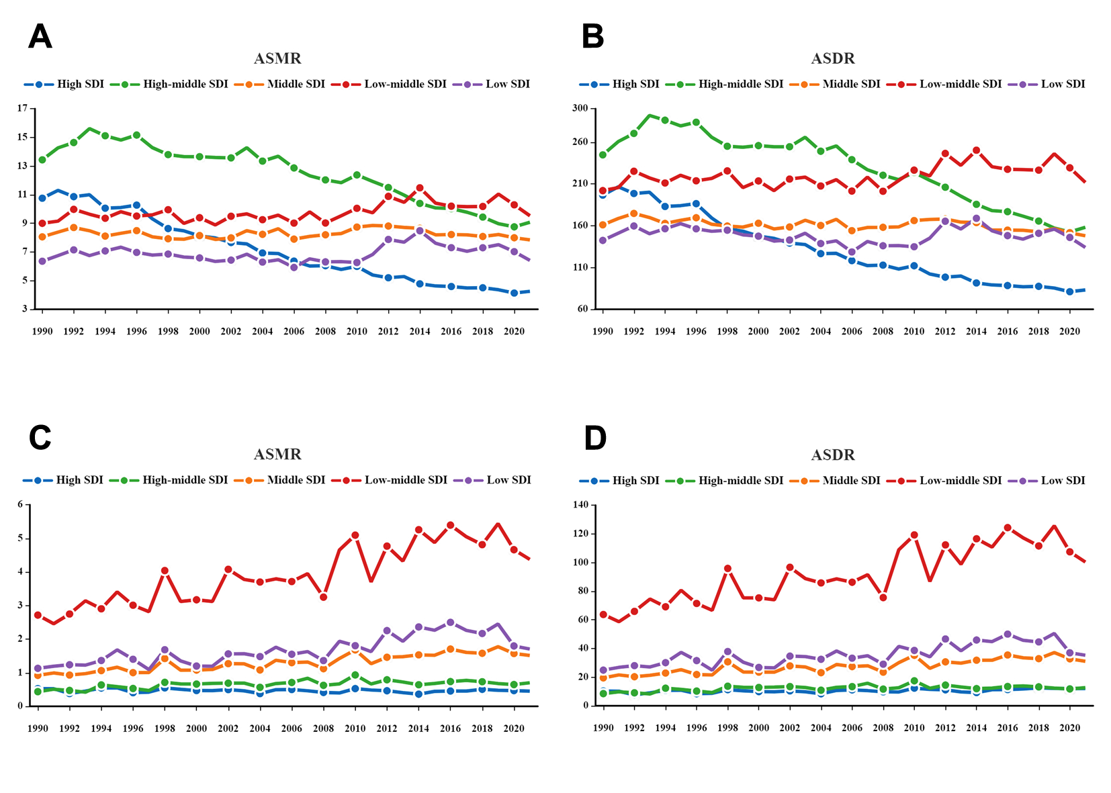 Fig. S1 Trends in disease burden related to non-optimal temperatures and high temperature IHD in five SDI regions
(A) ASMR of non-optimal temperatures. (B) ASDR of non-optimal temperatures. (C) ASMR of high temperatures. (D) ASDR of high temperatures. IHD, Ischemic heart disease. ASMR, age-standardized mortality rate; ASDR, age-standardized disability-adjusted life year rate; SDI, socio-demographic index.
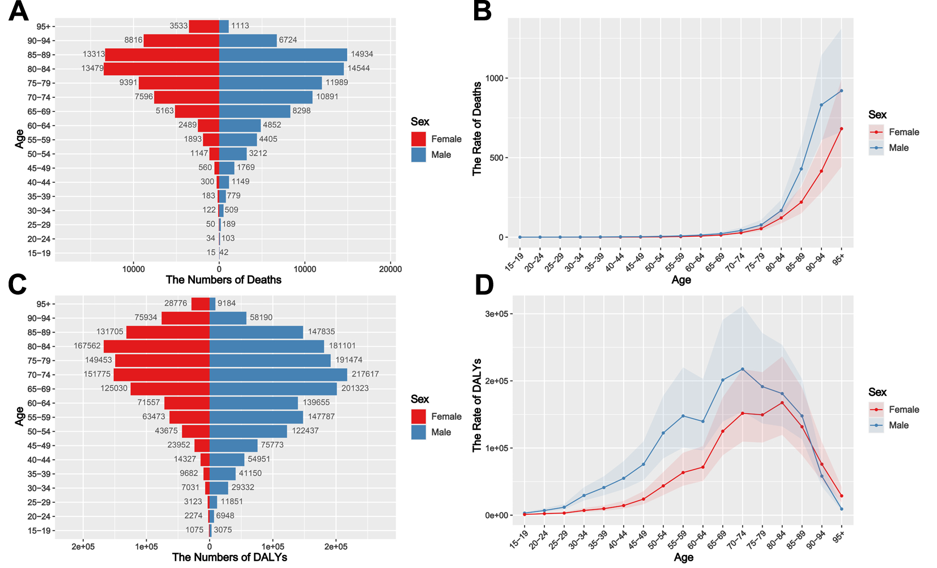 Fig. S2 Age-specific IHD numbers (dual-axis plot) and rates (line plot) of deaths and DALYs attributable to non-optimal temperatures stratified by sex in China in 2021
- (B) Number of deaths in 2021. (C) (D) Number of DALYs in 2021. IHD, Ischemic heart disease; DALYs, disability-adjusted life years.

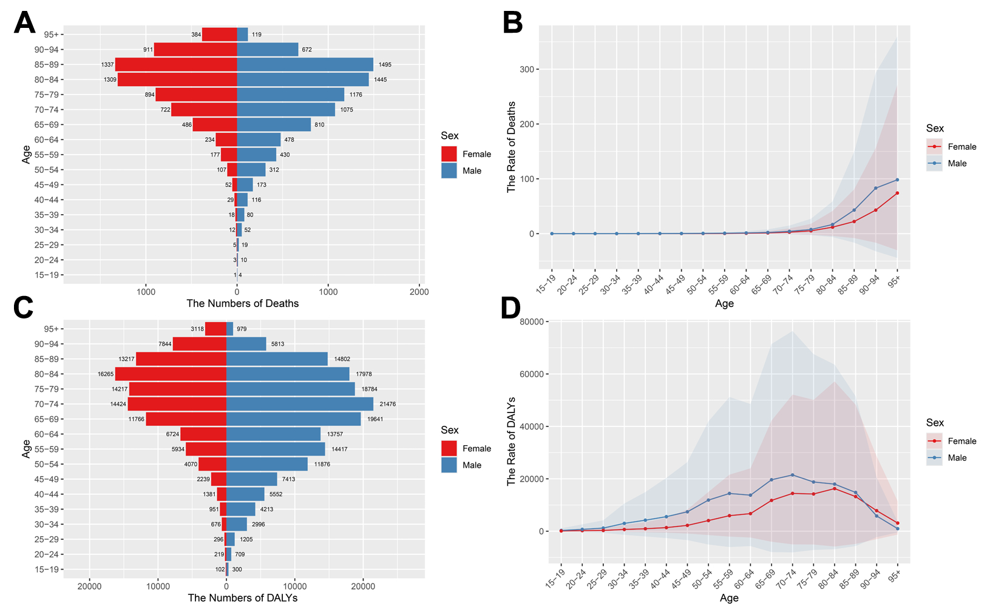
Fig. S3 Age-specific IHD numbers (dual-axis plot) and rates (line plot) of deaths and DALYs attributable to high temperatures stratified by sex in China in 2021
- (B) Number of deaths in 2021. (C) (D) Number of DALYs in 2021. IHD, Ischemic heart disease; DALYs, disability-adjusted life years.

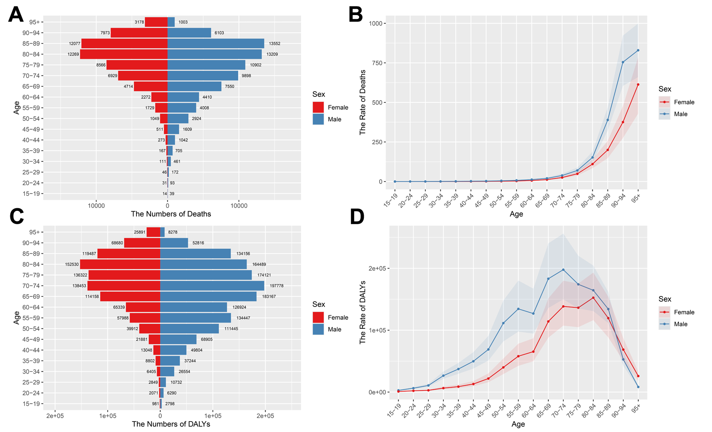
Fig. S4 Age-specific IHD numbers (dual-axis plot) and rates (line plot) of deaths and DALYs attributable to low temperatures stratified by sex in China in 2021
(A) (B) Number of deaths in 2021. (C) (D) Number of DALYs in 2021. IHD, Ischemic heart disease; DALYs, disability-adjusted life years.
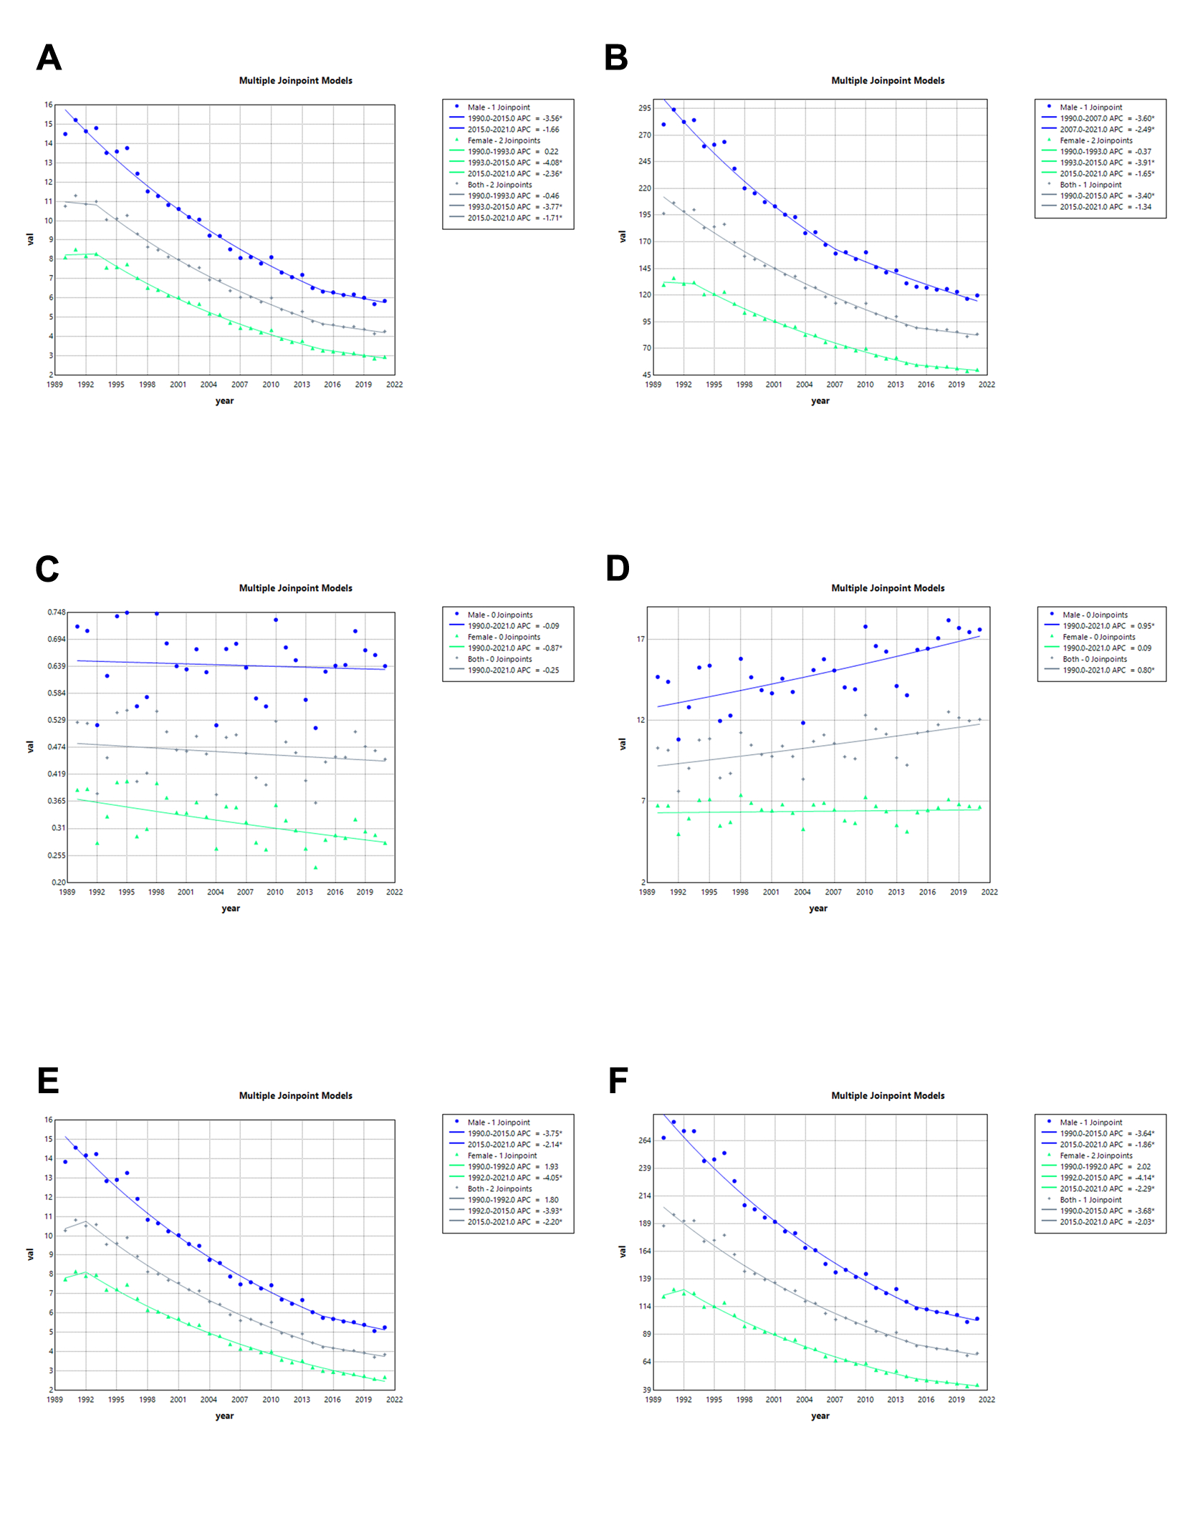
Fig. S5 Joinpoint regression analysis of the sex-specific ASMR and ASDR for IHD in High SDI from 1990 to 2021. (A) Non-optimal temperatures of ASMR. (B) Non-optimal temperatures of ASDR. (C) High temperatures of ASMR. (D) High temperatures of ASDR. (E) Low temperatures of ASMR. (F) Low temperatures of ASDR. IHD, Ischemic heart disease; ASMR, age-standardized mortality rate; ASDR, age-standardized disability-adjusted life year rate; SDI, socio-demographic index.

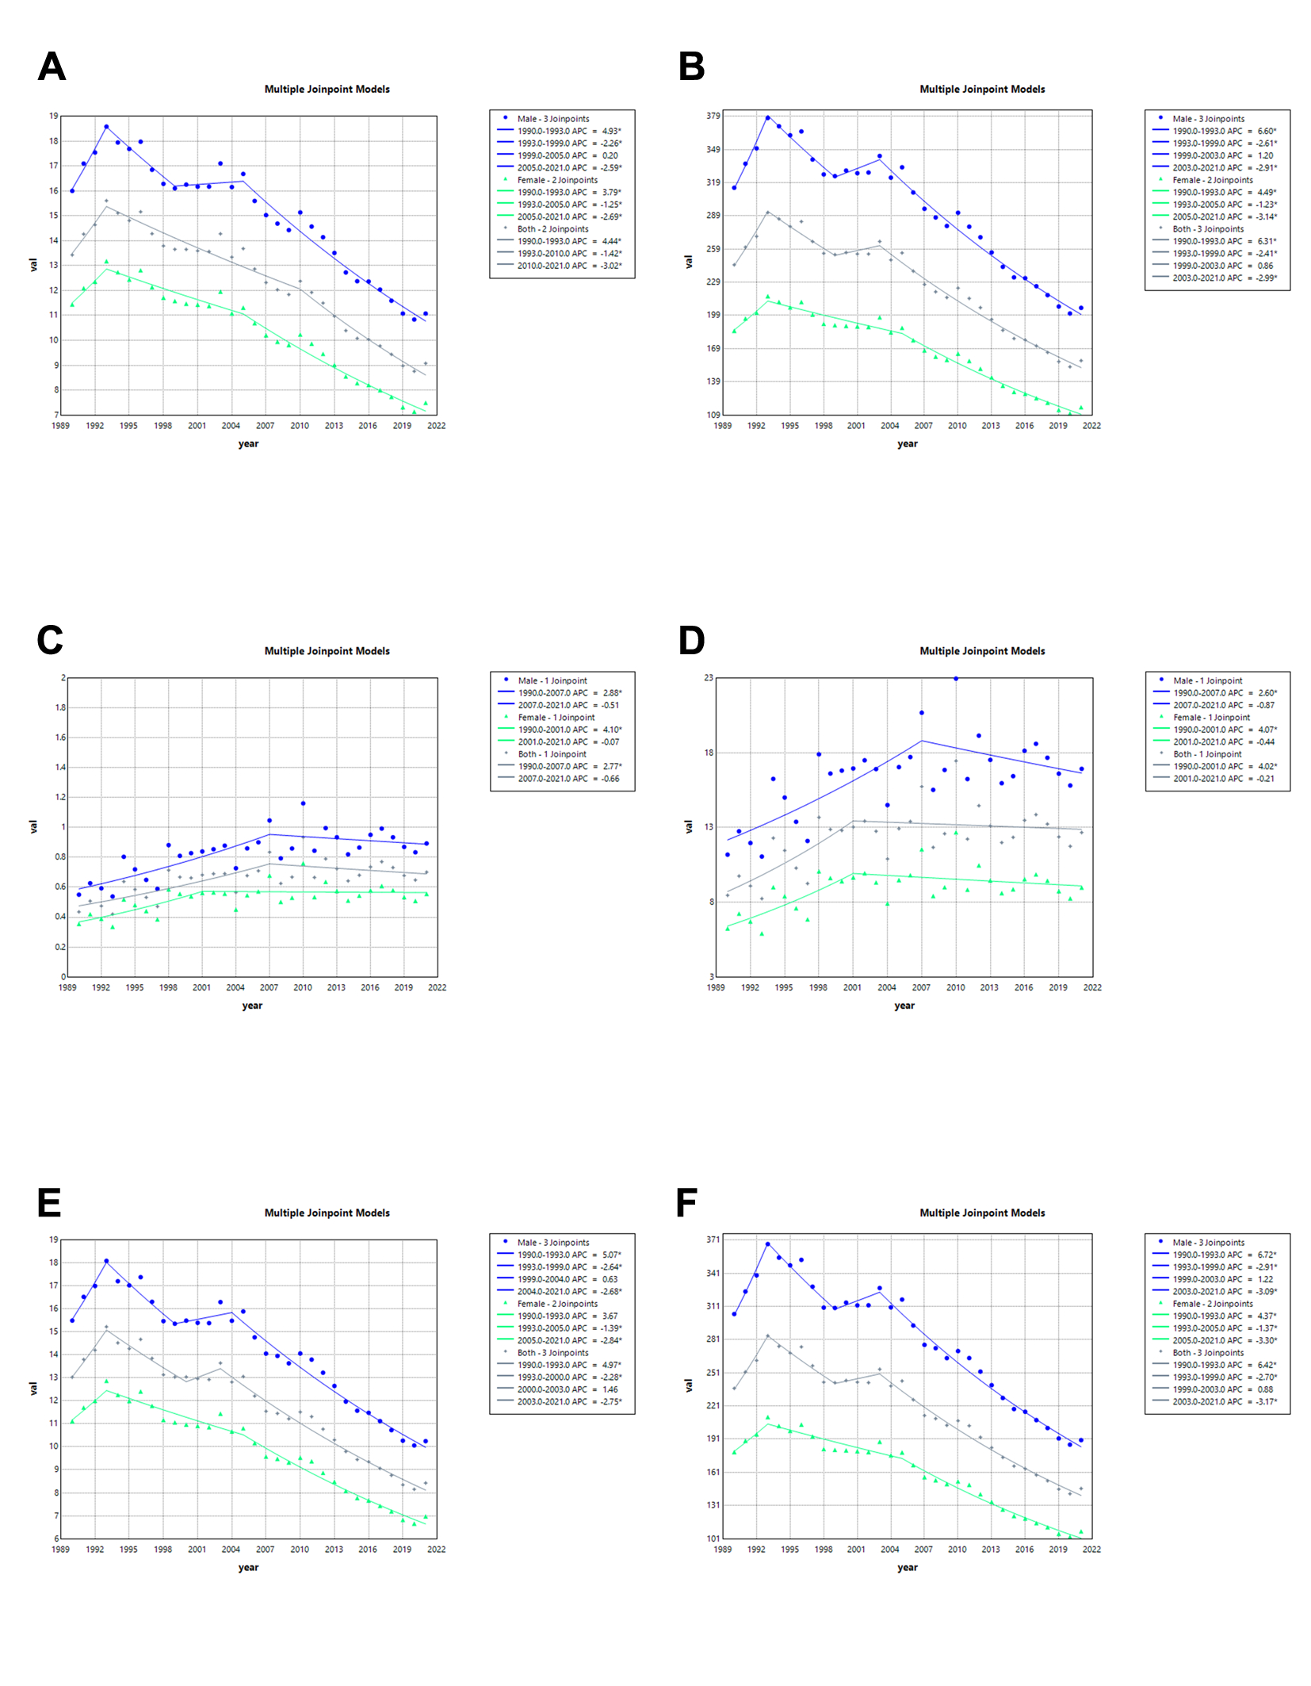
Fig. S6 Joinpoint regression analysis of the sex-specific ASMR and ASDR for IHD in High-Middle SDI from 1990 to 2021
(A) Non-optimal temperatures of ASMR. (B) Non-optimal temperatures of ASDR. (C) High temperatures of ASMR. (D) High temperatures of ASDR. (E) Low temperatures of ASMR. (F) Low temperatures of ASDR. IHD, ischemic heart disease; ASMR, age-standardized mortality rate; ASDR, age-standardized disability-adjusted life year rate; SDI, socio-demographic index.

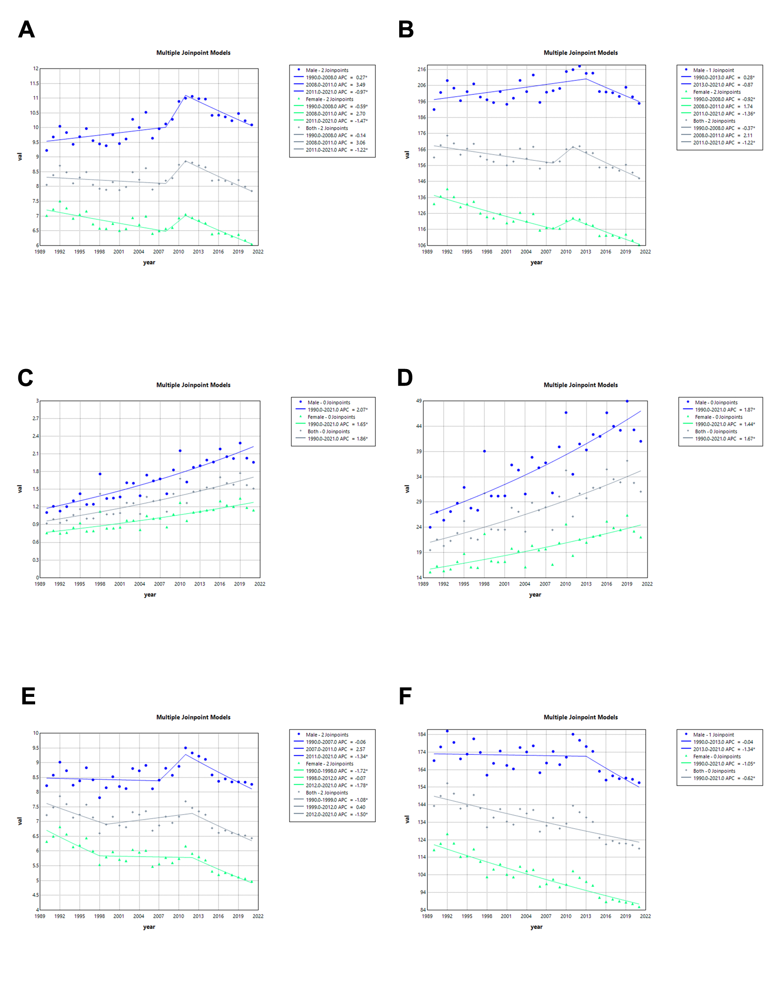
Fig. S7 Joinpoint regression analysis of the sex-specific ASMR and ASDR for IHD in Middle SDI from 1990 to 2021. (A) Non-optimal temperatures of ASMR. (B) Non-optimal temperatures of ASDR. (C) High temperatures of ASMR. (D) High temperatures of ASDR. (E) Low temperatures of ASMR. (F) Low temperatures of ASDR. IHD, ischemic heart disease; ASMR, age-standardized mortality rate; ASDR, age-standardized disability-adjusted life year rate; SDI, socio-demographic index.

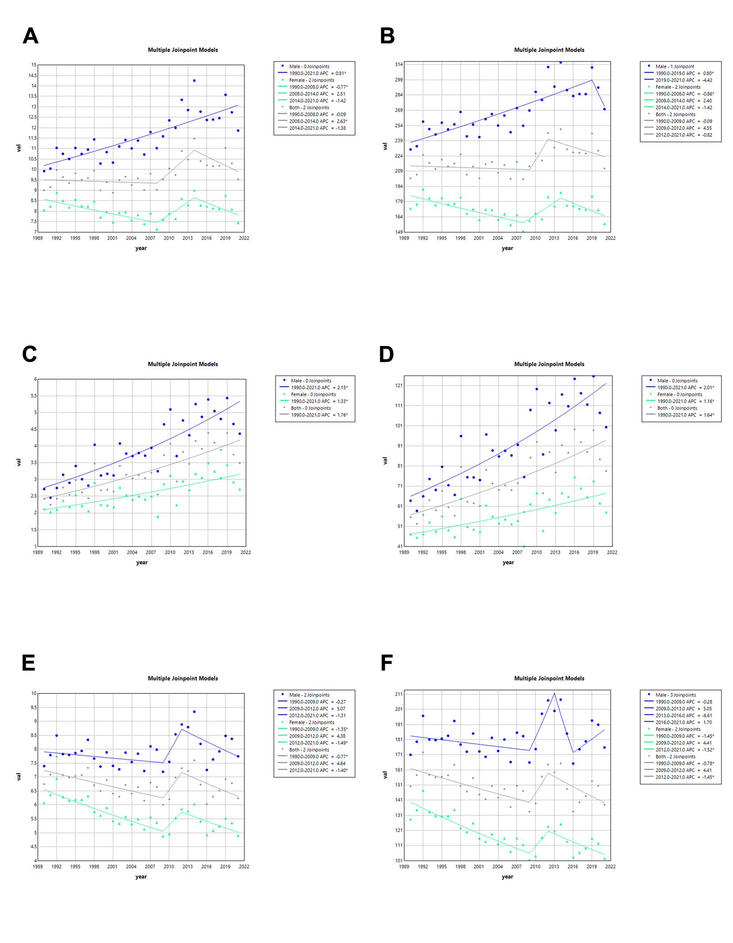
Fig. S8 Joinpoint regression analysis of the sex-specific ASMR and ASDR for IHD in Low-Middle SDI from 1990 to 2021. (A) Non-optimal temperatures of ASMR. (B) Non-optimal temperatures of ASDR. (C) High temperatures of ASMR. (D) High temperatures of ASDR. (E) Low temperatures of ASMR. (F) Low temperatures of ASDR. IHD, ischemic heart disease; ASMR, age-standardized mortality rate; ASDR, age-standardized disability-adjusted life year rate; SDI, socio-demographic index.

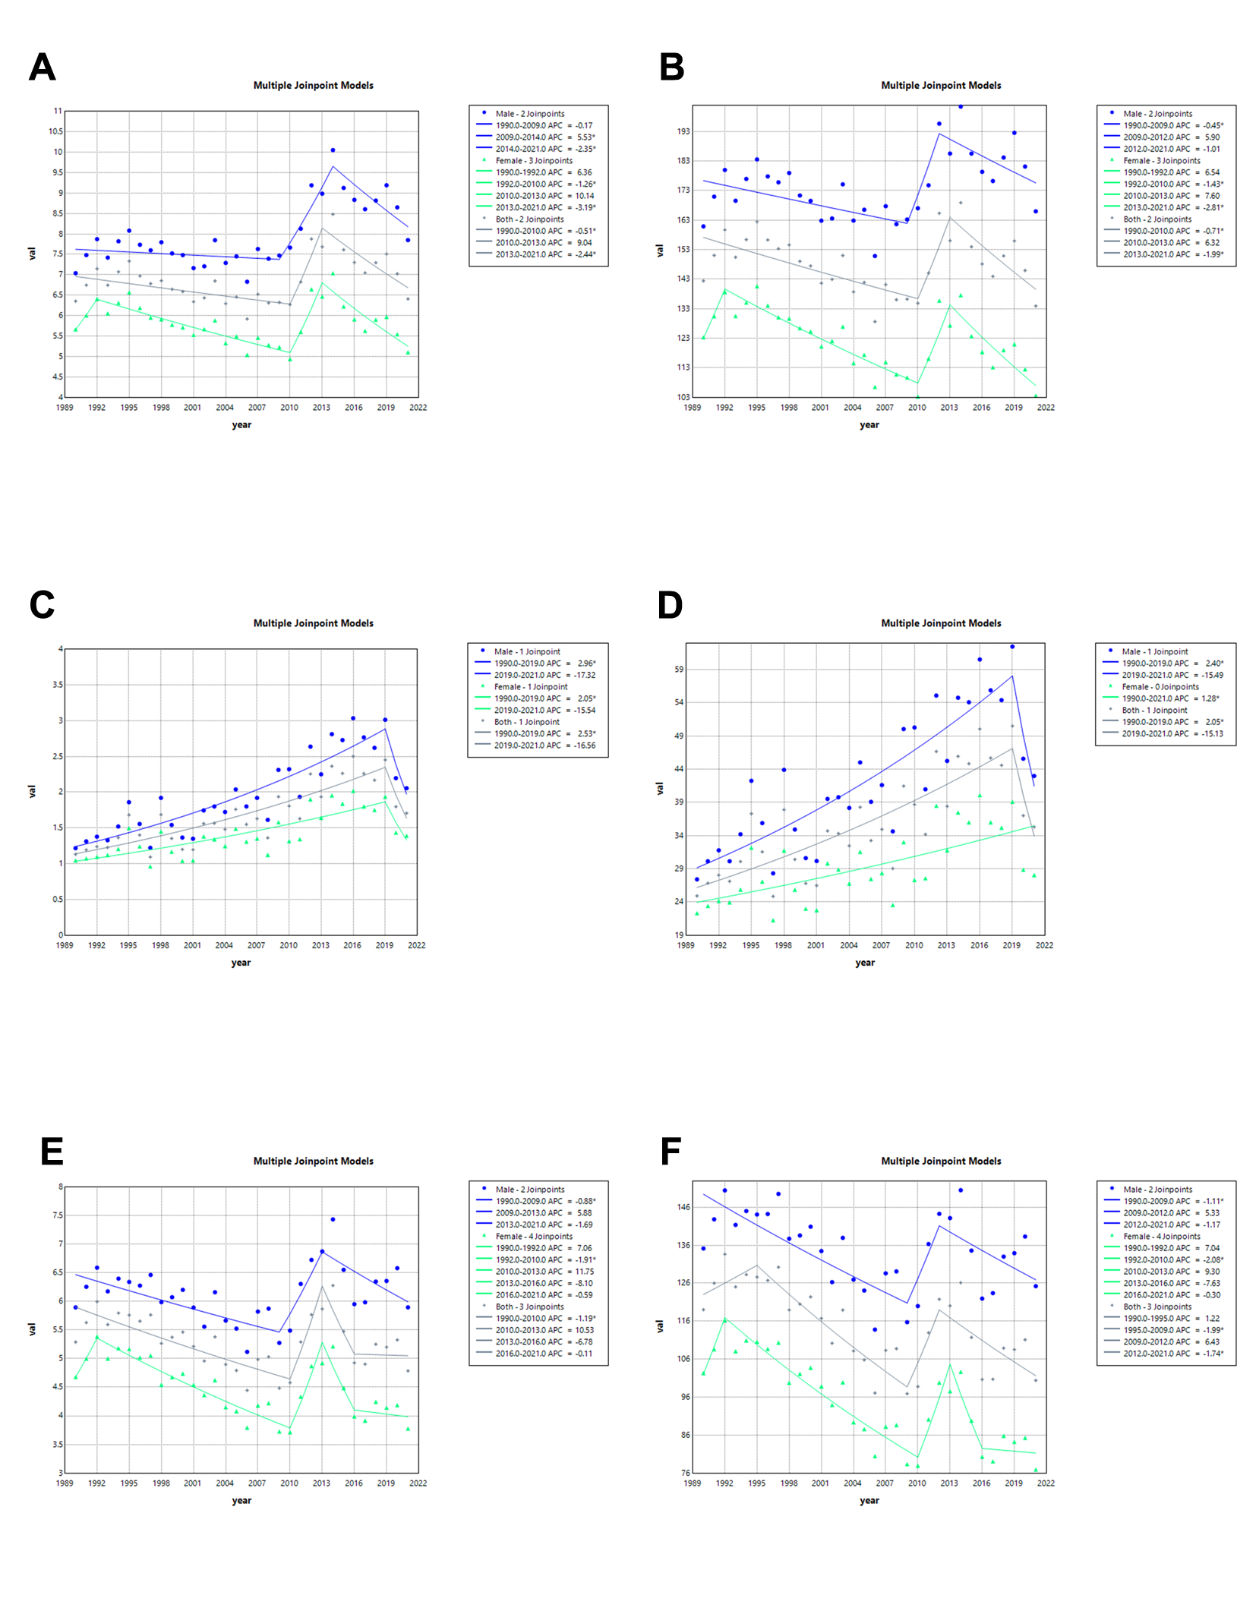
Fig. S9 Joinpoint regression analysis of the sex-specific ASMR and ASDR for IHD in Low SDI from 1990 to 2021. (A) Non-optimal temperatures of ASMR. (B) Non-optimal temperatures of ASDR. (C) High temperatures of ASMR. (D) High temperatures of ASDR. (E) Low temperatures of ASMR. (F) Low temperatures of ASDR. IHD, ischemic heart disease; ASMR, age-standardized mortality rate; ASDR, age-standardized disability-adjusted life year rate; SDI, socio-demographic index.

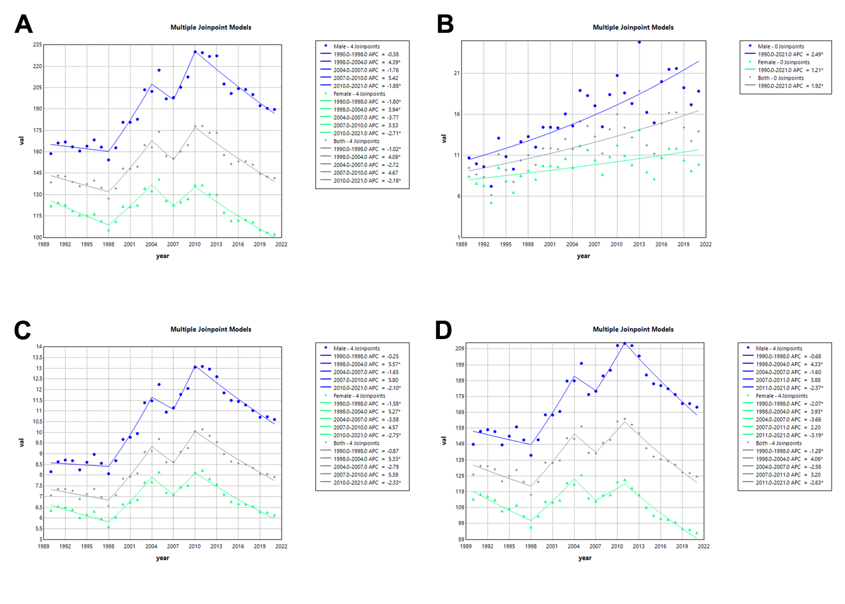
Fig. S10 Joinpoint regression analysis of the sex-specific ASMR and ASDR for IHD in China from 1990 to 2021. (A) Non-optimal temperatures of ASDR. (B) High temperatures of ASDR. (C) Low temperatures of ASMR. (D) Low temperatures of ASDR. IHD, ischemic heart disease; ASMR, age-standardized mortality rate; ASDR, age-standardized disability-adjusted life year rate; SDI, socio-demographic index.
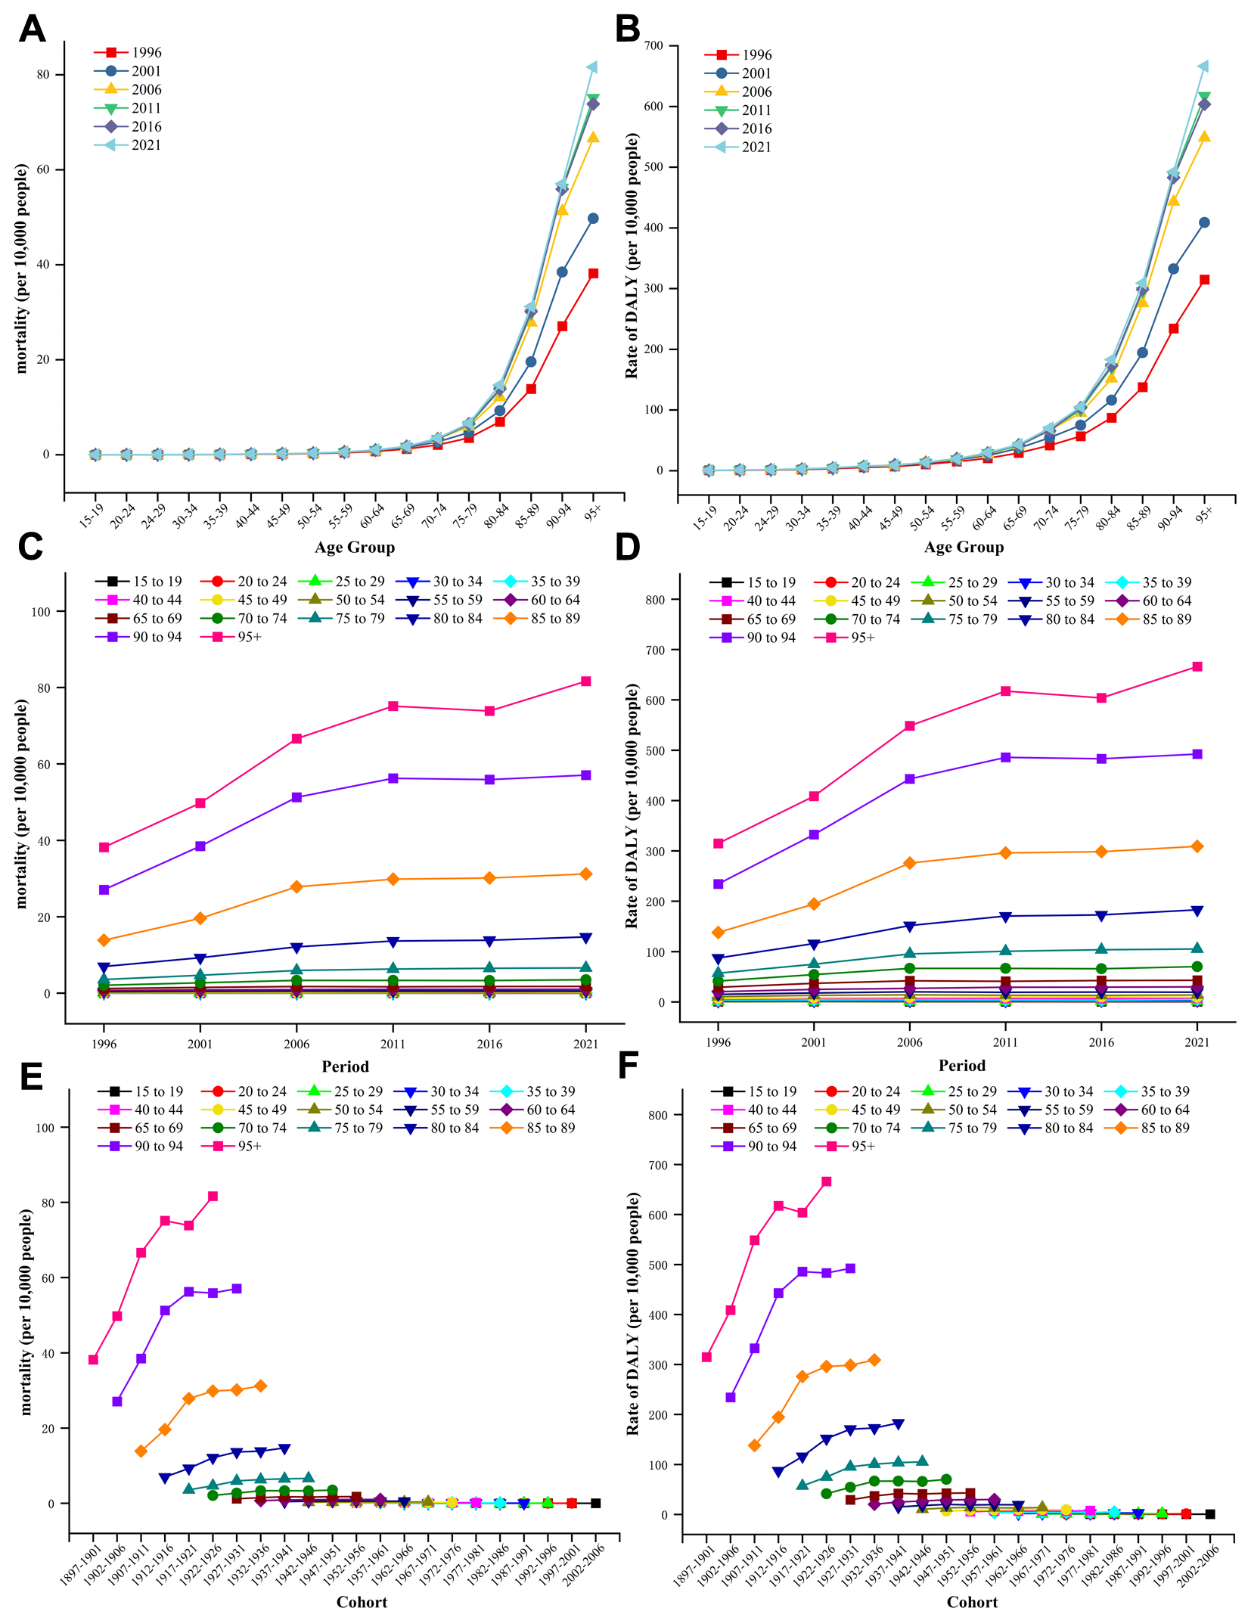
Fig. S11 Trends of age-specific, period-based and cohort-based variation of IHD due to high temperatures mortality and DALY rate in China
(A) (B) Age-specific IHD mortality and DALY rate. (C) (D) period-based IHD mortality and DALY rate. (E) (F) cohort-based IHD mortality and DALY rate. IHD, ischemic heart disease; DALY, disability-adjusted life year.

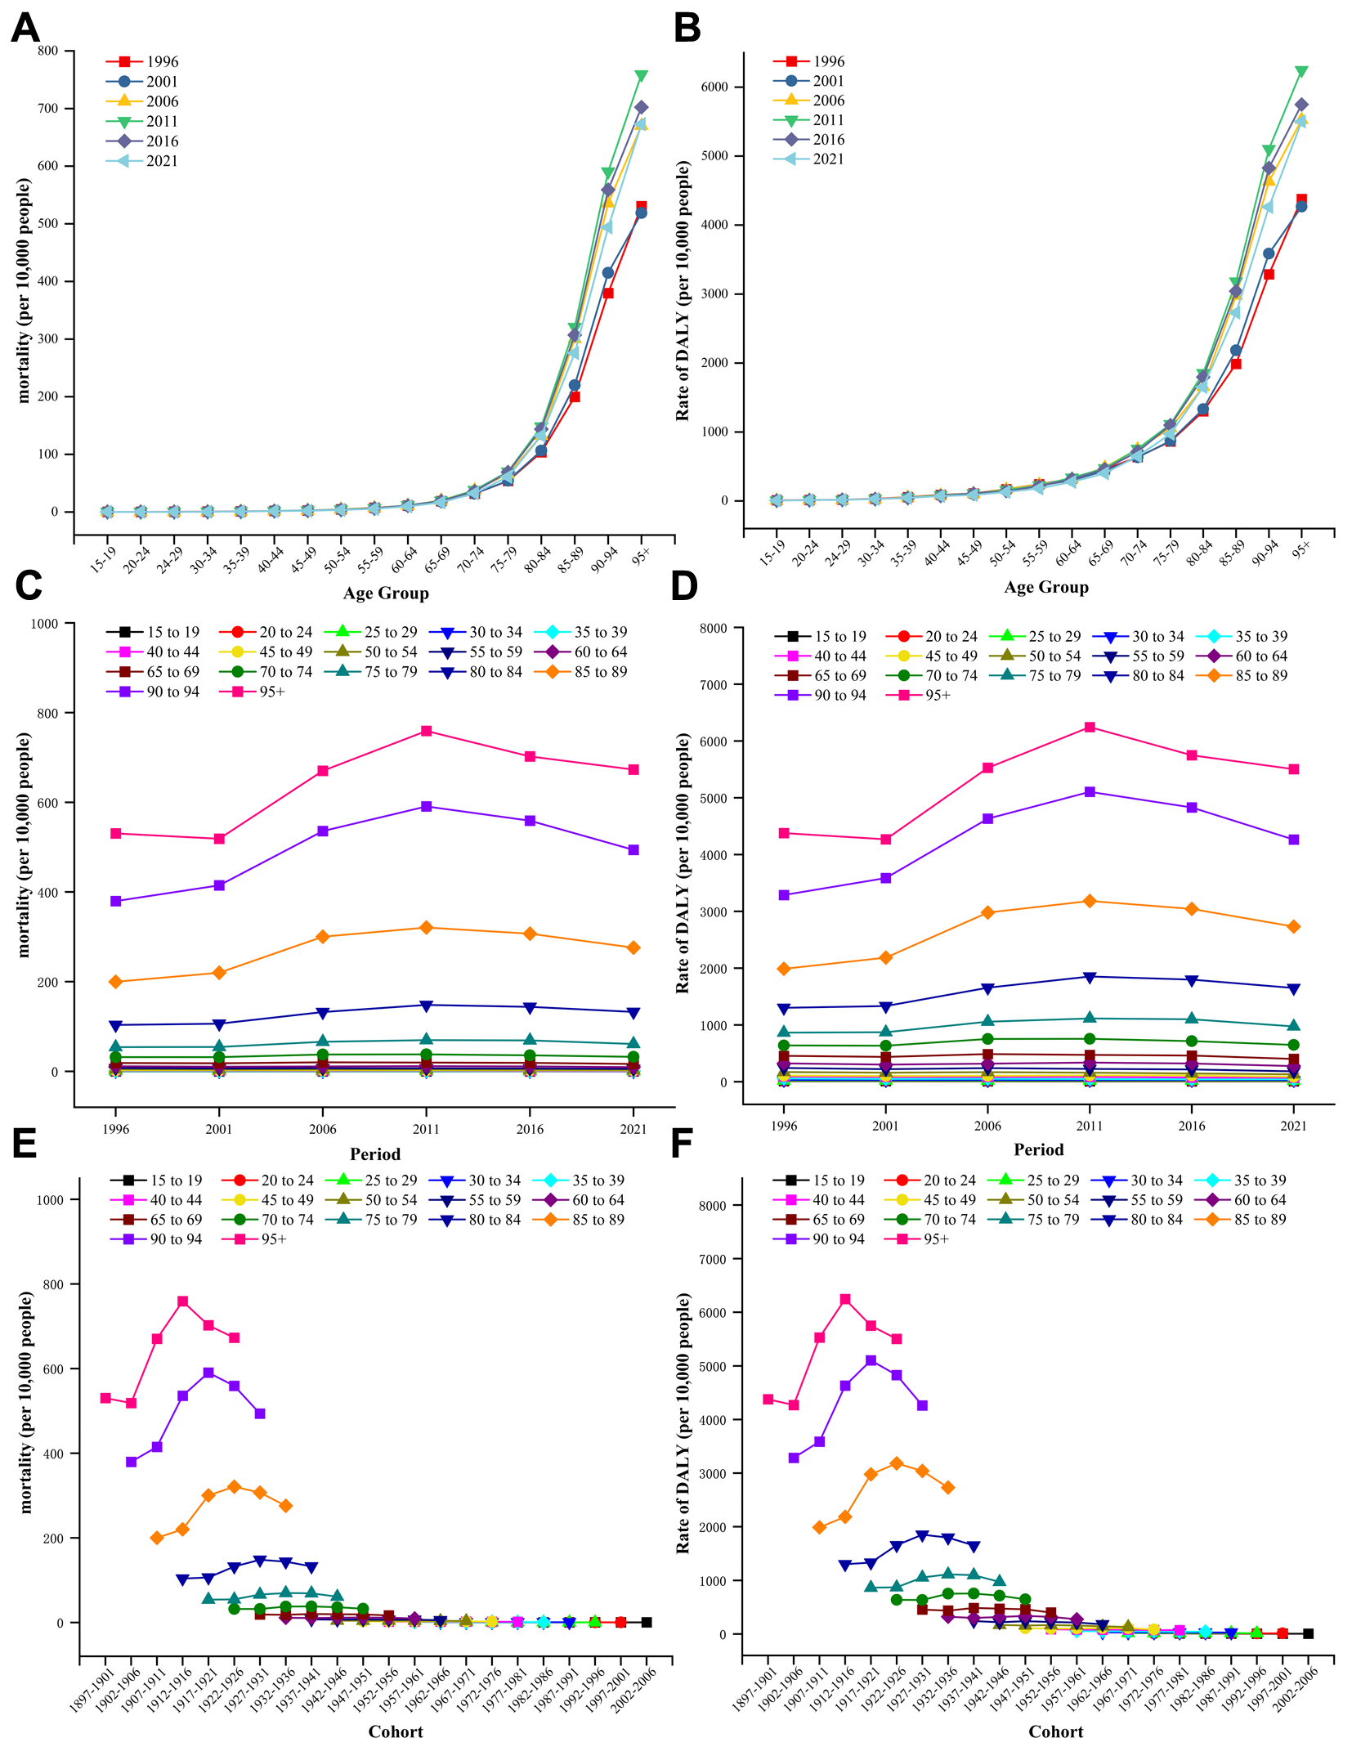
Fig. S12 Trends of age-specific, period-based and cohort-based variation of IHD due to low temperatures mortality and DALY rate in China
(A) (B) Age-specific IHD mortality and DALY rate. (C) (D) period-based IHD mortality and DALY rate. (E) (F) cohort-based IHD mortality and DALY rate. IHD, ischemic heart disease; DALY, disability-adjusted life year.
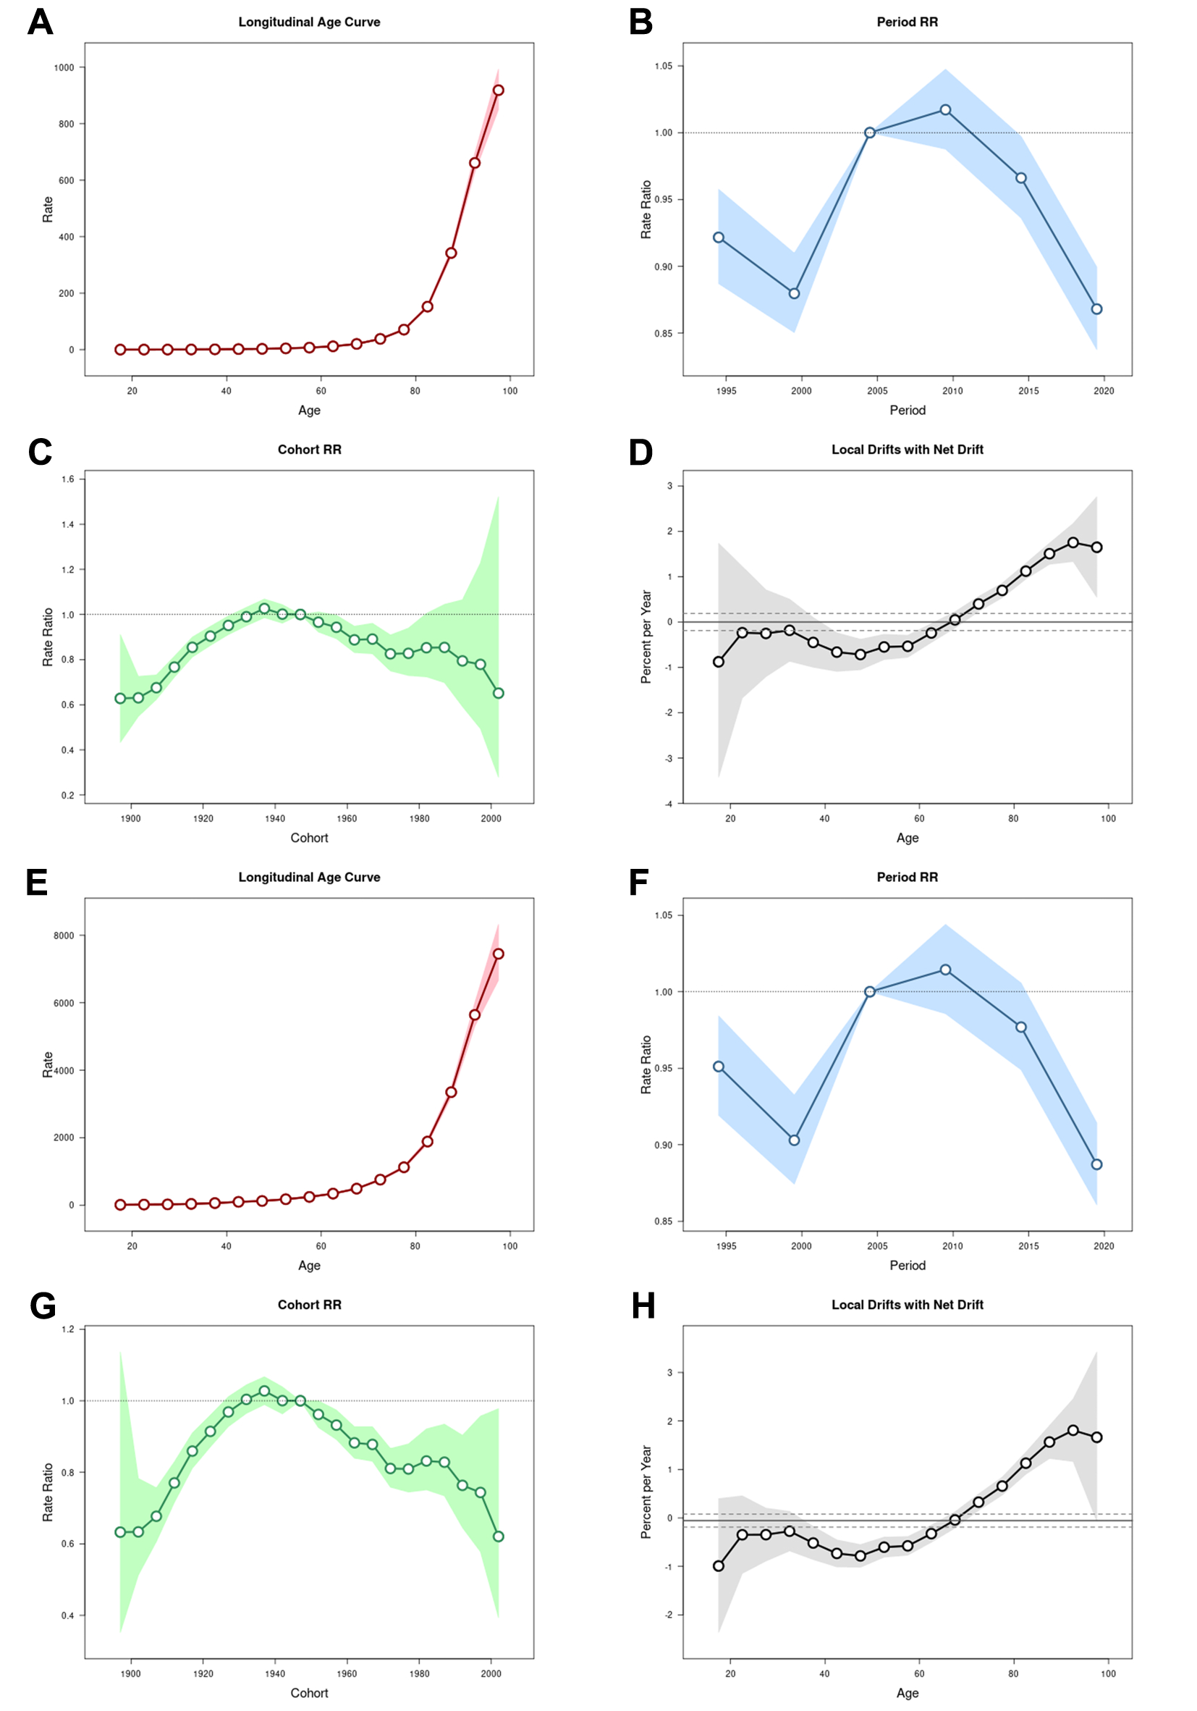
Fig. S13 Age, period and cohort effects on IHD due to non-optimal temperatures mortality and DALYs rate in China during 1990-2021
(A) Age effects of mortality. (B) period effects of mortality. (C) cohort effects of mortality. (D) Local Drifts with Net Drift of mortality. (E) Age effects of DALYs. (F) period effects of DALYs. (G) cohort effects of DALYs. (H) Local drifts with net drift of DALYs. IHD, ischemic heart disease; DALYs, disability-adjusted life years.

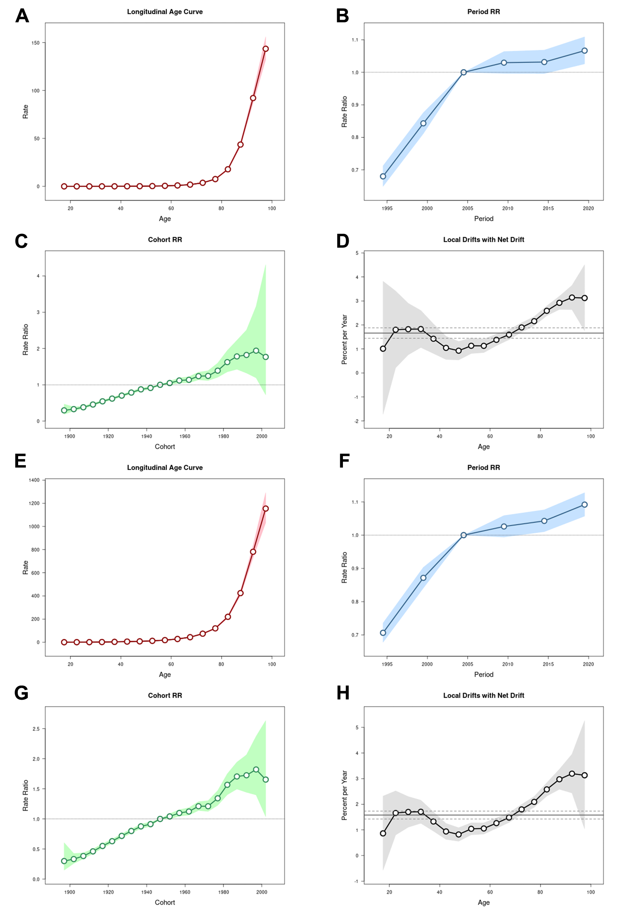
Fig. S14 Age, period and cohort effects on IHD due to high temperatures mortality and DALY rate in China during 1990-2021
(A) Age effects of mortality. (B) period effects of mortality. (C) cohort effects of mortality. (D) Local Drifts with Net Drift of mortality. (E) Age effects of DALY rate. (F) period effects of DALY rate. (G) cohort effects of DALY rate. (H) Local drifts with net drift of DALY rate. IHD, ischemic heart disease; DALY, disability-adjusted life year.

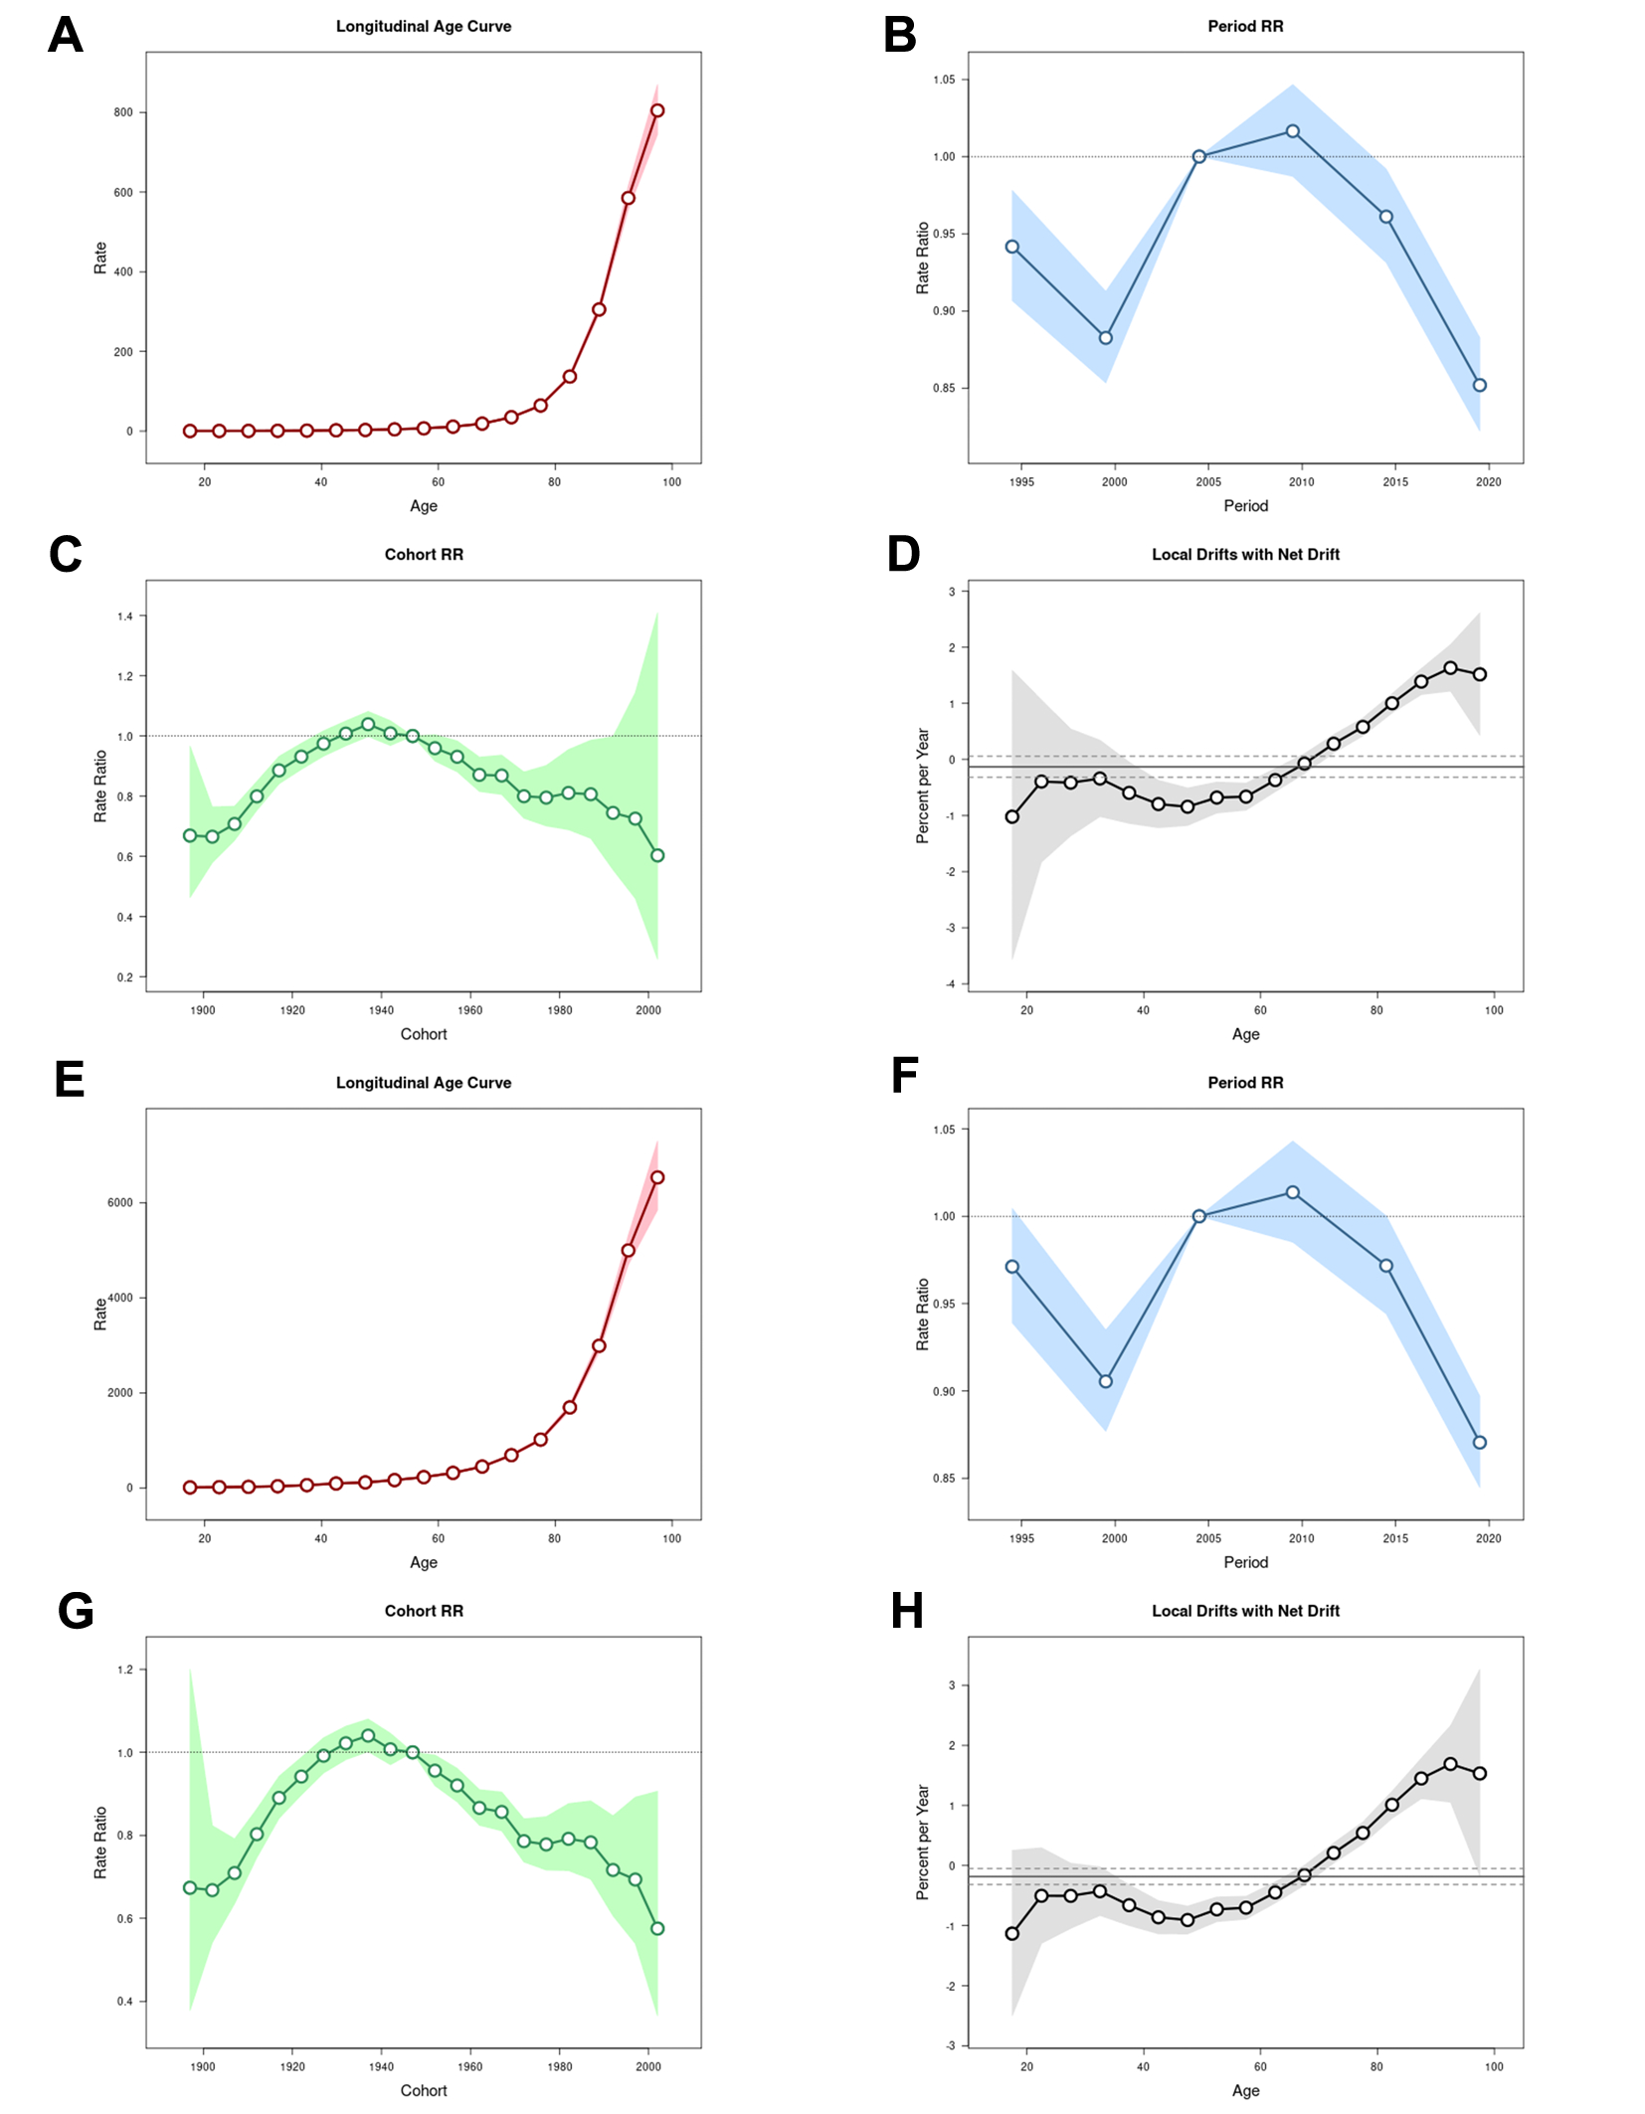
Fig. S15 Age, period and cohort effects on IHD due to low temperatures mortality and DALY rate in China during 1990-2021. (A) Age effects of mortality. (B) period effects of mortality. (C) cohort effects of mortality. (D) Local Drifts with Net Drift of mortality. (E) Age effects of DALY rate. (F) period effects of DALY rate. (G) Cohort effects of DALY rate. (H) Local drifts with net drift of DALY rate. IHD, ischemic heart disease; DALY, disability-adjusted life year.

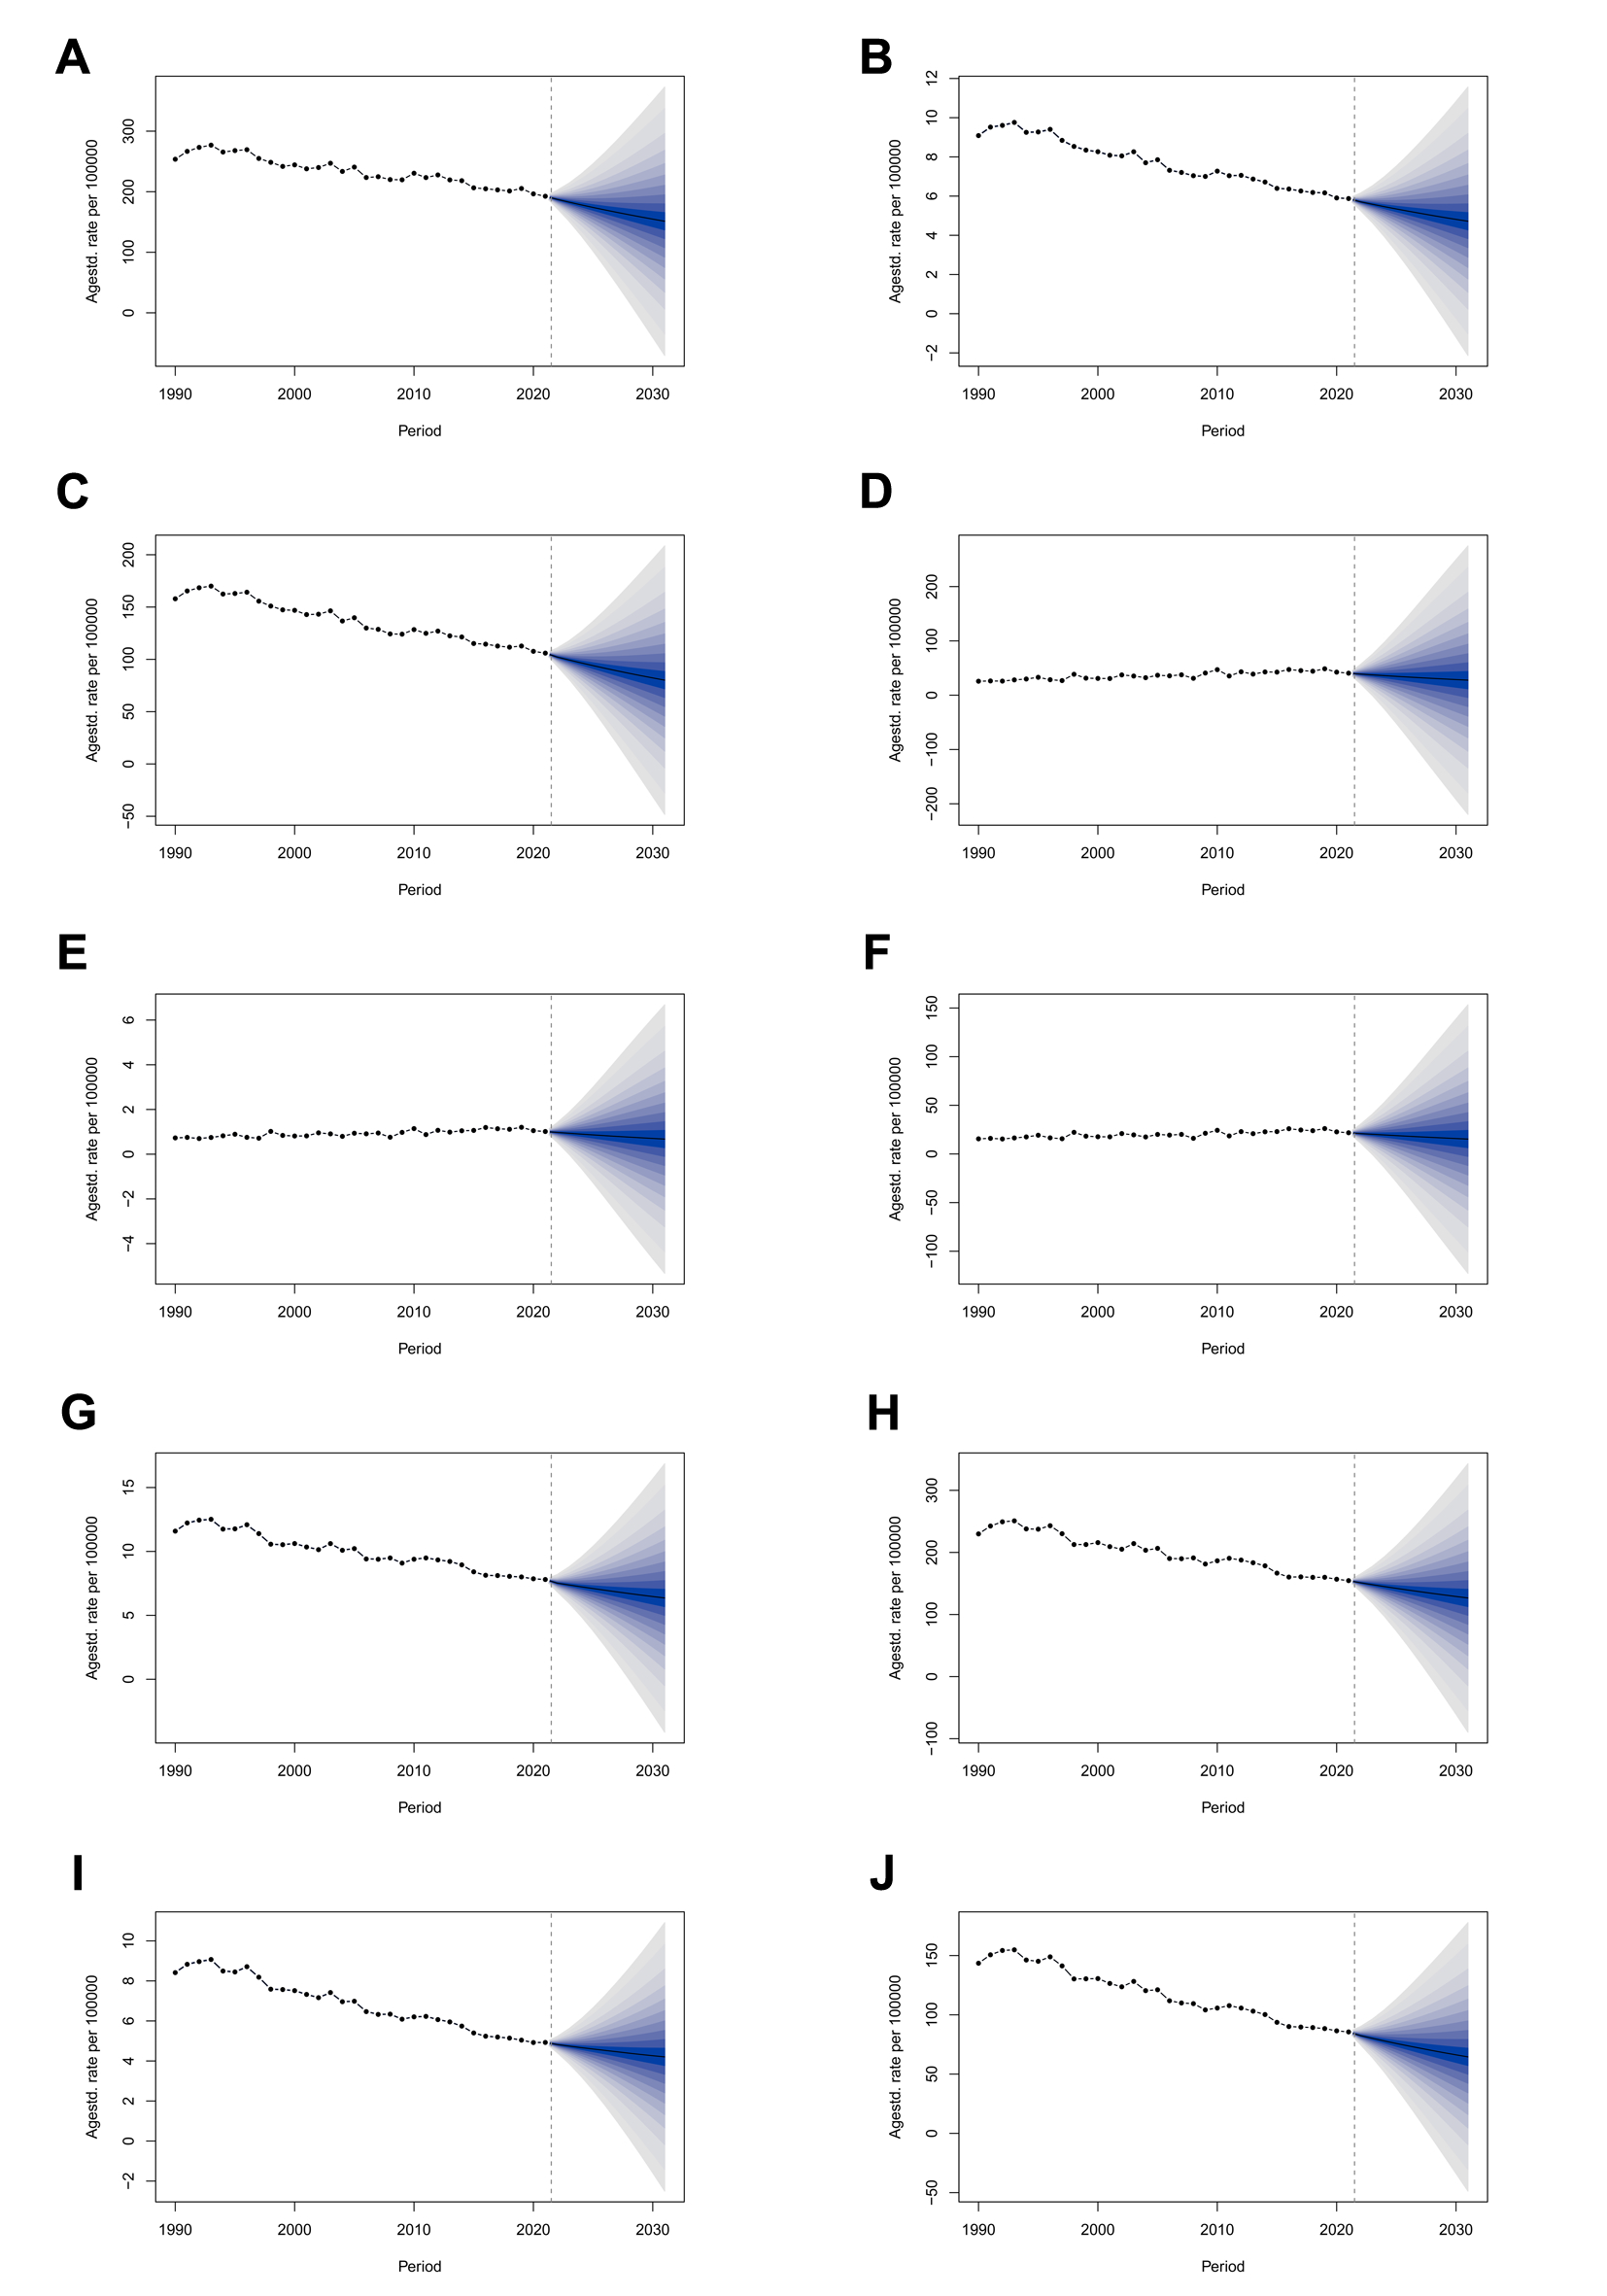
Fig. S16 BAPC predictive analysis, ASMR, per 100,000 and ASDR, per 100,000 of IHD in Global, 1990-2031
(A) Non-optimal temperature exposure and ASDR in male. (B) Non-optimal temperature exposure and ASMR in female. (C) Non-optimal temperature exposure and ASDR in female. (D) High temperature exposure and ASDR in male. (E) High temperature exposure and ASMR in female. (F) High temperature exposure and ASDR in female. (G) Low temperature exposure and ASMR in male. (H) Low temperature exposure and ASDR in male. (I) Low temperature exposure and ASMR in female. (J) Low temperature exposure and ASDR in female. IHD, ischemic heart disease; ASMR, age-standardized mortality rate; ASDR, age-standardized disability-adjusted life year rate.

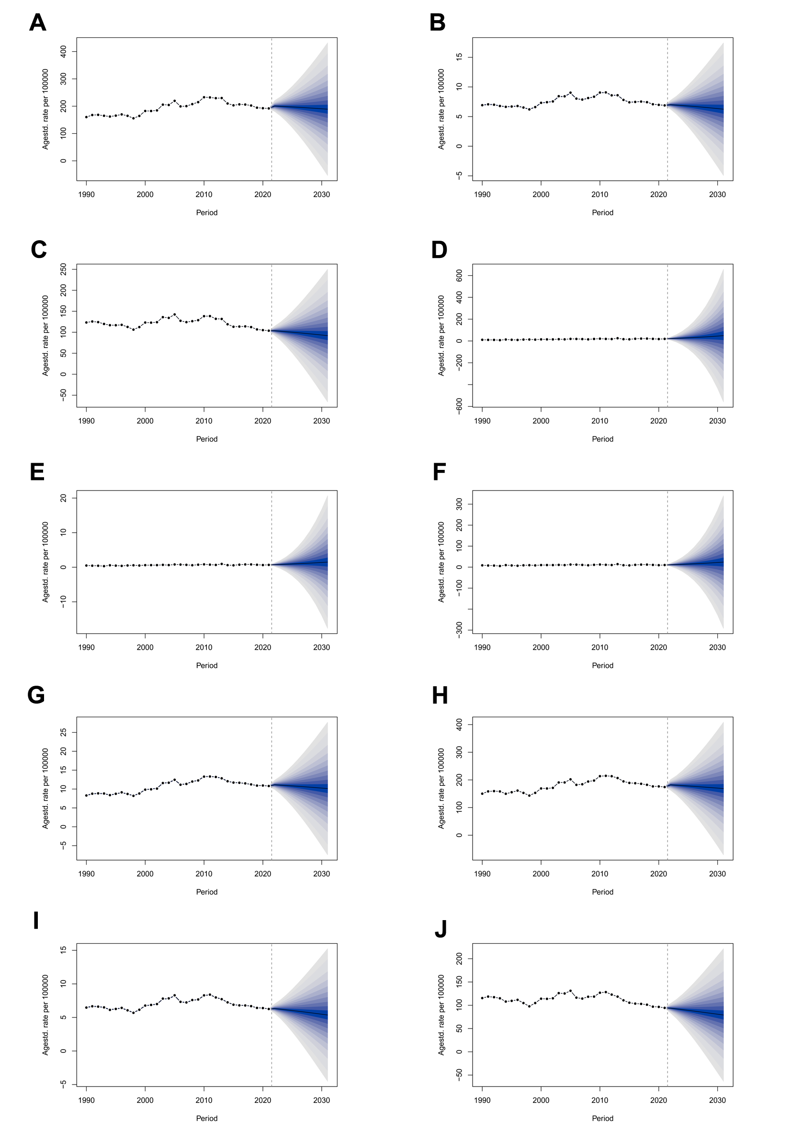
Fig. S17 BAPC predictive analysis, ASMR, per 100,000 and ASDR, per 100,000 of IHD in China, 1990-2031
(A) Non-optimal temperature exposure and ASDR in male. (B) Non-optimal temperature exposure and ASMR in female. (C) Non-optimal temperature exposure and ASDR in female. (D) High temperature exposure and ASDR in male. (E) High temperature exposure and ASMR in female. (F) High temperature exposure and ASDR in female. (G) Low temperature exposure and ASMR in male. (H) Low temperature exposure and ASDR in male. (I) Low temperature exposure and ASMR in female. (J) Low temperature exposure and ASDR in female. IHD, ischemic heart disease; ASMR, age-standardized mortality rate; ASDR, age-standardized disability-adjusted life year rate.

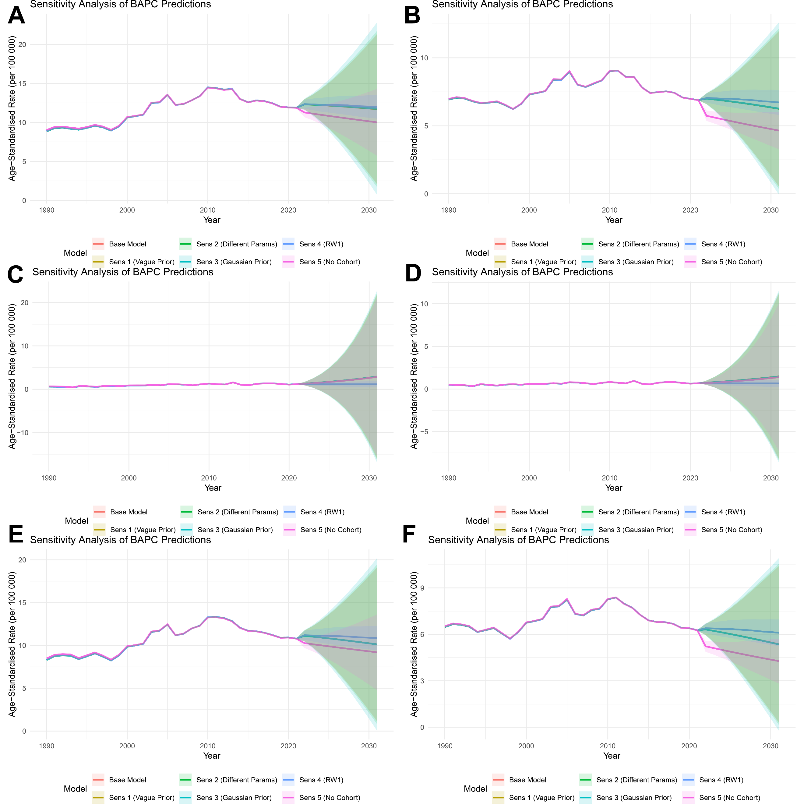
Fig. S18 Sensitivity analysis of BAPC, ASMR, per 100,000 of IHD in China, 1990-2031
(A) Non-optimal temperature exposure in male. (B) Non-optimal temperature exposure in female. (C) High temperature exposure in male. (D) High temperature exposure in female. (E) Low temperature exposure in male. (F) Low temperature exposure in female. IHD, ischemic heart disease; ASMR, age-standardized mortality rate; ASDR, age-standardized disability-adjusted life year rate.
Fig. S19 Sensitivity analysis of BAPC, ASDR, per 100,000 of IHD in China, 1990-2031
(A) Non-optimal temperature exposure in male. (B) Non-optimal temperature exposure in female. (C) High temperature exposure in male. (D) High temperature exposure in female. (E) Low temperature exposure in male. (F) Low temperature exposure in female. IHD, ischemic heart disease; ASMR, age-standardized mortality rate; ASDR, age-standardized disability-adjusted life year rate.

Fig. S20 Sensitivity analysis of BAPC, ASMR, per 100,000 of IHD in Global, 1990-2031
(A) Non-optimal temperature exposure in male. (B) Non-optimal temperature exposure in female. (C) High temperature exposure in male. (D) High temperature exposure in female. (E) Low temperature exposure in male. (F) Low temperature exposure in female. IHD, ischemic heart disease; ASMR, age-standardized mortality rate; ASDR, age-standardized disability-adjusted life year rate.

Fig. S21 Sensitivity analysis of BAPC, ASDR, per 100,000 of IHD in Global, 1990-2031
(A) Non-optimal temperature exposure in male. (B) Non-optimal temperature exposure in female. (C) High temperature exposure in male. (D) High temperature exposure in female. (E) Low temperature exposure in male. (F) Low temperature exposure in female. IHD, ischemic heart disease; ASMR, age-standardized mortality rate; ASDR, age-standardized disability-adjusted life year rate.

