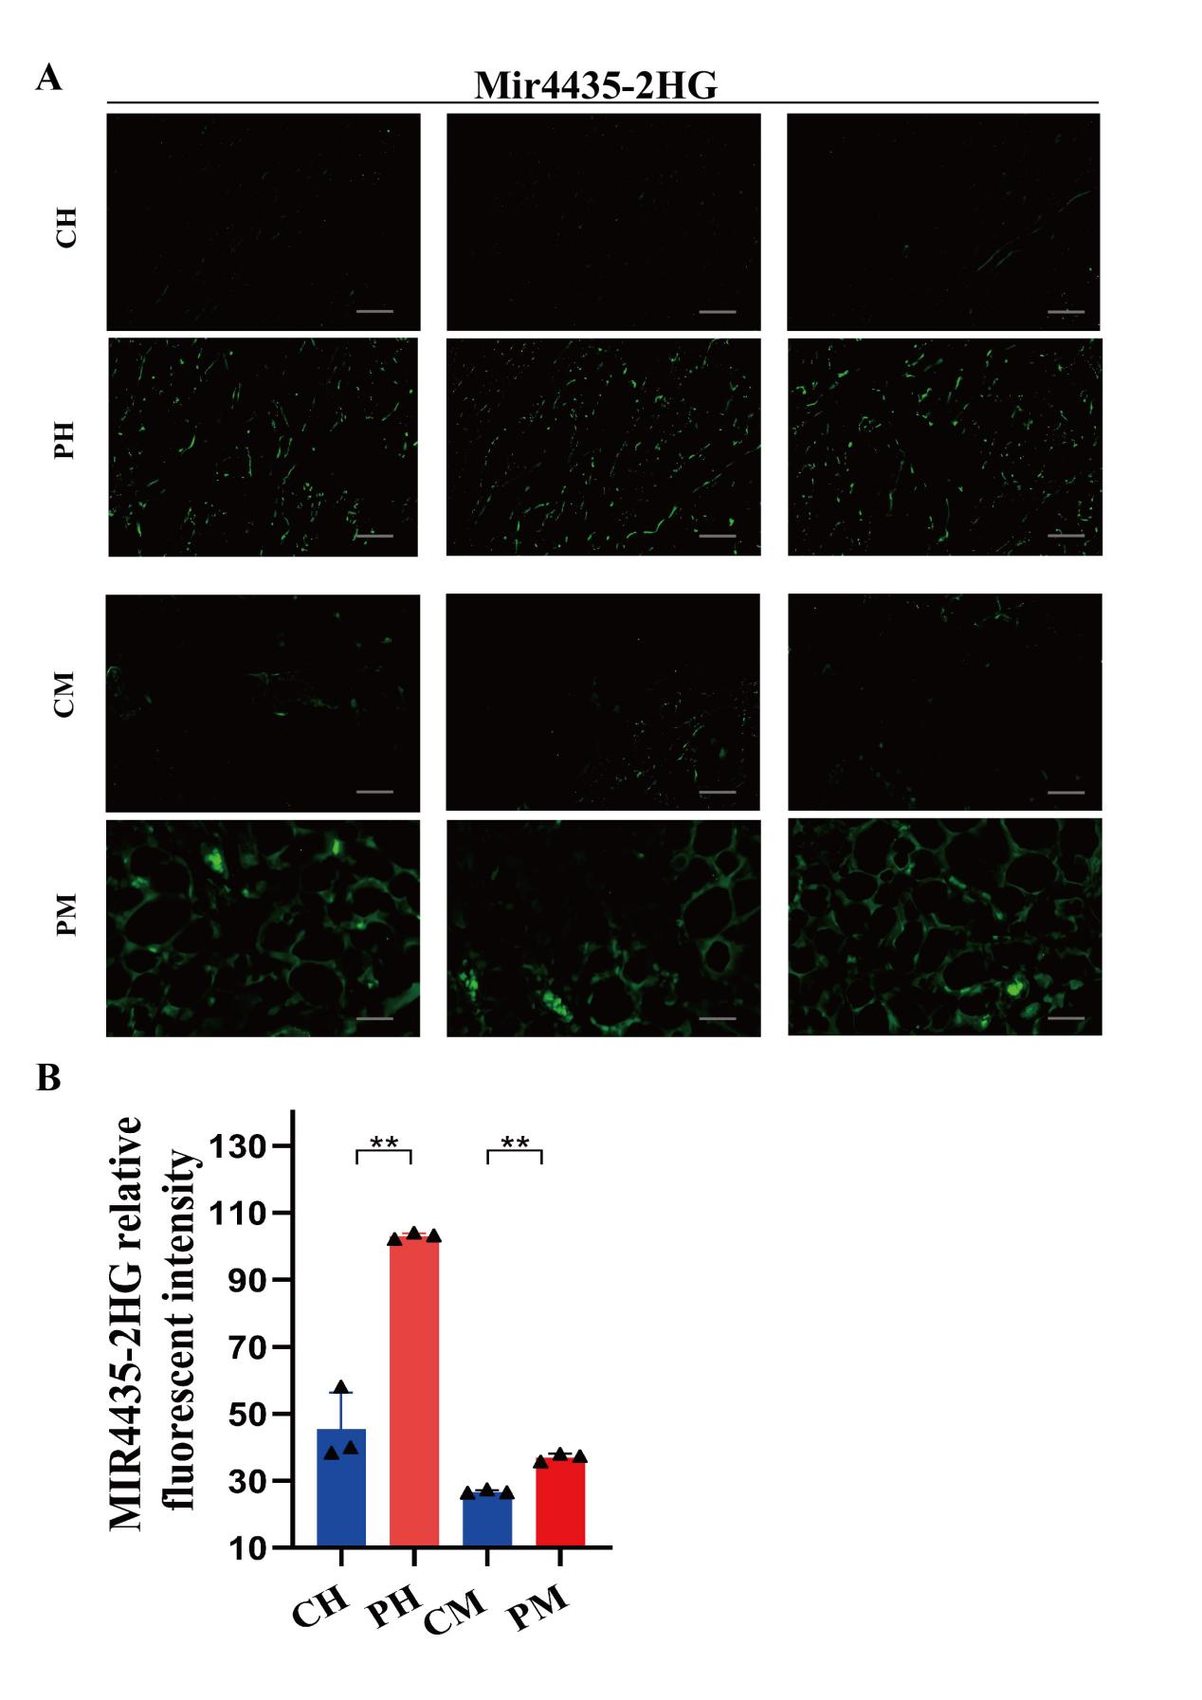

Supplementary Fig. 1 Quantitative Analysis of FISH Signals
(A) Fluorescence in situ hybridization (FISH) analysis showing MIR4435-2HG expression (green) in human and mouse healthy and psoriatic skin. CH: human healthy control; CM: mouse healthy control; PH: human psoriasis; PM: mouse psoriasis. Scale bar: 50 μm. (B) Quantitative analysis showing significantly stronger MIR4435-2HG signals in psoriatic dermis compared with normal skin (P < 0.01, N = 3).

